EMAIL 1
Subject: Update on August 15 Workshop (plus...Does LinkedIn really matter?)
<< Test First Name >>,
Thank you for registering for the August 15 workshop,

"How Accounting Firms Can Generate Consistent Leads with LinkedIn."

Even though it's a couple weeks away...we all know the 15th will be here before we know it.

You should have received a confirmation email with your login link.

Be sure to add that to your calendar entry so it's handy.

In the meantime...

...I've had a few CPA's follow up and ask me questions along the lines of: "I'm not sure if this workshop is really for me. Yes, I'm trying to grow my practice. But I don't know if LinkedIn is a good place to focus."
Here's what I'd say to that. Check out this study released in late 2012 by an independent research firm, Ipsos:
http://emea.marketing.linkedin.com/audience/global-business-elite/
After surveying thousands of top business decision makers, they found that:
- LinkedIn reaches more business elite and c-suite monthly than any other international news and business website measured.
- LinkedIn attracts the highest number of business elite purchase decision makers with high net worth and big purchasing budgets.
- LinkedIn is seen as an important business destination for senior executives globally as visitors most often come from strategic planning, management, finance and marketing functions.
Need I say more? Your prospects are paying attention to LinkedIn in a major way. On 8/15 I'll show you how to reach them.
Looking forward to it!

Josh
Josh Turner
Founder, LinkedSelling and Linked University
We help our clients generate broad market awareness AND consistent lead volume.
Hit reply and let me know if you'd like to talk.
Connect with me: linkedin.com/in/joshbturner
Unsubscribe << Test Email Address >>.
Our mailing address is 3407 S. Jefferson, St. Louis, MO 63118
Forward this email to a friend or Update your profile

Email 2
Subject: What questions do YOU have about LinkedIn?
<< Test First Name >>,
Just about 10 days until the workshop...

"How Accounting Firms Can Generate Consistent Leads with LinkedIn."

In the meantime, I want to answer any questions that you might have.
Here's what I need you to do...
Hit reply and let me know any questions you have about LinkedIn.
I'll be taking the questions and putting together a brief pre-workshop tutorial.
BUT, I need you to hit reply and let me know what's on your mind. I'm sure 90% of the CPA's attending the workshop have some of the same questions.
If we get them tackled BEFORE the workshop, then we can have the stage set to dive right into the training on generating leads on 8/15. Sound good?
Ok. So, hit reply and let me know....
What questions about LinkedIn do you have?
I'll be collecting questions for the next 1-2 days, and will send you the pre-workshop tutorial answering all of these questions by the end of the week.
Thanks,
Josh
Josh Turner
Founder, LinkedSelling and Linked University
We help our clients generate broad market awareness AND consistent lead volume.
Hit reply and let me know if you'd like to talk.
Connect with me: linkedin.com/in/joshbturner
Unsubscribe << Test Email Address >>.
Our mailing address is 3407 S. Jefferson, St. Louis, MO 63118
Forward this email to a friend or Update your profile

Email 3
Subject: Answering Your Questions about LinkedIn - Pre-Workshop Training
<< Test First Name >>,
The turnout for Thursday's workshop is going to be massive. As of right now, there are exactly 322 CPA firms signed up for:

"How Accounting Firms Can Generate Consistent Leads with LinkedIn."

I wanted to make sure your preliminary questions were answered ahead of time,
so we can dive right into the lead generation system on Thursday.
About a week ago I asked everybody to send over any questions you have about LinkedIn.
I've answered those questions in this private training I've put together for you.
One important note: About half of the questions received were along the lines of "How do I get business off of LinkedIn?" That's the sole focus of Thursday's training. So I'm not covering that specifically in this pre-workshop training, although it's certainly all related.
Click here for the video. It's about 20 minutes, and well worth your time.
Here's what I cover:
- Should you focus on your company page or personal LinkedIn profile?
- Should you connect with everybody?
- How important are status updates?
- Are endorsements important, and should you accept all of them?
- What's the difference between the paid and free LinkedIn accounts?
- Is the paid advertising worth it?
- And more.
Click here for the answers:
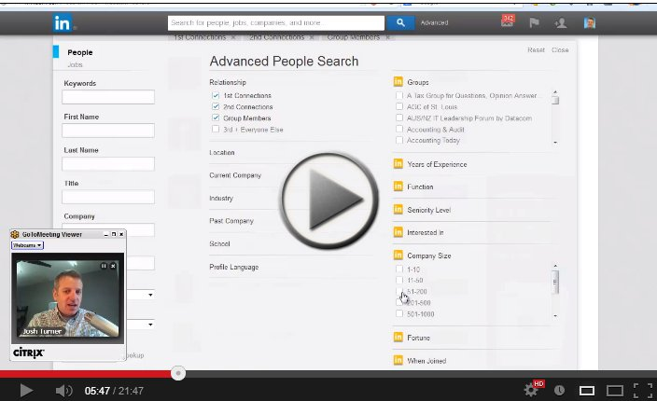
Thank you and I can't wait for the workshop on Thursday!!
Josh
Josh Turner
Founder, LinkedSelling and Linked University

Email 4
Subject: CPA Training re: LinkedIn Lead Gen - Replay is Live (+More)
<< Test First Name >>,
As expected, today's turnout was awesome for "How Accounting Firms Can Generate Consistent Leads with LinkedIn."
It was tough for Ben and I to manage all of the feedback and questions that came in on the chat!
What you care about:
1. The replay is now live here:
http://linkedselling.com/cpa-webinar-replay/
I'm going to leave it up until next Wednesday 8/21.
2. We have some spots available for the fully outsourced lead gen service (5 leads per month) that I outlined. But they won't last long. On that same link, you'll see the zip codes that are already spoken for. If you're within proximity to any of those cities, we probably can't work together due to the area exclusivity we offer clients.
3. The bonus I offered at the end ($224 value) is still good, but I'm going to take that down Wednesday as well.
4. The special discount for participants today ($1,000 off); I'll leave that open for a while longer as well. A lot of people were asking if there was a deadline on that. I've thought about it more, and we can hold that discount for you until next Friday 8/23.
Once again, here's the link:
Click here for replay and other info.
Most importantly, thank you for being a part of today's event!
Thanks,
Josh
Josh Turner
Founder, LinkedSelling and Linked University
We help our clients generate broad market awareness AND consistent lead volume.
Hit reply and let me know if you'd like to talk.
Connect with me: linkedin.com/in/joshbturner

Email 5
Subject: (Last Call) CPA Training re: LinkedIn Lead Gen - Replay is Live (+More)

<< Test First Name >>,
Last reminder about the workshop replay and the offer.
I've had some people request a couple more days to watch the replay, so we're going to leave it up until the end of the work day Friday.
All the info is below, from the email I sent you last week.
Josh
-----------------------------------------------------------------------------------------------------------
<< Test First Name >>,
As expected, today's turnout was awesome for "How Accounting Firms Can Generate Consistent Leads with LinkedIn."
It was tough for Ben and I to manage all of the feedback and questions that came in on the chat!
What you care about:
1. The replay is now live here:
http://linkedselling.com/cpa-webinar-replay/
I'm going to leave it up until next Wednesday 8/21.
2. We have some spots available for the fully outsourced lead gen service (5 leads per month) that I outlined. But they won't last long. On that same link, you'll see the zip codes that are already spoken for. If you're within proximity to any of those cities, we probably can't work together due to the area exclusivity we offer clients.
3. The bonus I offered at the end ($224 value) is still good, but I'm going to take that down Wednesday as well.
4. The special discount for participants today ($1,000 off); I'll leave that open for a while longer as well. A lot of people were asking if there was a deadline on that. I've thought about it more, and we can hold that discount for you until next Friday 8/23.
Once again, here's the link:
Click here for replay and other info.
Most importantly, thank you for being a part of today's event!
Thanks,
Josh

