A New Approach to Lead Generation* for Forward Thinking Financial Advisors
*These strategies consistently generate a 29% favorable response rate.

Confidential: The systems and processes discussed within are proprietary and confidential in nature. Do not distribute or share this document without prior consent. All rights reserved, © LinkedSelling

Executive Summary
Without new leads, clients and profitable growth, the long term viability of your business has to be questioned. Yet it has become increasingly difficult to reach new clients with traditional marketing messages.
What everybody talks about these days is “engagement” and “relationships.” Yet, you and I both know that it’s virtually impossible to hang around all day shooting the breeze. Hoping that we’ll make some new friends, and that those friends will someday turn into clients. No thanks.
What busy financial advisors like your need is a SYSTEMATIC approach to convert cold prospects into warm leads.
A system for consistently adding new prospects to the top of the funnel, AND converting a high percentage into leads, phone calls and face-to-face meetings.
My company has developed such a system, and has been perfecting it since 2011.
That’s what this report is about.
I’m going to share the 4 key components of this system with you, and I’m going to keep it succinct because I know you’re busy.
Here’s what you can expect on the coming pages:
- What Doesn’t Work, or how to design a system that fails.
- What DOES Work (The Guts of Our System)
- How to Do It (The process for generating a flood of new leads)
- Options for Outsourcing The Entire System

What Doesn’t Work
How to Design a System That Fails

I recently spoke with a marketing firm that helps their clients generate new business. Their primary focus is telemarketing (cold calling) and direct mail.
You probably will not be surprised to hear that they rely on reaching an extremely large number of prospects, because they get such a low % response rate.
The associate I spoke with stated, “We aim to generate 1 new lead a month for our clients. Sometimes we go months without generating anything.”
(On a personal note, I was really floored by this. My company generates between 5-30 leads on a monthly basis for our clients, depending on the engagement. And this other marketing company charges a LOT more than mine.)
Here’s what it comes down to. Cold calling and cold mailing don’t really work. Sure, they can generate something every once in a while. But they sure as hell don’t come close to a system that consistently generates leads.
Here’s another problem with the old approach. You alienate a LARGE portion of your market who is turned off by these old school marketing tactics.
When that happens, there’s a real opportunity cost that in some cases outweighs the short term benefits of the few results that these efforts can bring.
So what do you do?
We call it “systematically building relationships to turn cold prospects into warm leads” and it generates a 29% response rate.

Footnote: Another thing that does not work? Not having something valuable to say. Luckily, our system solves that problem too.

What Does Work
The Guts of Our System

People do business with people that they KNOW, LIKE and TRUST.
That’s nothing new, you’ve heard it plenty of times before. Yet it remains very true.
Building relationships with new prospects is the very best way to turn them into new clients. Think about some of the new business and clients you’ve recently picked up.
Surely a lot of it has come from referrals. And some of it has probably come from prospects that you’ve been in contact with for a number of months, or even years.
Your relationships and contacts are at work for you every day, slowly moving people deeper into your funnel.
Now, what if you could accelerate this process with thousands of new prospects?
My company has developed a methodology for achieving just that.
You see, most people are wasting time with their online marketing efforts.
Social media? Please.
Instead of getting caught up in the time drain of facebook and all the other latest fancy gadgets that everybody claims you “must be a part of,” my company has focused instead on building a system based on generating leads. We leverage the latest online platforms to actually create measurable business opportunities.
We’re able to identify new prospects every month, and work them through a process that breaks down barriers, smashes through gatekeepers, and gets you on the phone with 29% of targeted prospects. Affluent types like business owners, CEO’s, Presidents, CFO’s…really, whoever your ideal prospect is.
Now let’s talk about HOW to do it.

How to Do It
The Process for Generating a Flood of New Leads

It all starts with the top of the funnel. Utilizing LinkedIn, you can quickly identify thousands of prospects that fit your prospect profile.
These are highly targeted prospects. And, because they’re on LinkedIn…you know they’re there to talk business. But that’s where most people struggle with HOW to actually make that happen.
The key is to systematically reach out to these prospects in a non-salesy manner. When you reach out to prospects and leverage common contacts, many of these affluent, high level people will be open to connecting with you. (Yes, there is an art & science to doing this the right way.)
“The best sales people are engaging customers even before the purchase journey starts. The place they’re increasingly going to do this are social networks. They’re positioning themselves as trusted advisors by helping people in the learning phase of the purchase journey, to learn about new opportunities and think through ideas.

They are disseminating as much information that is “other people’s stuff” as they do stuff that is about their business. By occasionally sprinkling in an insight that teaches a customer into their sales funnel, they earn the image of trusted advisor.

It’s a totally new way of engaging with customers, and social media has made it possible. We find that the best salespeople are taking advantage of this in unique and powerful ways.

- Matthew Dixon, Corporate Executive Board's Sales Executive Council, March 2013

Now, this is really important. Once connected to a prospect, DO NOT start pitching. That’s the best way to spoil the relationship.
Instead, you want to design and execute a campaign to stay in front of them on a regular basis. To position yourself as a trusted advisor.

This campaign should include 3 primary components:
- Top of Mind Campaign via Status Updates
- Personal Messaging Campaign (Position Yourself as a Trusted Resource)
- Zero Moment of Truth (Strategy for Going for the Phone Call)
Let’s talk about each of these more specifically.
Top of Mind Campaign via Status Updates
Drip marketing requires executing on a set of activities over an extended period of time. By keeping your name and message in front of prospects, you’ll be the one they think of when they are in the market for your services.
With the decline of traditional interruption marketing tactics, LinkedIn status updates have become one of the most powerful mechanisms for achieving a top of mind drip campaign. But why is that?
Here are some facts released in a recent survey (by Ipsos, a global market research company) of global business elite:
- LinkedIn reaches more business elite and c-suite monthly than any other international news and business website measured.
- LinkedIn attracts the highest number of business elite purchase decision makers with high net worth and big purchasing budgets.
- LinkedIn is seen as an important business destination for senior executives globally as visitors most often come from strategic planning, management, finance and marketing functions.

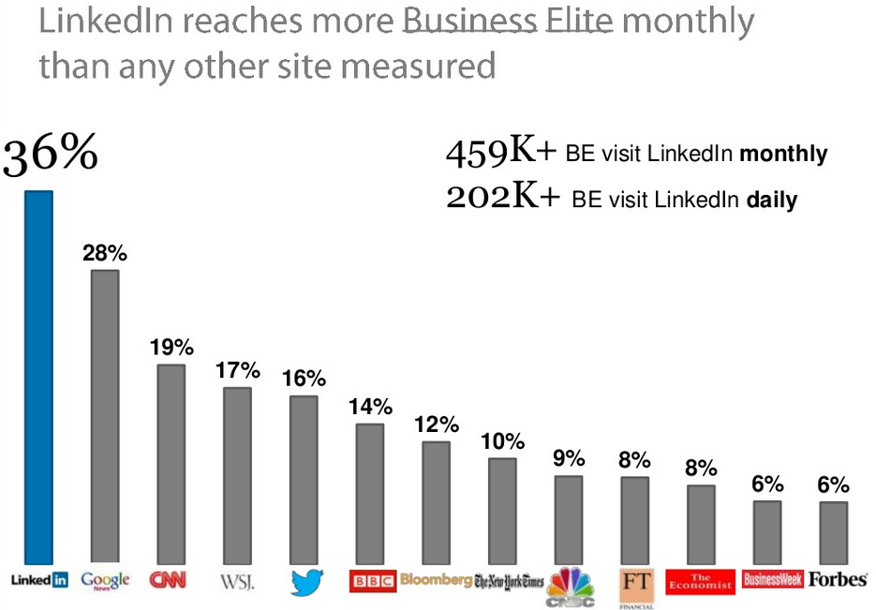
Source: IPSOS Business Elite Global 2012

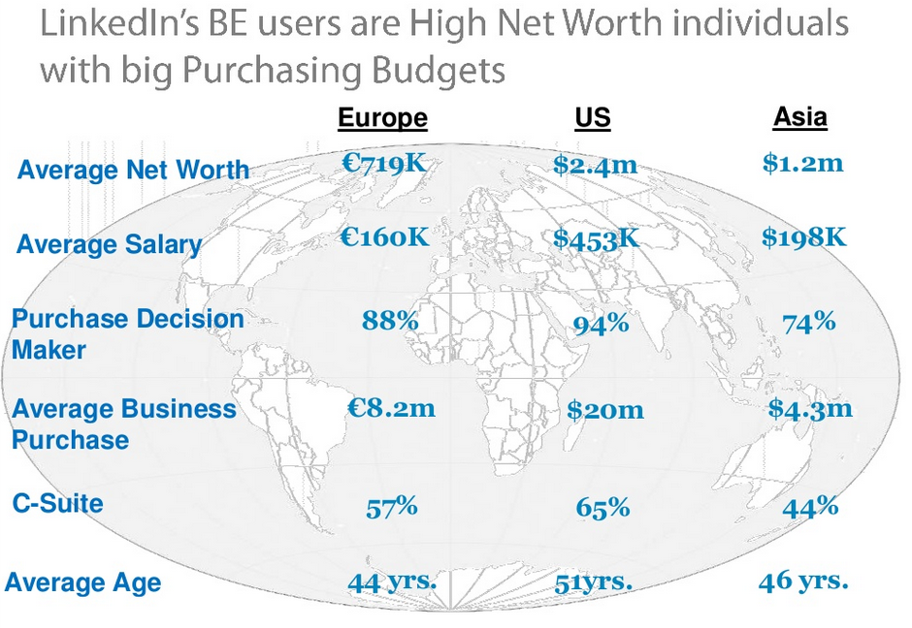
Source: IPSOS Business Elite Global 2012

Further, LinkedIn has become a POWERHOUSE for financial advisors.

You don’t need to look much further than this study to find out why:

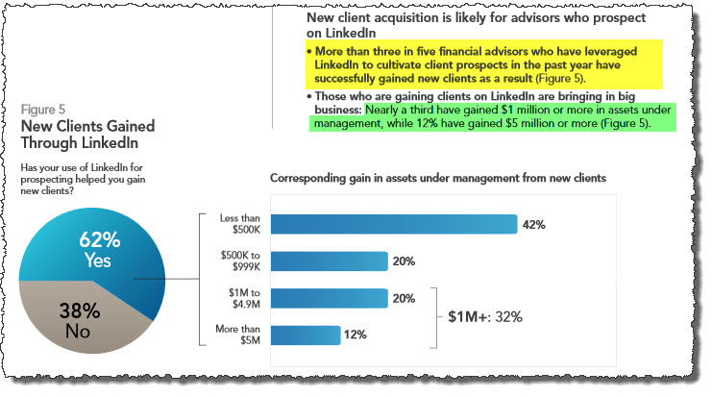

Personal Messaging Campaign (Position Yourself as a Trusted Resource)

Where the action really happens is behind the scenes. This is why your competitors literally have no clue that these strategies even exist.
By working our finely tuned processes, we’ll connect you with thousands of new prospects over time. And we’ll keep you top of mind.
But the consistent lead generation happens behind the scenes, with a systematic messaging campaign. The purpose of this campaign is to position you and your firm as a trusted resource.
Over a short time frame, we’ll send a number of personal one-on-one messages to your most important prospects.
For a while, these messages will contain nothing but valuable content. Case studies, articles, conversation. Your prospects will appreciate it, and love the content.

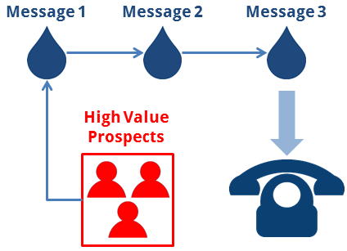

Zero Moment of Truth (Strategy for Going for the Phone Call)
Once we get them to this point, when they “know, like and trust” you, that’s when we go for the phone call. And at that point, they can hardly say no.
Using our proprietary scripting, modified to meet your goals, you will see 30% of prospects targeted agree to a phone call with you.
At this stage, some of these prospects may be in the market for your services today. Those are certainly ideal situations.
Others might not be ready right away, but now you’ve got them. Now you’ve built rapport. You’re in.
For one, now you can work them through your typical funnel with email follow-ups, invitations to grab a coffee or a round of golf, whatever your typical marketing consists of. And on top of that, we’ll continue running our top of mind campaign.
What it boils down to is this. Some will become clients quickly. Others will require more time. Either way, both scenarios are covered.

Options for Outsourcing
The Entire System

Does this sound like you?
- You understand that old school marketing tactics just don’t work that well anymore.
- You know that there is a virtually limitless pool of prospects on LinkedIn.
- You want to grow your business and need more leads, but you want to invest in marketing that generates clear ROI.
- You value a system that not only generates leads, but also positions you as a thought leader and maintains top of mind positioning for your brand in the minds of thousands of prospects.
If that’s you, then our managed lead generation services might be a fit.
Our services include a fully done-for-you package to continually build your database of prospects within LinkedIn, stay top of mind with targeted business owners and your local community, and to work the most important prospects through a drip marketing campaign that will consistently generate a predictable volume of leads.
The number of leads generated is only dependent on your budget.
What does this service include?
It starts with the planning and setup phase.
During this phase, we perform the following on your behalf:
- Development of campaign plan.
- Creation of prospect profile.
- Development of content plan.
- Review of existing LinkedIn presence and profile.
- Optimization of LinkedIn profile.
- Create scripts for messaging.
- Proprietary campaign tracking database.
- Identify & join relevant groups.
- Initital prospect database build (Connection Requests Sent to Targeted Prospects).
- Company page setup.
Once the initial planning and setup phase is complete…
…We move into the monthly management phase.
This includes the following:
Top-of-Mind Campaign
The top of mind campaign includes daily status updates that are distributed to the home page of all prospects in the funnel. Our team develops all of this content for you, and submits for your approval prior to posting. (Yes, you can also repurpose this content on facebook and twitter.)
By doing this, you stay top of mind with every prospect you're connected to and solidify your position as a trusted advisor.
Result: You'll be the one they think of when they're ready to engage.
LinkedIn Group Management
We will distribute the best content we develop, into all LinkedIn groups you are a member of. (In the setup phase, we’ll make sure you are in the correct groups to maximize your exposure to targeted prospects.)
This exposes your business to thousands of additional prospects every single month.
Result: Attract new prospects into your funnel and position your brand as a leader in your market.
Prospect & Develop New Connections
Working on your behalf, we find and target new prospects each month, to solicit new 1st degree connections (and leads). This consistently builds your database of targeted prospects.
Result: Constantly have new prospects that we're adding to your sales funnel.
Manage Proprietary Tracking Tool
Our services include the management of a tracking tool that shows every prospect's place in the campaign. With thousands of prospects in the campaign, this keeps everything well organized.
Result: When on the phone with new prospects, you’ll know exactly what content they’ve seen. Not to mention, having a comprehensive database to track all of your prospects.

Lead Generation Drip Marketing Campaign
Utilizing our proprietary methodologies, we will work prospects through a systematic drip marketing messaging campaign. These prospects will be identified as targeted, relevant prospects who you want to do business with.
This quickly builds a personal relationship with prospects, opening the door to business conversations.
Result: Generate new leads with new prospects every month.
Next Steps

If you need more targeted leads, we’d love to talk with you to see if our services are a fit.
For a complimentary consultation and information about our LinkedIn lead generation program, please contact me at:

Josh Turner
Founder, LinkedSelling
JoshTurner@LinkedSelling.com
O: 314-499-8892

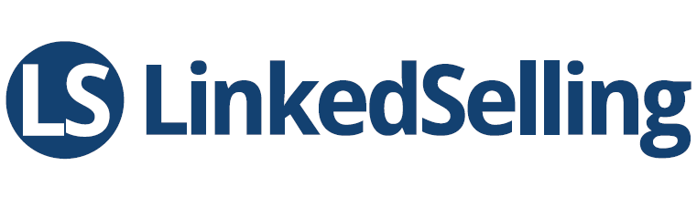

“One man has had a laser focus on LinkedIn for the past few years; he created a whole business out of it. His name is Josh Turner. He calls himself a "B2B Marketing Expert Specializing In LinkedIn," and as the founder of Linked University, which offers webinars and trainings to get the most out of LinkedIn, and LinkedSelling, which has done work with LinkedIn marketing campaigns since 2010, it's a well-deserved title.
- Huffington Post

