Group Management Workbook

Daily Activity in the Group
- Approve/decline join requests.
- Patrol discussion board.
- Respond to comments where applicable.
- Create post/discussion (1-2 per day).
- Group Announcements (at least once a month).

What to Aim For (review)
- A community of like-minded people sharing, discussing, commenting on topics that interest them.
- The sole focus should not be on your client’s business, product, services, but sharing content/resources that the prospect will care about.
- Position your client as the founder of this community that is different than all the others out there. Not “me, me, me” focused.
- Position your client as an authority leader on the topic of the greatest important to the prospect.

What to Allow on the Discussion Board?
- Is it relevant?
- Is it spammy/overly promotional?
- Is it reputable?
- Is the poster a prospect?
- Is it valuable?

Responding to Group Members Comments
- Does it require a response?
- Is a question over your head?
- How to encourage comments and discussion.

Group Announcements
Group announcements allow a group owner to correspond with all group members by sending a message directly to their email inbox. These can be sent once a week.
Topics to cover:
- Most often we post one group announcement per month for our clients.
- Usually the topic of this message is focused on promoting 2-4 recent discussion posts with a call to “get involved” in the debate to the reader.
- However, if the client has something in particular to promote (i.e. a new ebook, a webinar, a live event or an awesome new promo or release) we can craft a specific message on that item.
Example #1:

Subj: 10 Reasons to Advertise On the Bing Network

Last week Marketing Leaders of Australia reached its 3,000th member. It is truly awesome to see this community continue to grow as we all work together to provide even better resources within the group. Whether you have recently joined or you have been a member for a while now, you’ll want to check out some of the recent discussions that have been in the group.

Below are links to several discussion threads that I think you will enjoy. Don’t hesitate to jump in on the conversation and share your thoughts.
How Tesco, De Beers and others use digital to enhance the in-store experience

Check out this article on how retailers are using technology to improve the in-store shopping experience.

http://lnkd.in/bjy2t5w

10 Reasons to Advertise On the Bing Network

Google is the top dog in this race but here are some reasons to not sleep on Bing.

http://lnkd.in/bihZEEa

7 Tips to Make Your Email Marketing More Mobile-Friendly

Don’t miss out on these great tactics that will help improve your emails.
http://lnkd.in/bzbAf3m

Thanks so much for your continued dedication and support to Marketing Leaders of Australia. I always look forward to hearing from group members if you ever have any questions or comments.
Cheers,

NAME
Founder-Marketing Leaders of Australia

Example #2:


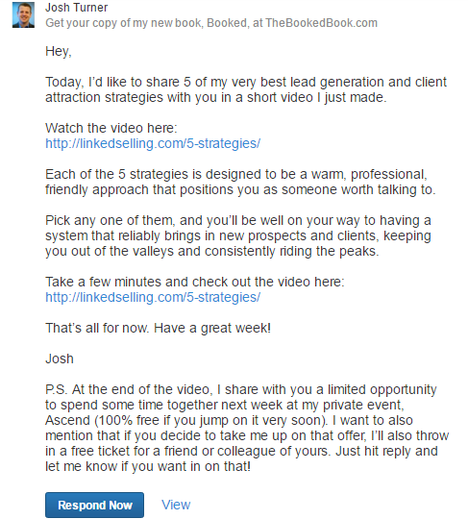

Getting Started
- Write out the weekly schedule of when you’ll manage your group each day (M-F).
___________________________________________________________________________________________________________________________________________________________________________________________________________________________
- How often are you allowed to send a group announcement? And list an example or two of the themes you could follow for one of these announcements.
____________________________________________________________________________________________________________________________________________________________________________________________________________________________________________________________________________________________________

- How many times should you typically post into your group each day?
_________________________________________________________________________

- Write an explanation of the type of content you’ll allow into the group. What themes/topics are allowed to be shared by others?

____ _ _
____ _ _
____ _ _
____ _ _
____ _ _
____ _ _
____ _ _
____ _ _
____ _ _
____ _ _
____ _ _

