Messaging Campaign Workbook

The Playbook

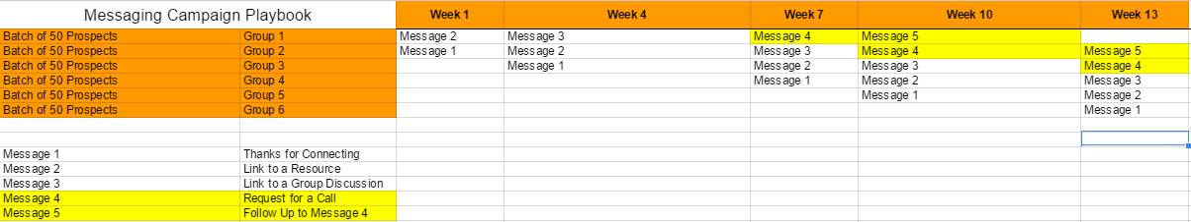

Why Batches of 50?
- It could be batches of 50 or batches of 500 – with 50 prospects at a time and if our campaign is firing on all cylinders we should get around 15 leads from that batch.
- We want to create a consistent flow of leads coming to the client month after month.
- The size of each batch should be chosen with the size of the database in mind.
  - If we ran every new prospect in the database through a campaign at once it becomes:
    - Difficult for the client to handle all these incoming leads.
    - AND we are out of prospects at this point and the campaign has to pause until you reload the prospect pool (there’s a limit to the amount of connection requests we can send out on LinkedIn).

Frequency between Messages
- We often start with sending messages every 3 weeks.
  - This time frame keeps the client in front of the prospect regularly enough without being too pushy.
- Switching to 2 weeks between can definitely still work for a campaign and is an option you can switch to if you need to increase the amount of prospects and leads in a campaign.
- Because the template we begin with has 5 messages doesn’t mean you have to end there.
  - Some clients want more touchpoints.
  - Other clients might only want 4 touchpoints.
  - Remember: the goal with the messaging and playbook is to build the “know, like and trust” factor the prospect has with your client.
    - Don’t go for the sale before the relationship.
    - Don’t go for the hard pitch. Be an anti-spammer.

Getting Started
- Using the template scripts and scriptwriting theory training, write out all the scripts you will start with in your messaging campaign below.
___________________________________________________________________________________________________________________________________________________________________________________________________________________________
___________________________________________________________________________________________________________________________________________________________________________________________________________________________
___________________________________________________________________________________________________________________________________________________________________________________________________________________________
___________________________________________________________________________________________________________________________________________________________________________________________________________________________
___________________________________________________________________________________________________________________________________________________________________________________________________________________________
___________________________________________________________________________________________________________________________________________________________________________________________________________________________
___________________________________________________________________________________________________________________________________________________________________________________________________________________________
___________________________________________________________________________________________________________________________________________________________________________________________________________________________
___________________________________________________________________________________________________________________________________________________________________________________________________________________________
___________________________________________________________________________________________________________________________________________________________________________________________________________________________
___________________________________________________________________________________________________________________________________________________________________________________________________________________________

- Write 2 reasons why it’s in your prospects best interest to get on the phone with you. (could be used in any more “direct” messaging)
____________________________________________________________________________________________________________________________________________________________________________________________________________________________________________________________________________________________________

