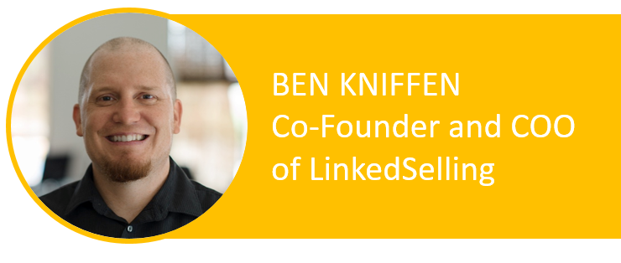
My name is Ben Kniffen, and I want to welcome you to this very special workshop:
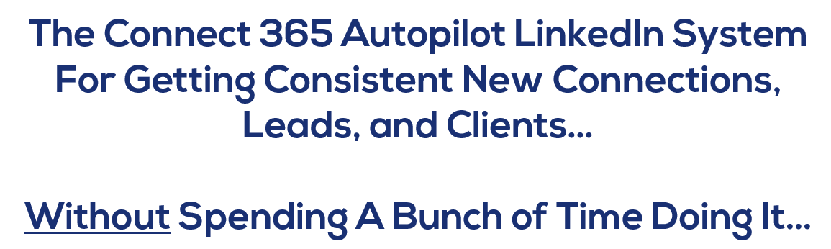
Before we begin, I want to encourage you to be focused during our time together today.
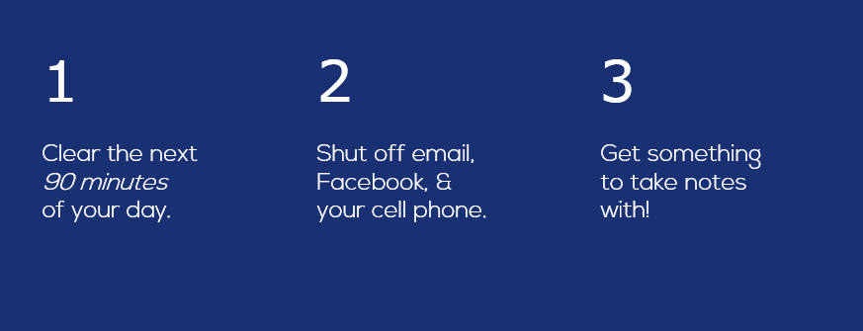
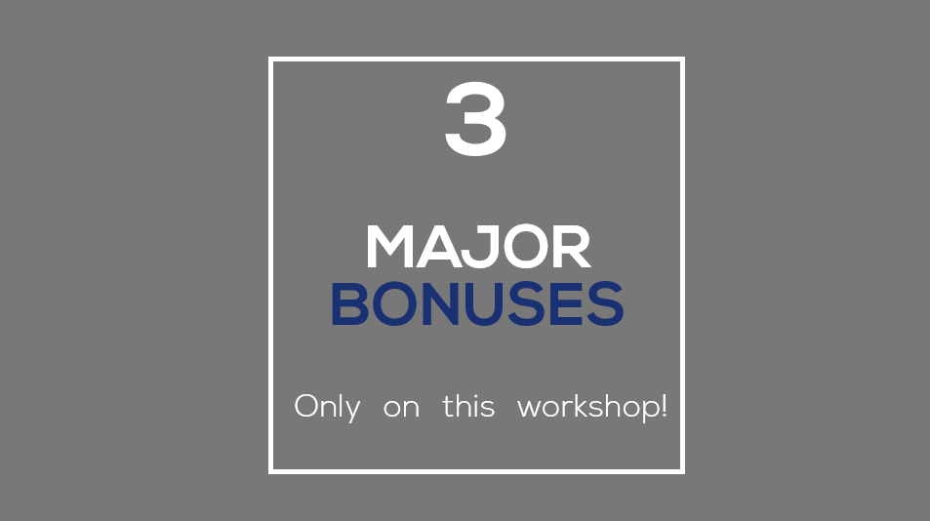

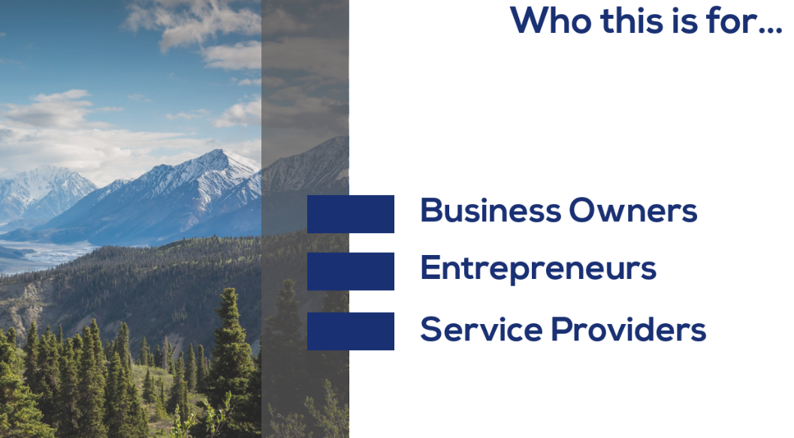
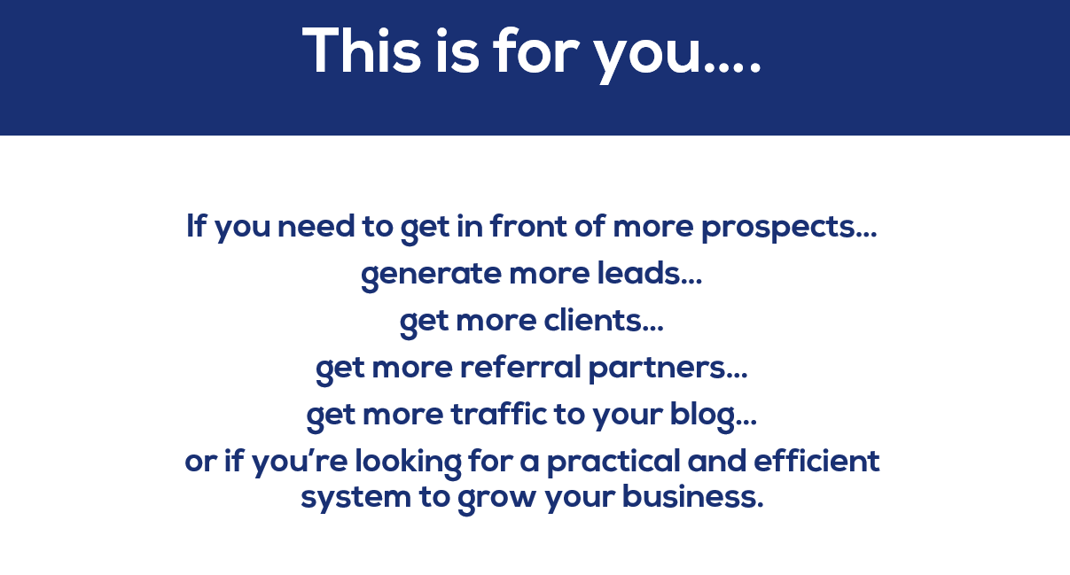
I am going to show you how to create a lead generation system that:
- Leverages your time and energy
- Establishes you as a RESPECTED and SOUGHT AFTER AUTHORITY
- Draws Qualified Prospects right to your Doorstep
- Reveals the BEST method for closing those prospect into high value, repeat customers (ON AUTOPILOT)
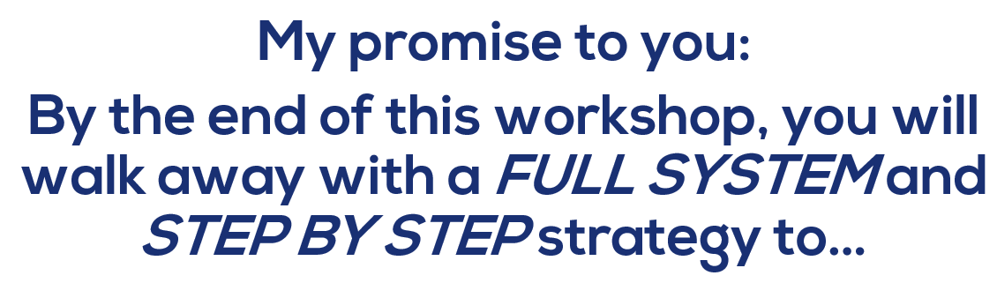

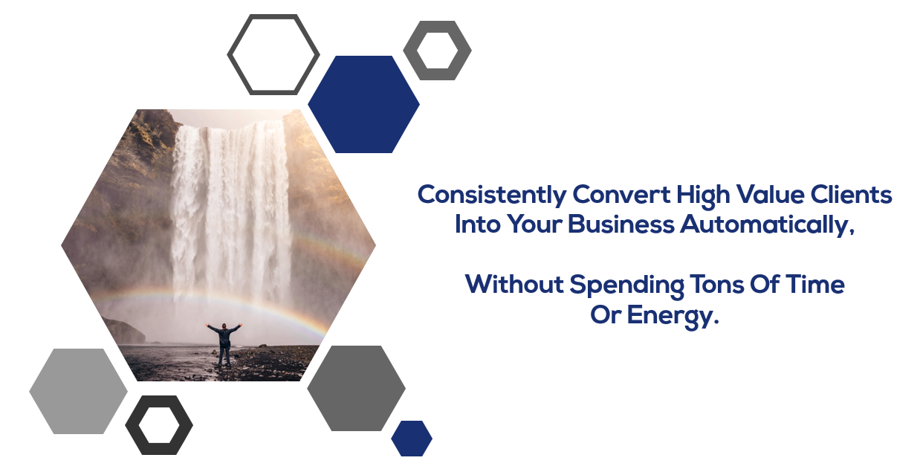

Today, I’m going to be making you an offer to become a charter member of our newest program and automated software, Connect 365.
HOWEVER…
I do NOT want you to invest in it….
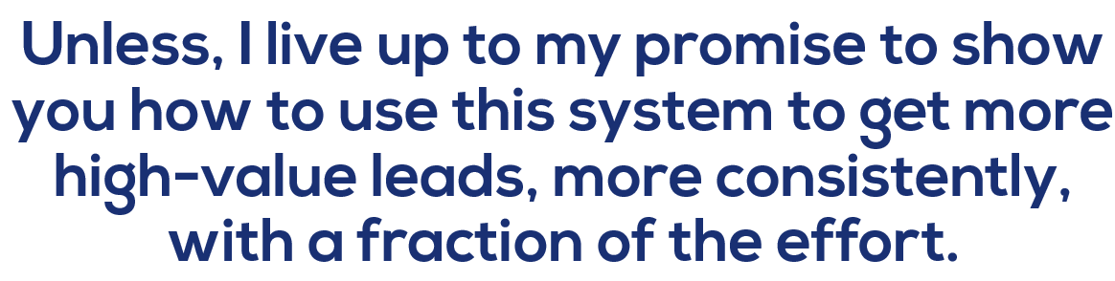
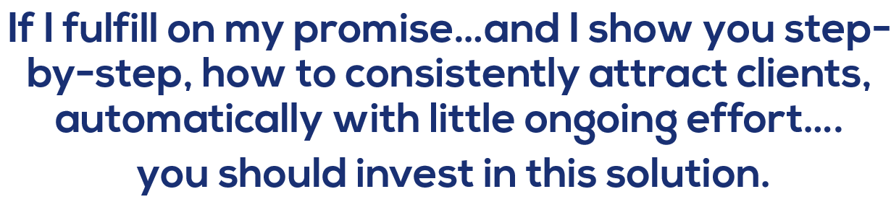

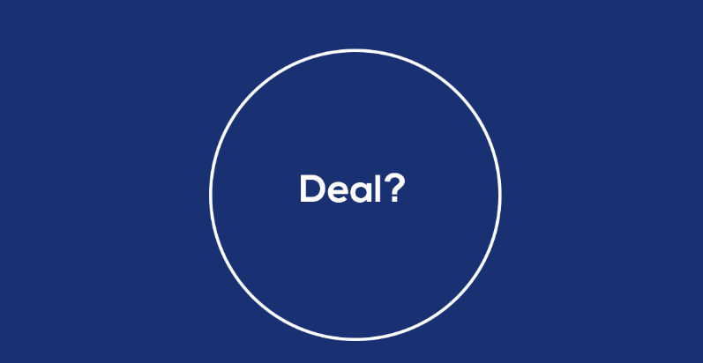


- Do you have some months where you get a ton of cash into your business…but you struggle to maintain it?
- Do you start out each month scared that you won't find any new clients or projects?
- Do you secretly know your work is worth WAY more than you're currently charging?
- Are you constantly looking for new ways to get clients...but things typically don't quite pan out?
- Are you constantly working your butt off, but you barely make enough to scrape by each month?
- Are you taking on projects that don’t excite you, with clients you don’t like…just to pay the bills and keep the lights on?
- Are you having trouble standing out in your industry and getting swallowed by all the noise?
- Are you talking with unqualified prospects who waste your time but could never afford your service?
- Are you dealing with too many people who say “I’ll think about it” and then disappear, never to be heard from ever again?
- And lastly, do any of you feel like you just don’t have the TIME to implement the systems you KNOW you need?

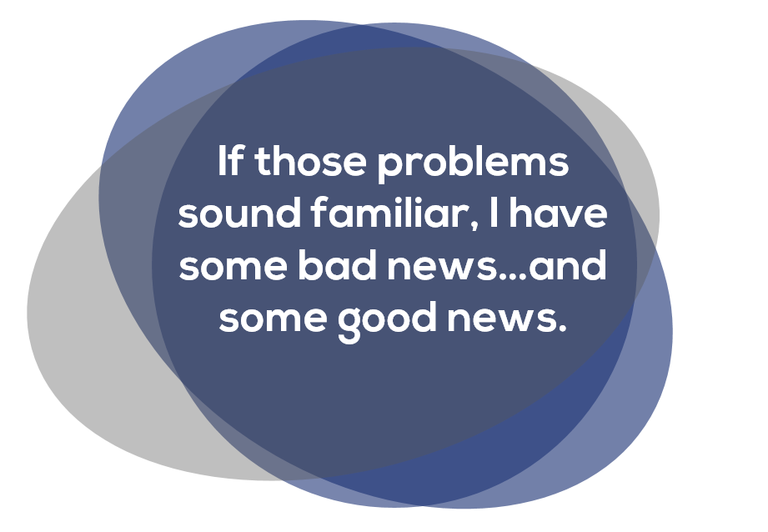



YOU ARE NOT ALONE
After surveying over 2000 business owners in all sorts of industries, we found that 88% of them, unfortunately, struggled with those same exact problems.
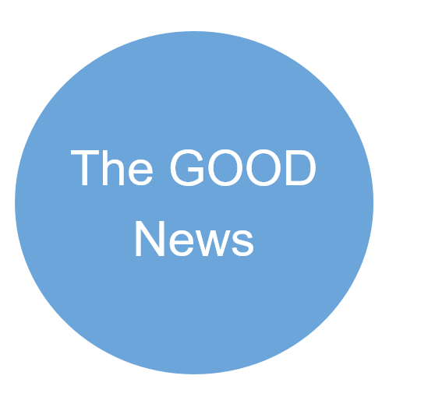

ALL OF THOSE PROBLEMS
They are just symptoms of a much larger, much more insidious…but also, much more SOLVABLE problem…
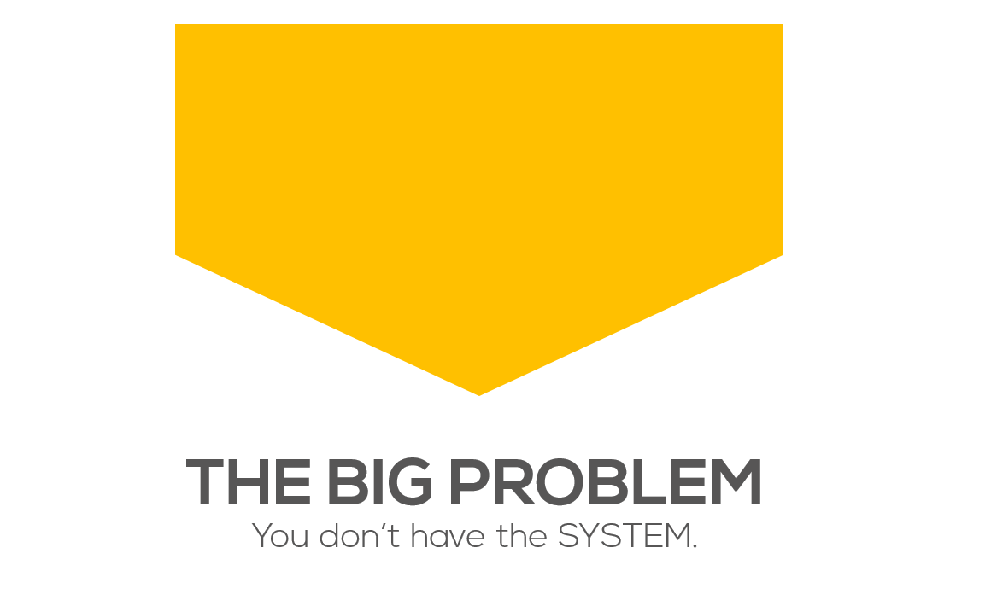
Once you have the right SYSTEM in place…
- You’ll start to easily convert prospects into high value clients
- And attract the best client’s right into your business without the need to chase them down
- You’ll be respected and admired as one of the top authorities in your industry
- And your presence will chase away problem clients and low-ballers who’ll never bother you again.
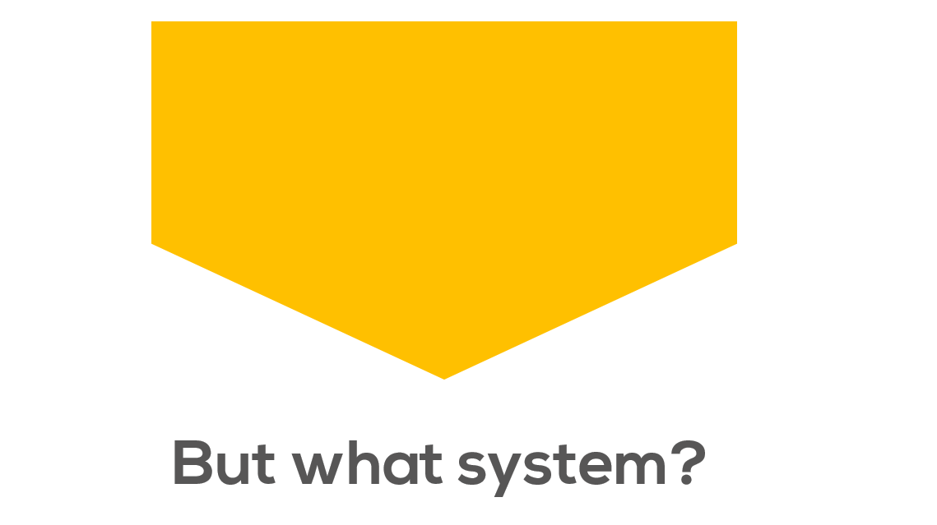
How do you figure out what is the RIGHT system that you can really count on and rely on?
We wanted to answer that question, and we really wanted to uncover…
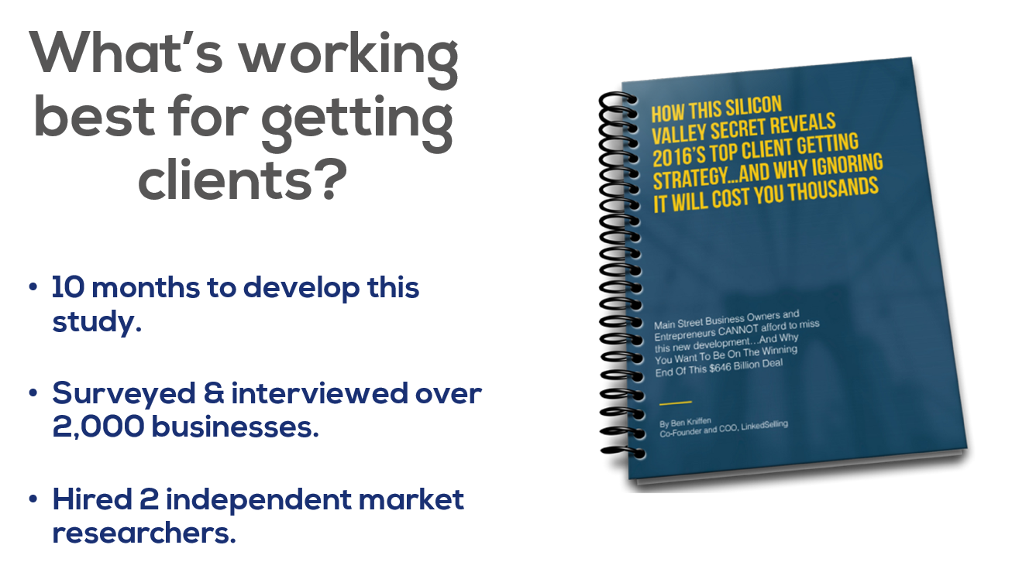
And let me tell you. We found some really startling and surprising information.
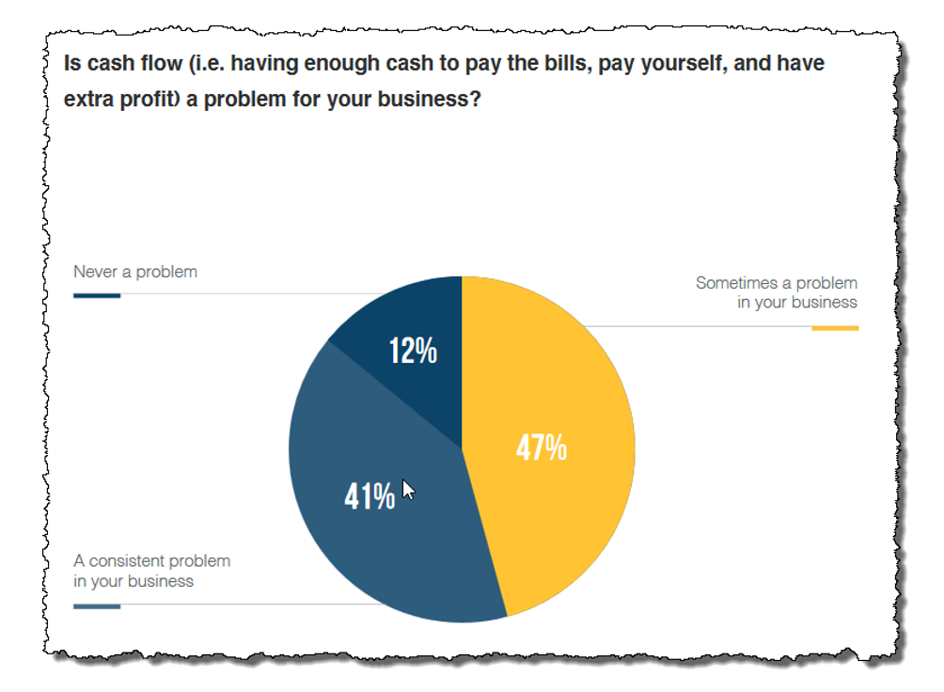
For one, we found that 88% of businesses struggle with cash flow. Only 12% of businesses reported that they consistently maintain positive cash flow.
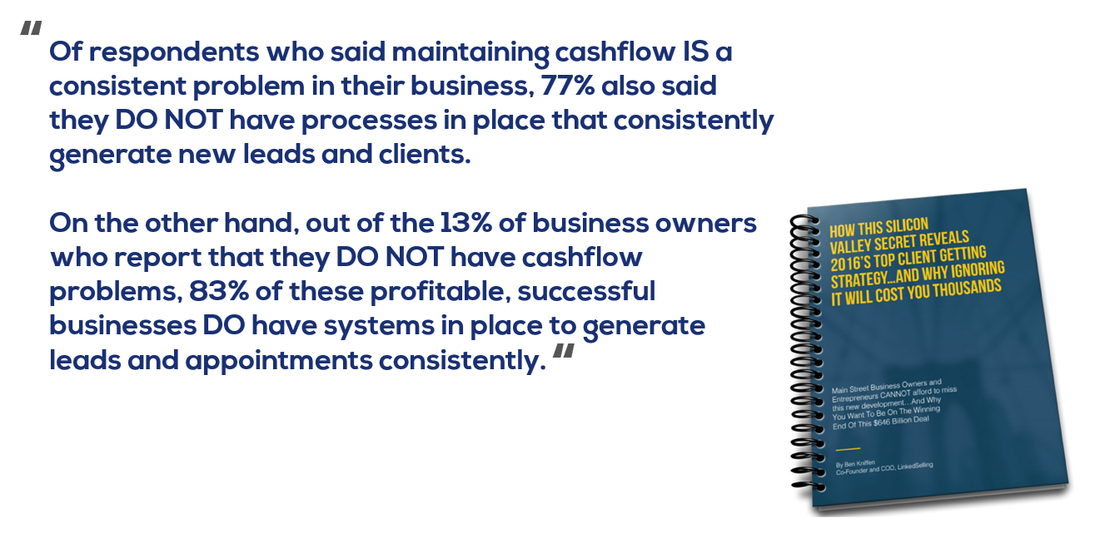
If you want to get off the cash flow rollercoaster, you need marketing SYSTEMS to bring in new leads and clients.
But just knowing that isn’t enough. We wanted to dig deeper, and figure out…
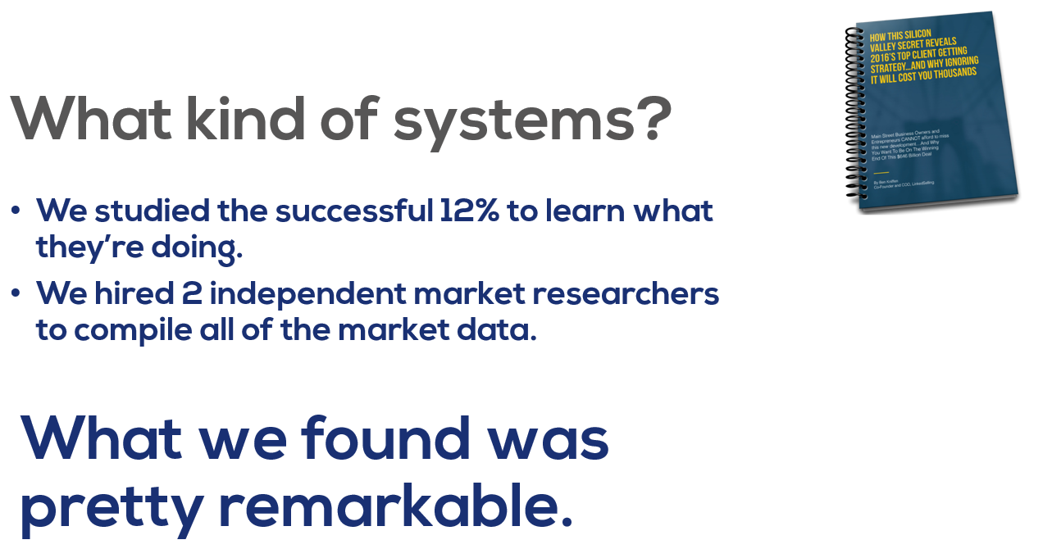
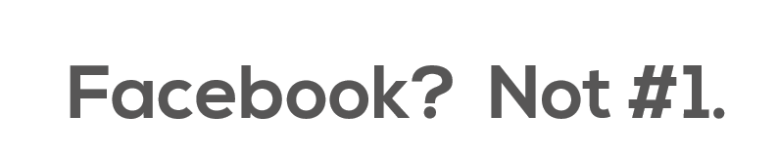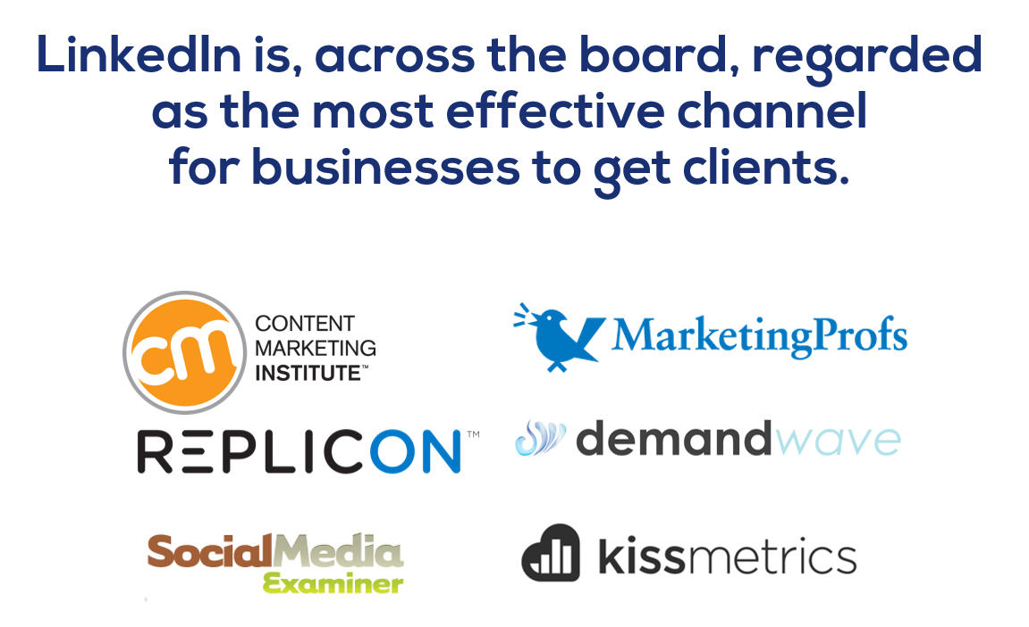
Content Marketing Institute and MarketingProfs, found that…
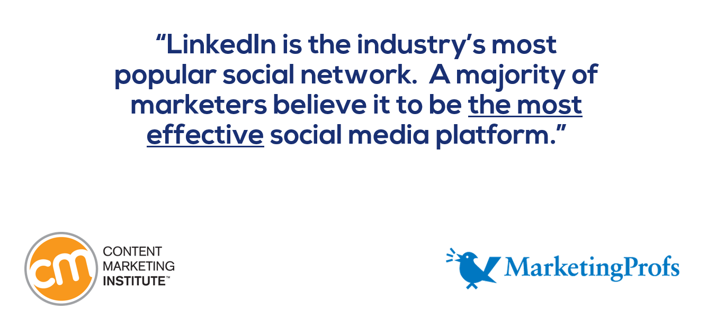
A study from analytics firm Kissmetrics discovered that…
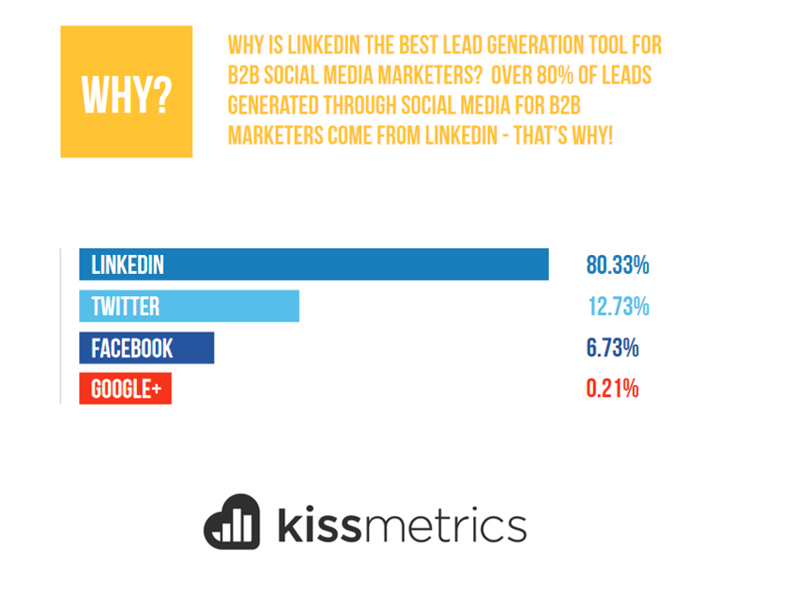
And a recent study by DemandWave also found…
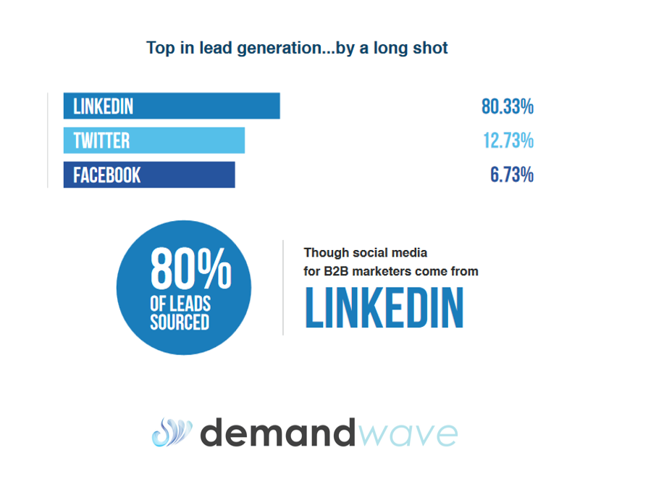
Replicon found LinkedIn messages to generate…
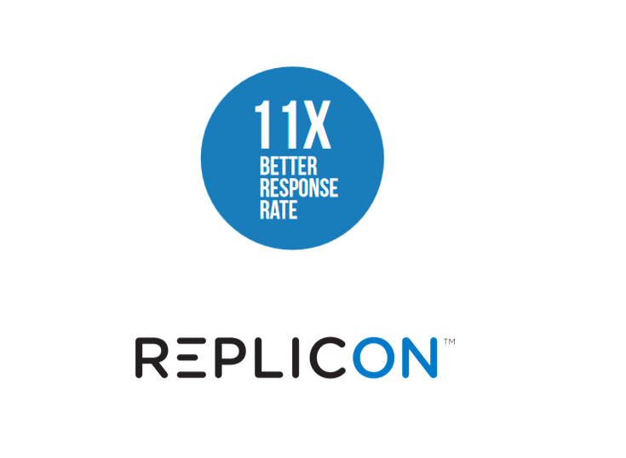
…compared with other methods.
Social Media Examiner discovered…
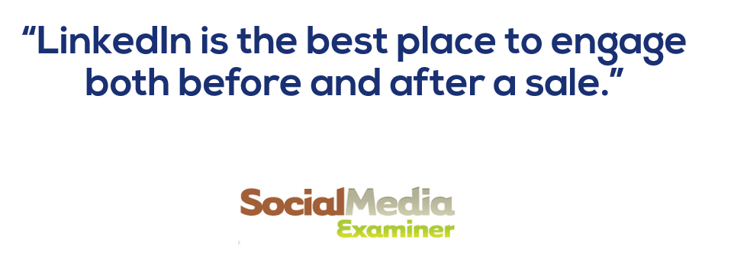
Along the same lines, a study but Regalix found that…
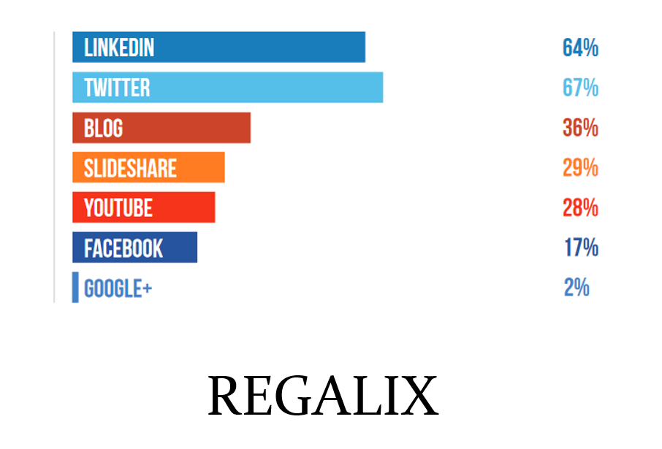
LinkedIn is right at the top of the list when it comes to channels found to be most effective for customer engagement both before and after sales.
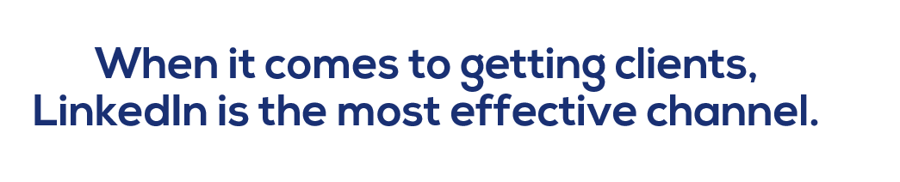
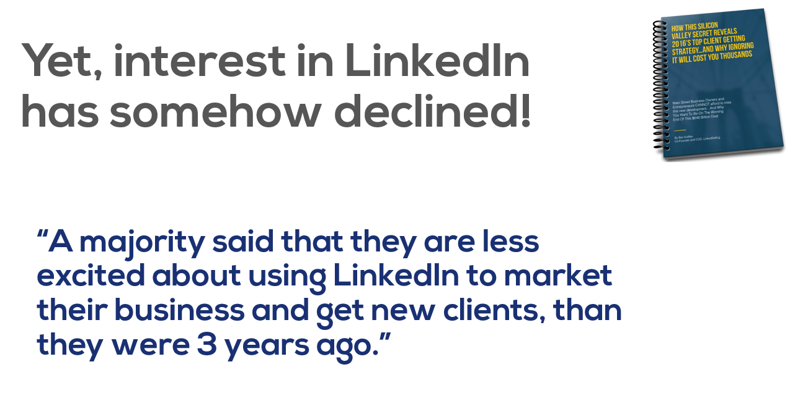
If LinkedIn is the most effective channel for getting new business online, why have so many turned to new, shiny objects?
The answer lies in a phenomena called the Gartner Hype Cycle.
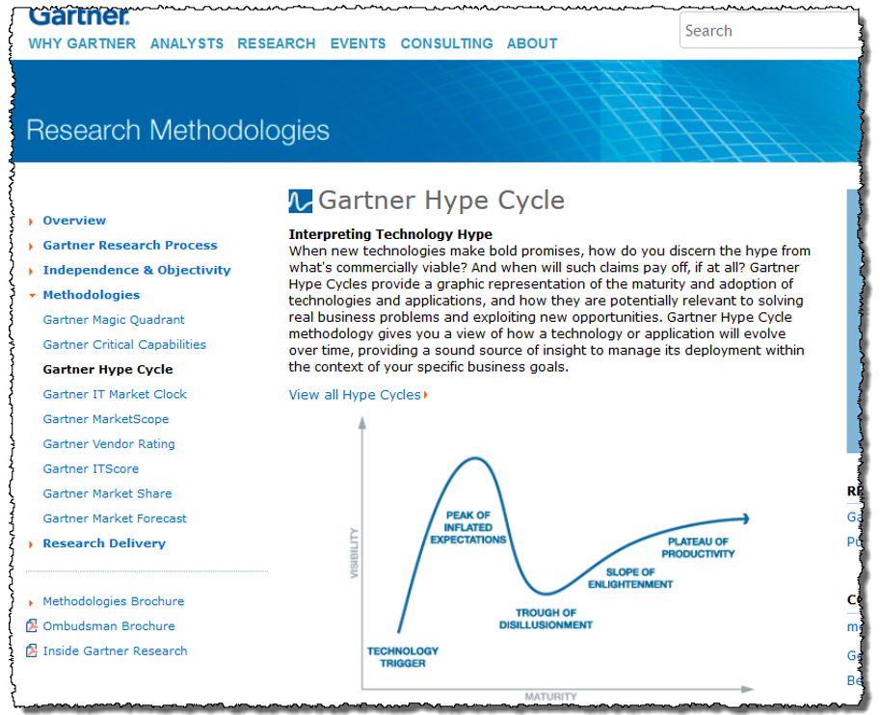
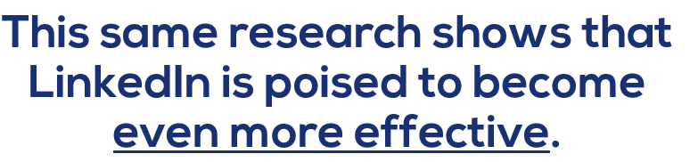
The Gartner Hype Cycle, is a concept for emerging technologies which predicts they’ll go through five stages:
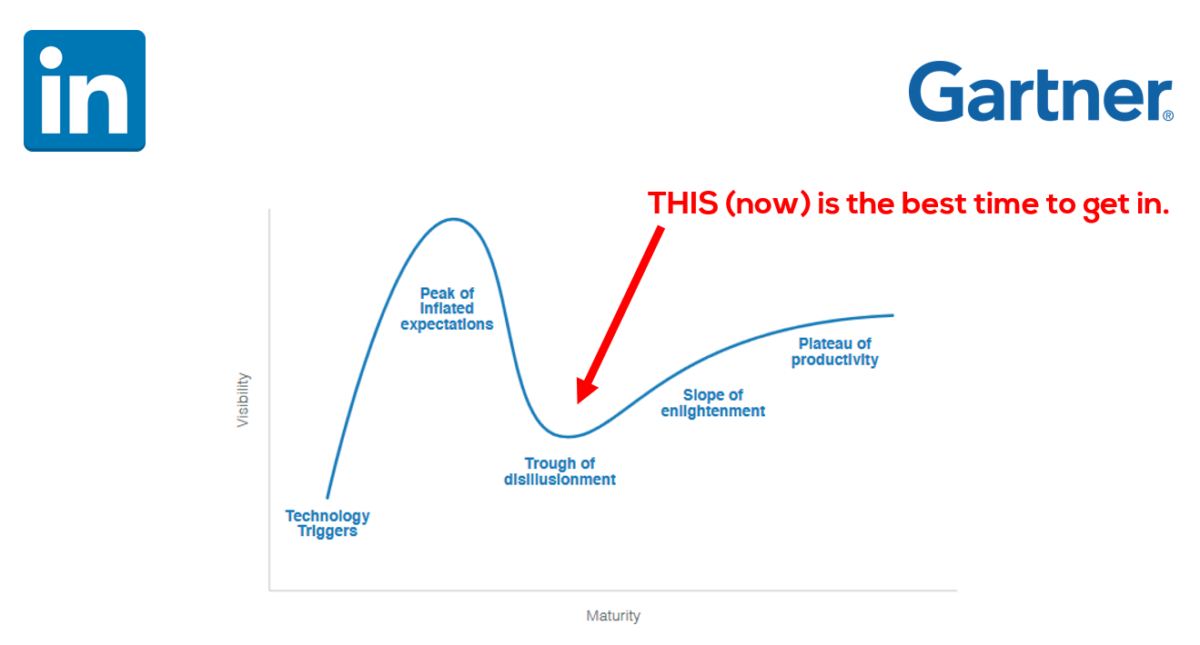 Just like most other technologies that go through this cycle, the LinkedIn buzz has died down a bit. And a lot of business owners have moved on to the next shiny thing.
But, many have NOT moved on.
And what the Gartner Curve has proven time and time again, is at these points of over correction that this is REALLY the best time to get in.
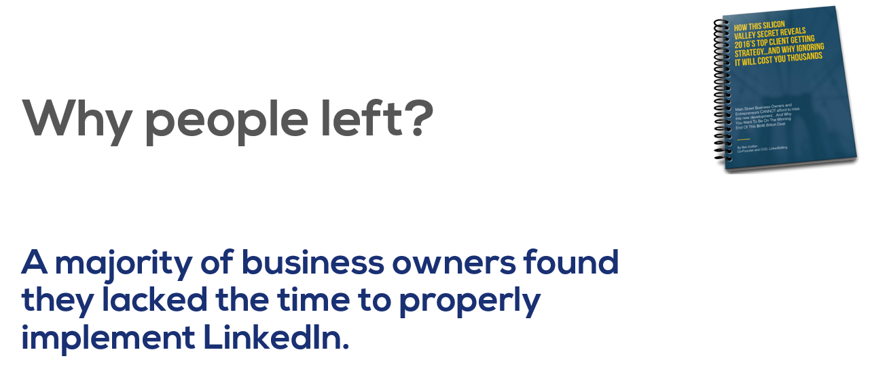
Now, we saw this is a big problem.
And so over the last year, we’ve been developing and perfecting a solution that minimizes most of this time-intensive work.
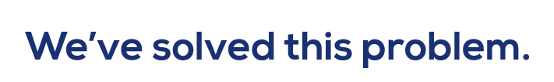
The data clearly shows that many business owners are indeed generating consistent results from LinkedIn.
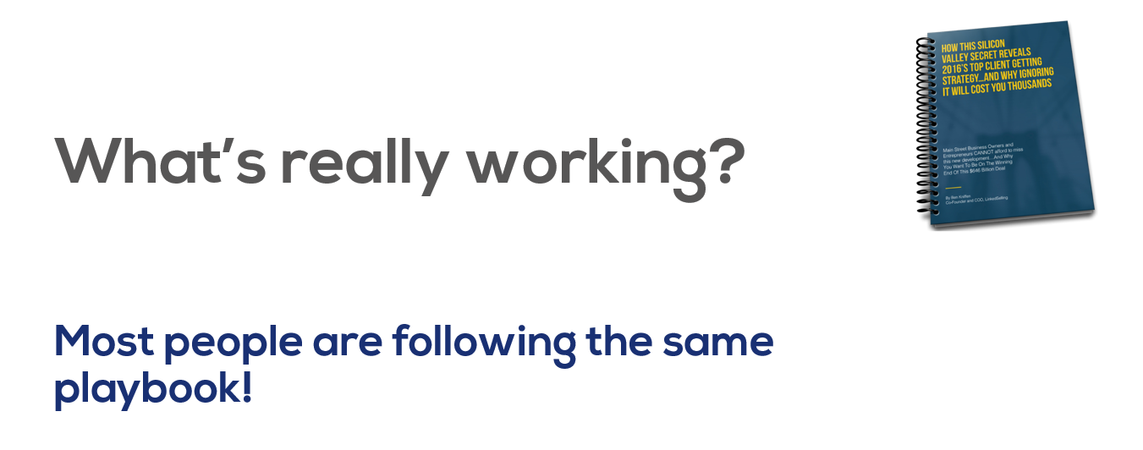
In the 5 years that we have been managing LinkedIn marketing campaigns for clients across the globe, we’ve found a few core practices generate the vast majority of results.
The 5, 6 and multi-7 figure deals that our clients have generated have all come from a 5 step system (the 5 Pillars), and it’s what we NOW call the Connect 365 SYSTEM.
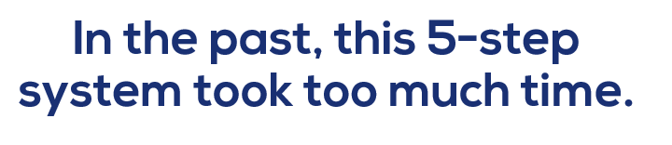
Now it doesn’t have to.
This new technology has completely changed the game.
Let’s talk about the 5 Pillars.

But first I want to introduce myself….


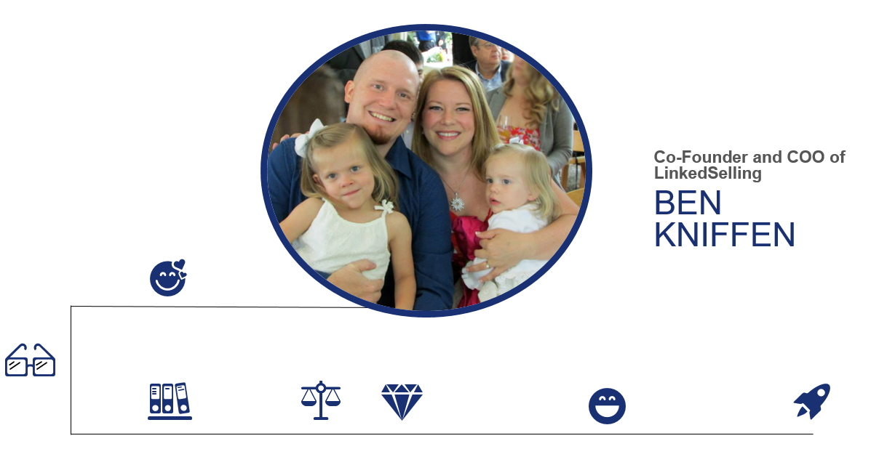
When I started my family, with my wife Erin and our two daughters, I was determined from the start to create an amazing quality of life for them.
But for some reason, my path wasn’t easy.
Tried several times…only to keep failing.
That all changed in 2011, when I finally discovered the process that I’m going to tell you about today.
Recently, we were recognized as #252 on the Inc. 500/5000 list of the fastest private growing companies in the U.S
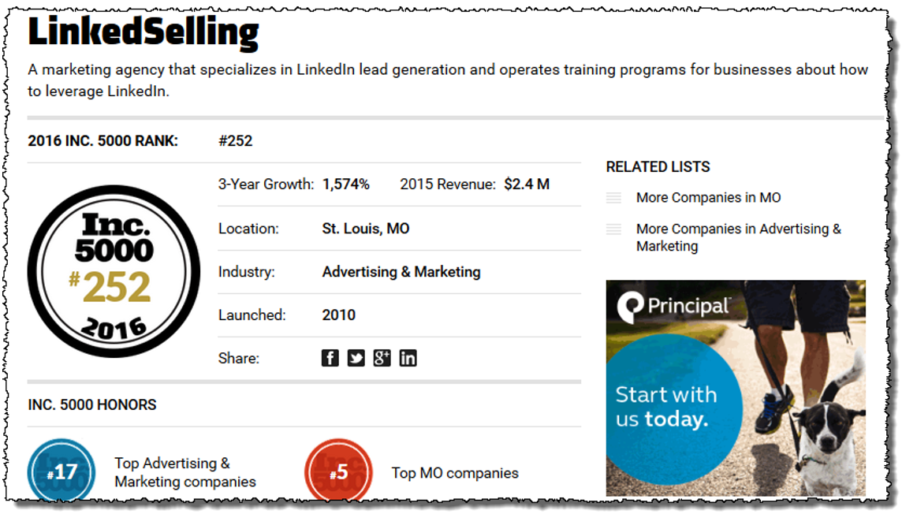
We’ve worked for big name companies and clients.
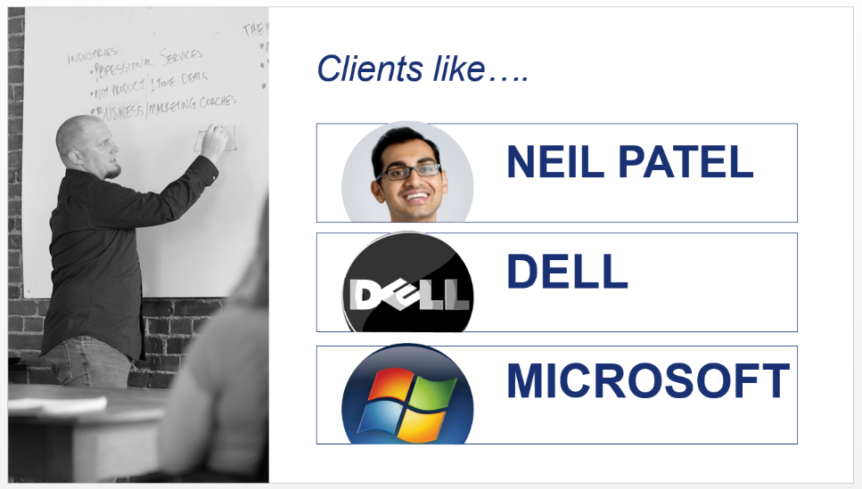
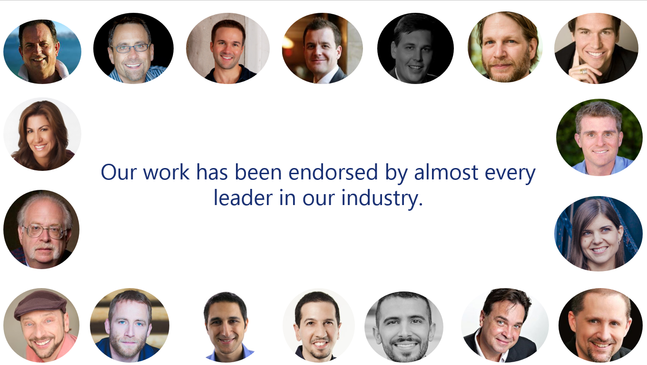
And we’ve been featured in all sorts of amazing publications.
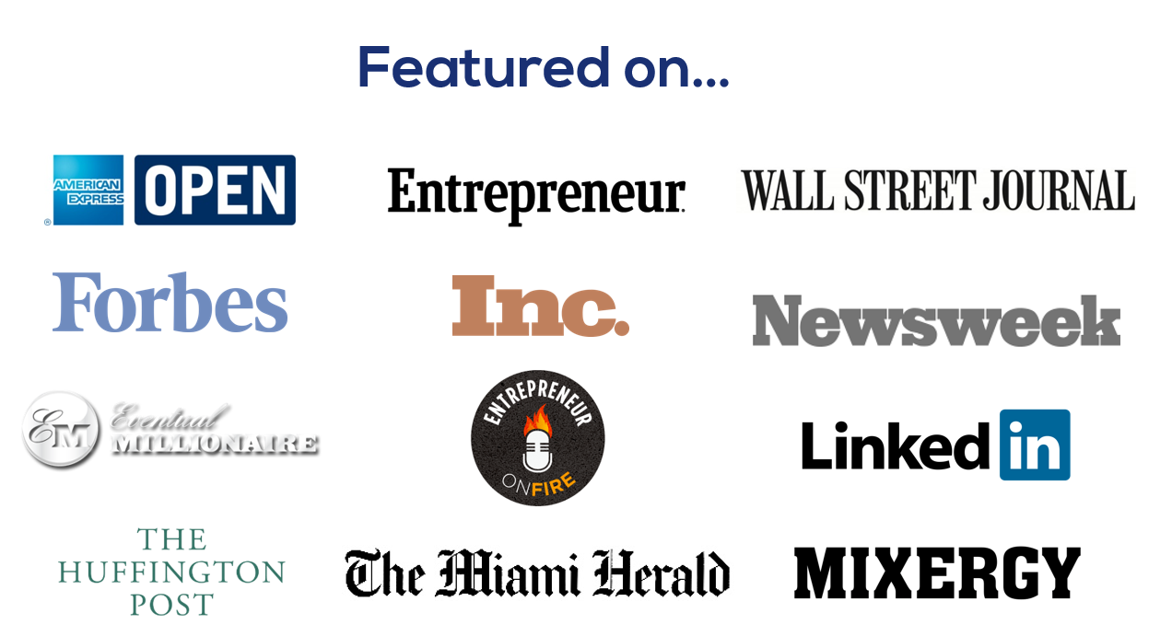
I don’t have those cash flow problems any more. And I’m very proud of being able to provide for my family.
My life is much different now than it was 5 years ago…
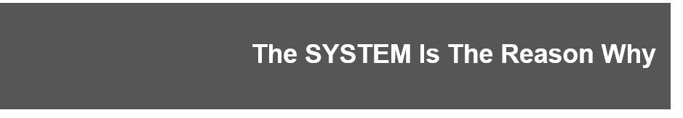
Let’s dive right in to The 5 Pillars…
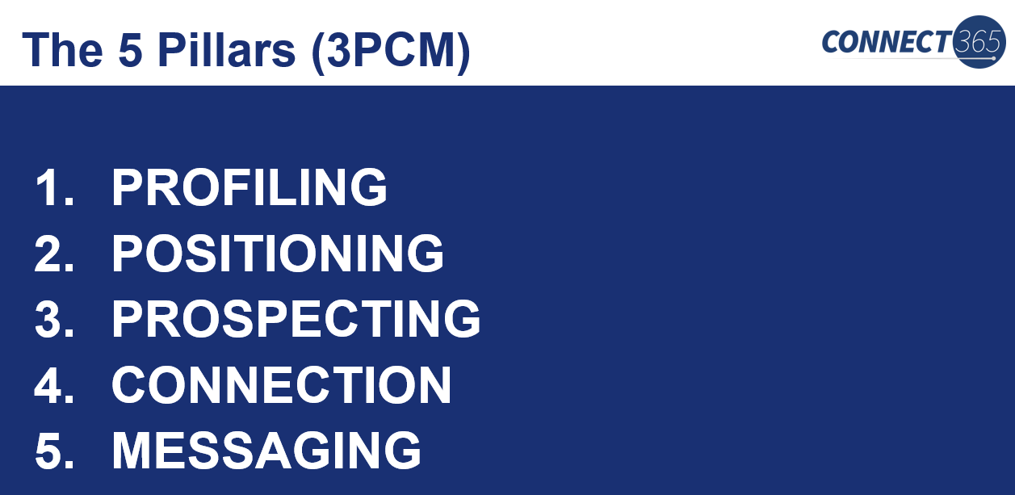
These pillars are the exact step-by-step phases for implementing the Connect 365 system.
The first 3…
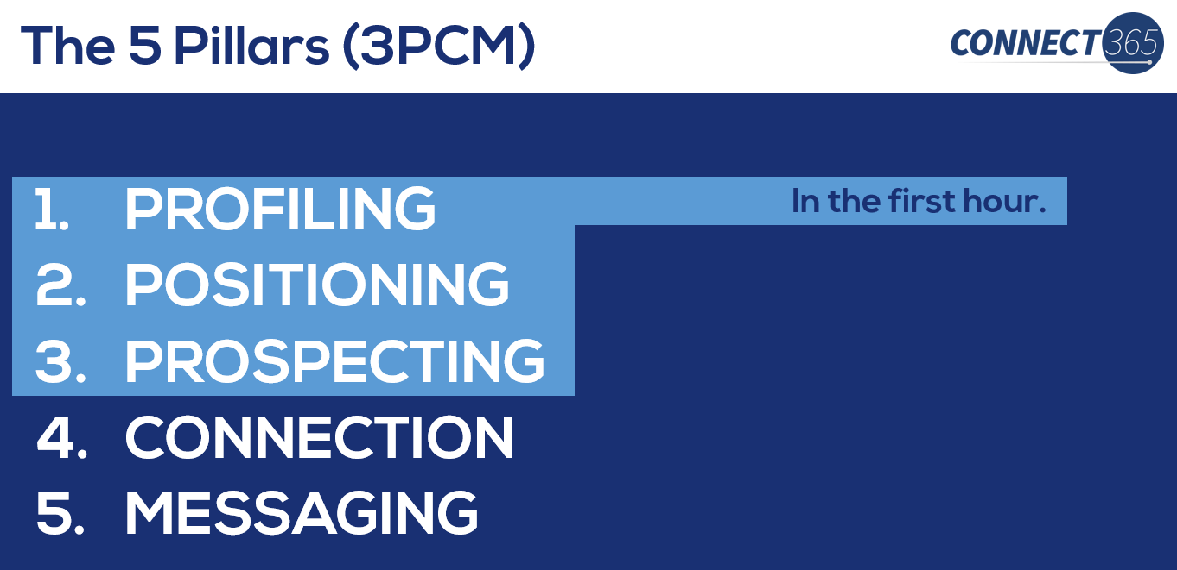
…are all done at the beginning of marketing the process, and then typically don’t need to be addressed again.
Then once you’ve completed the 3P’s you’re ready to start…
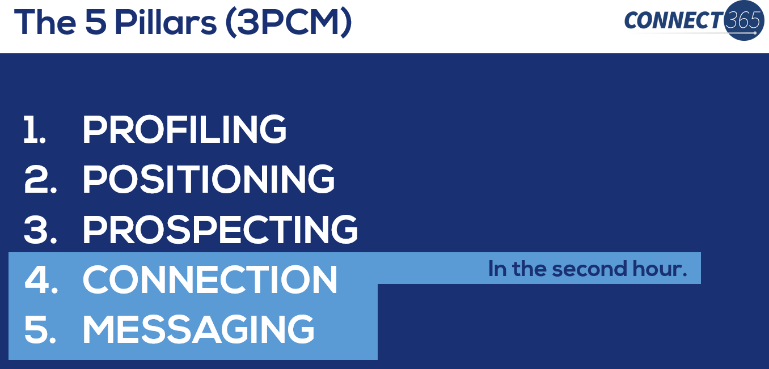
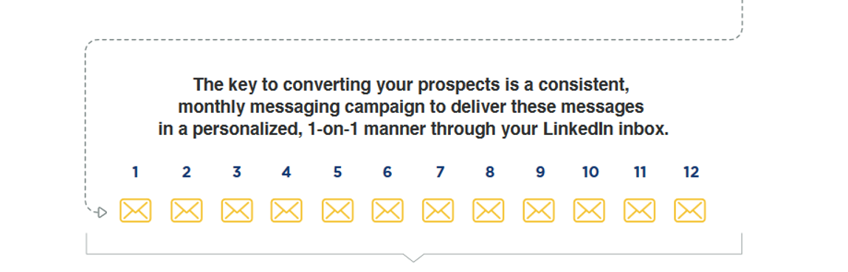
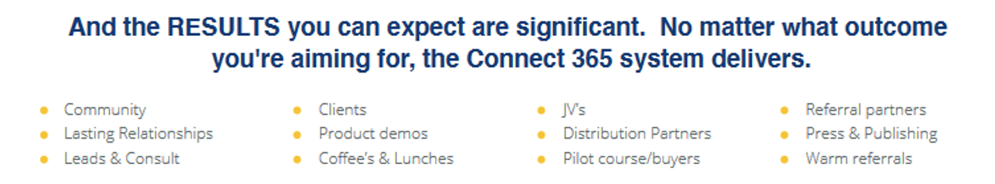
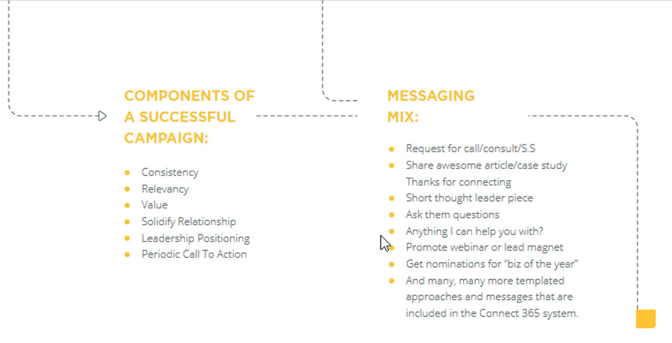So let’s dive in…
Most businesses have absolutely no clue who they’re trying to target.
By not having CLARITY on their exact target market, and not speaking directly to that market’s needs and pain points, they never create any compelling reason for clients to work with them over anyone else.
A recent study showed…
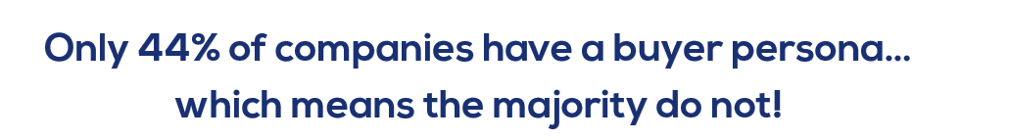
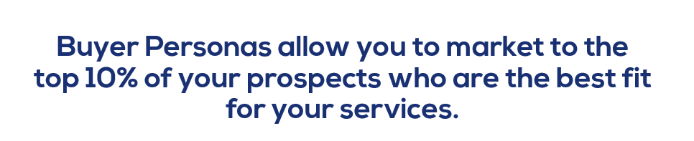

Not having a crystal clear profiling and buyer personas.
If you don’t have crystal clarity on who you’re trying to speak to and serve…how do you expect your best clients to have that clarity?
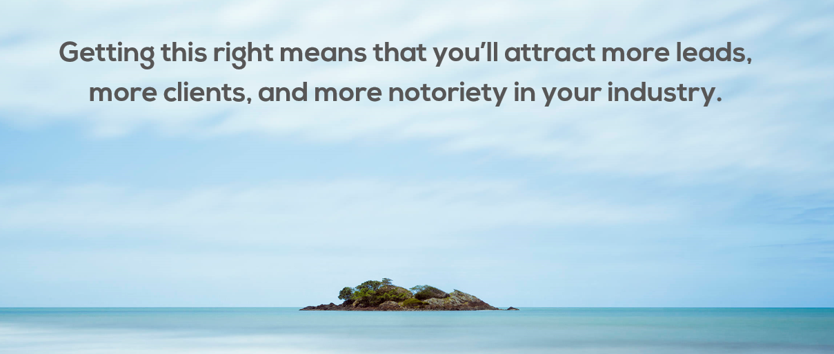

How to properly profile your best clients:
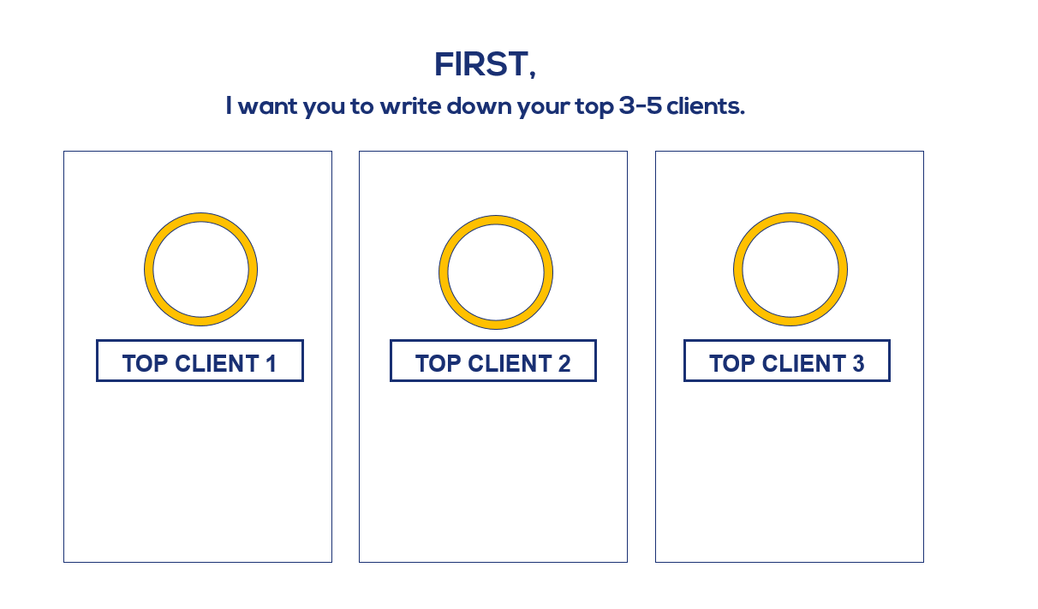
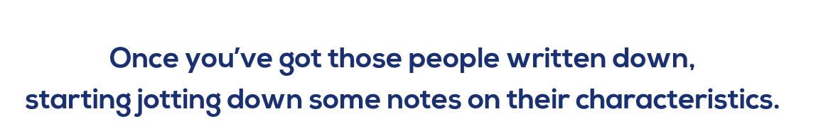
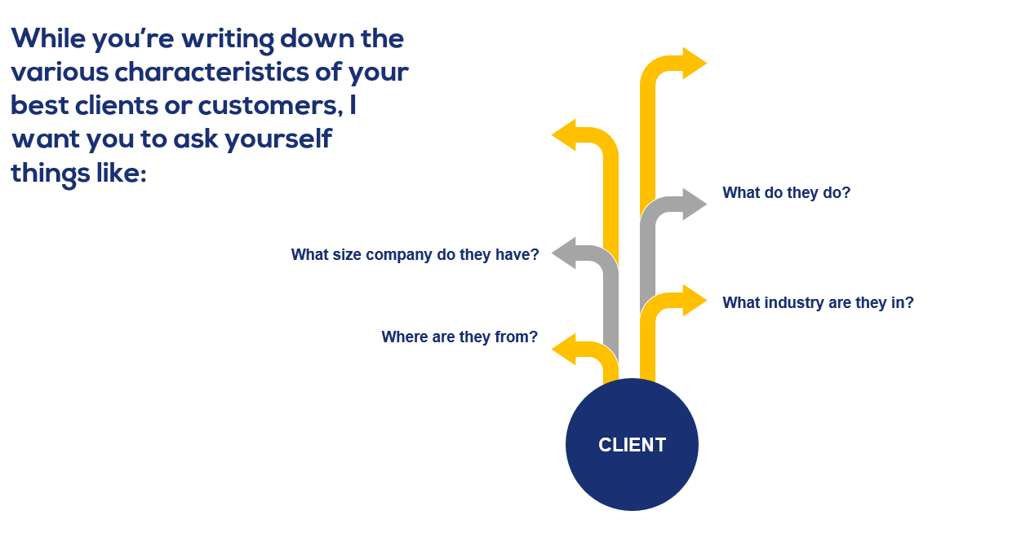
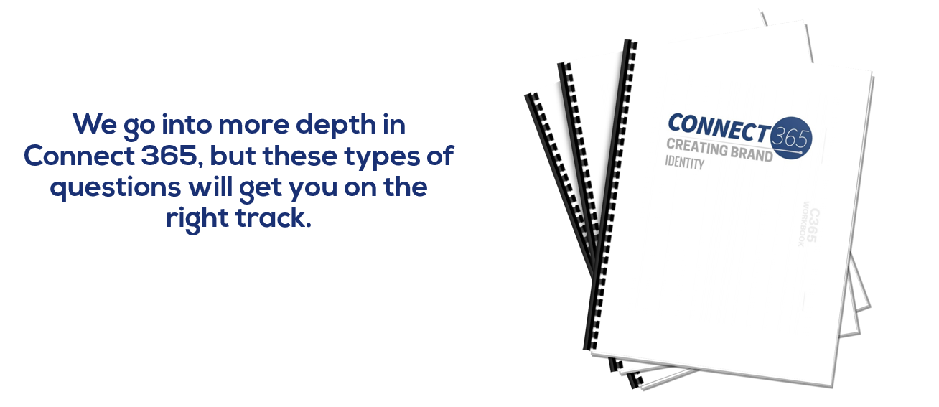
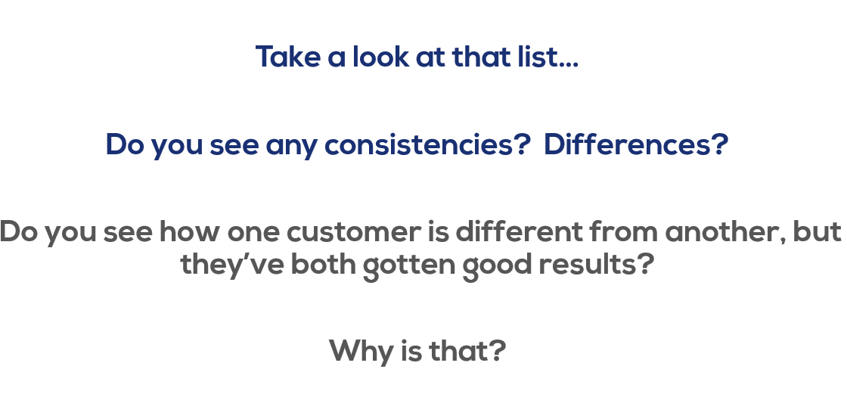
These types of questions are what you want to ask when building your…
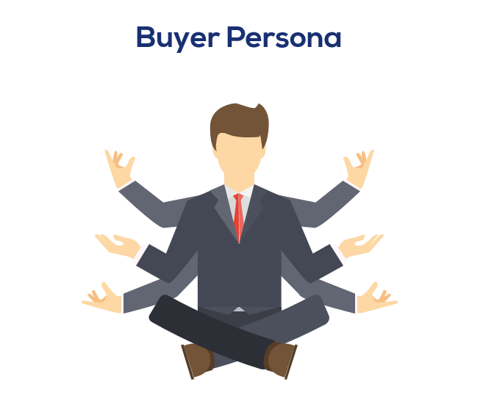

Let me share a story about one of our students…
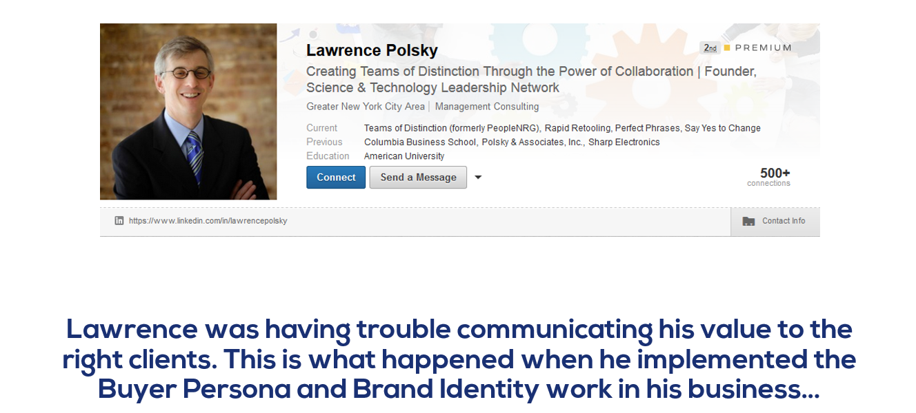
He was already doing well on LinkedIn, but even though he started with 2,045 connections….they weren’t as targeted or focused as he’d like.
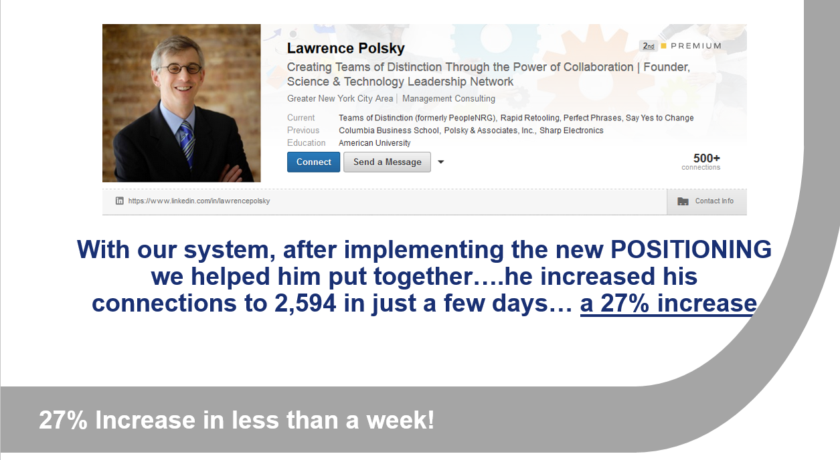
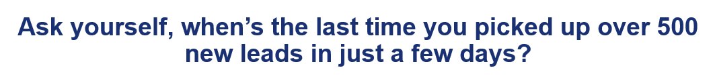
Since then, he’s added an additional 602 new connections….taking him to a total of 3,194 connections.
Now he’s got leads coming in consistently, and he’s working on multiple deals with $80,000.

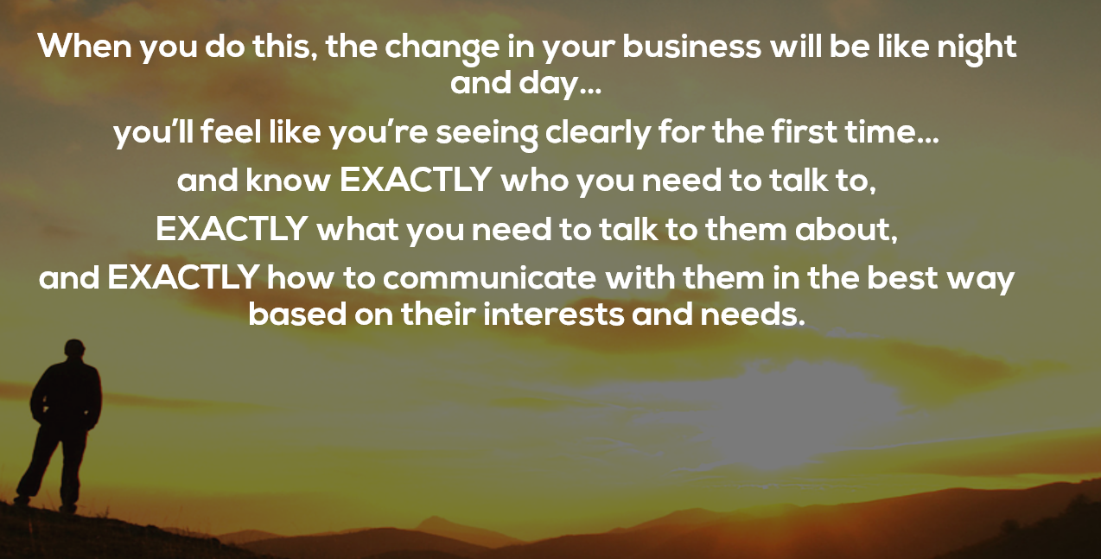
OK, onto the next pillar…
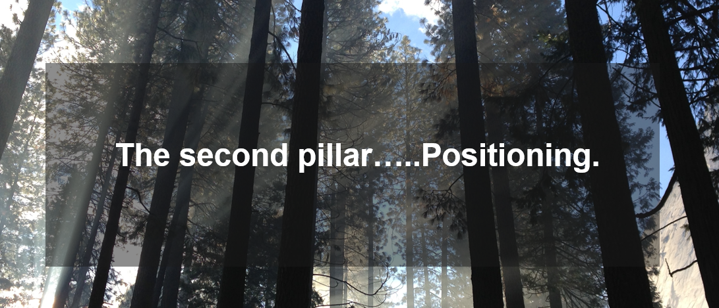
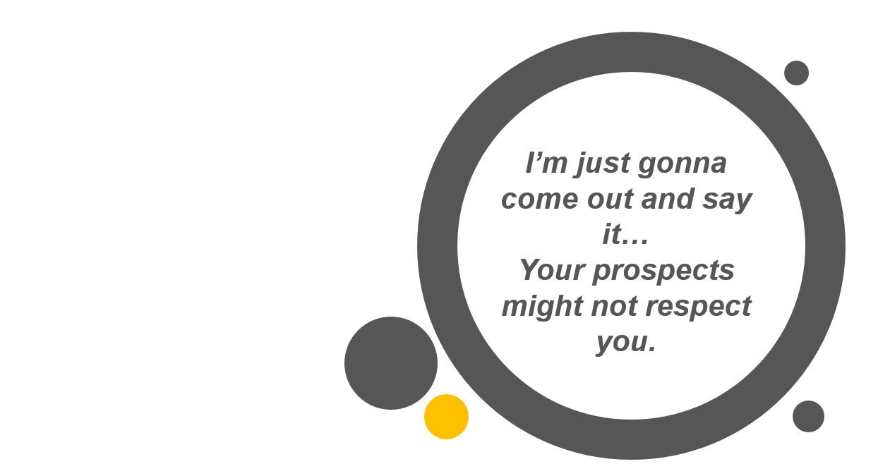
I know it sounds harsh…but you got to be honest with yourself about whether or not it’s true.
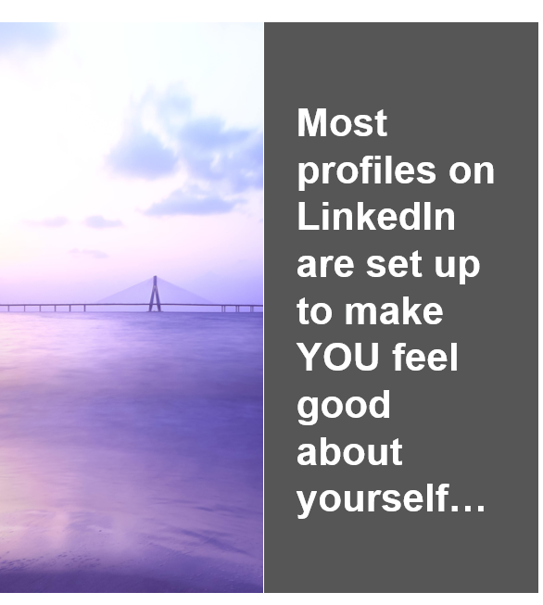
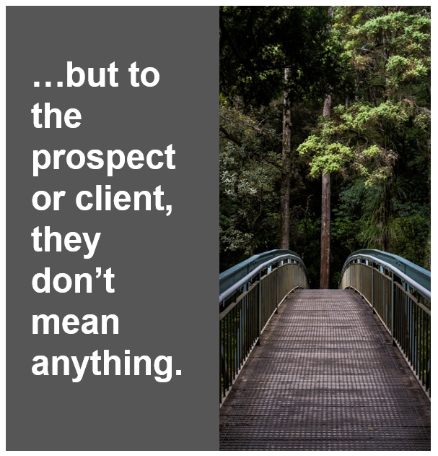
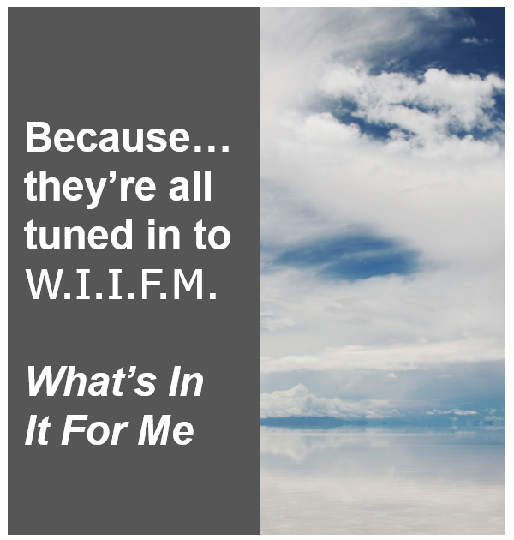

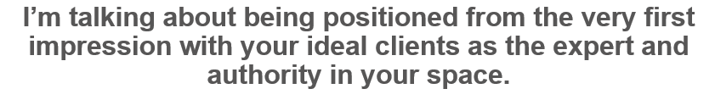
The way your LinkedIn profile is laid out and exactly what it says, and how it says it, is really critical to your success.
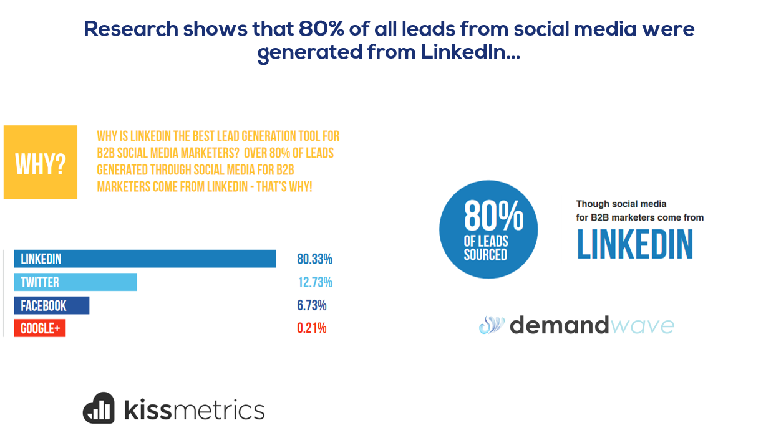
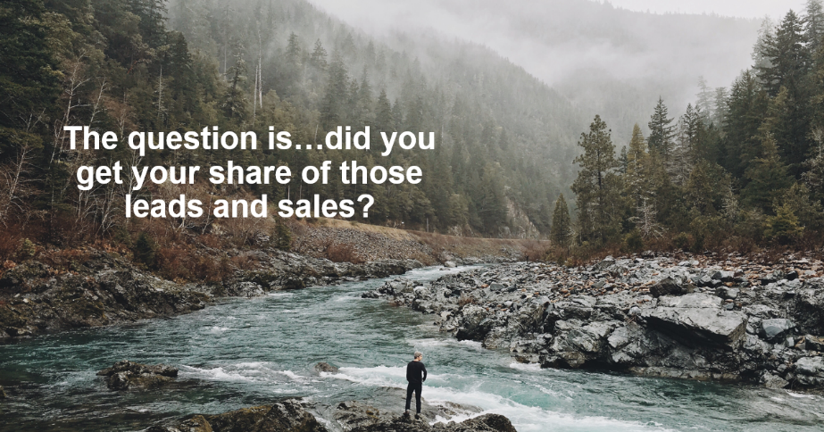
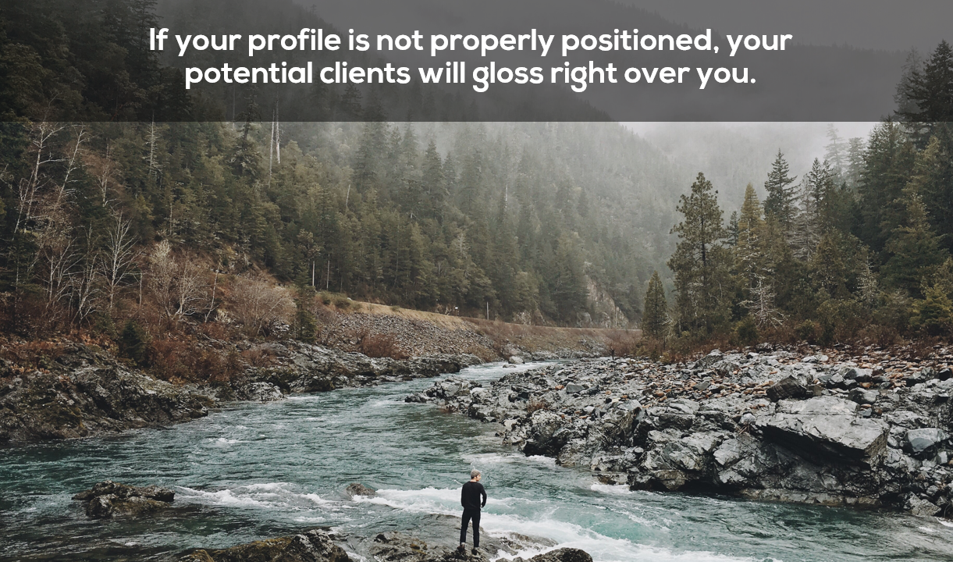
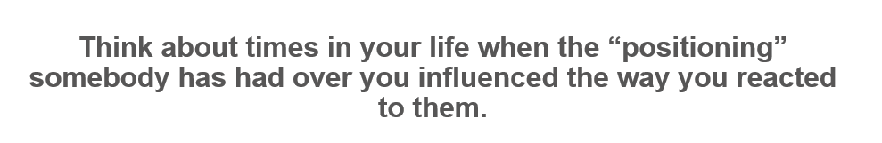
Maybe it was the last time you went to see a doctor.
Your first call went to voicemail in his office, but an assistant with a friendly demeanor quickly called you back to set up your appointment.
Your appointment was booked quickly, not weeks out…but not too quickly, so you knew that he was probably very busy.
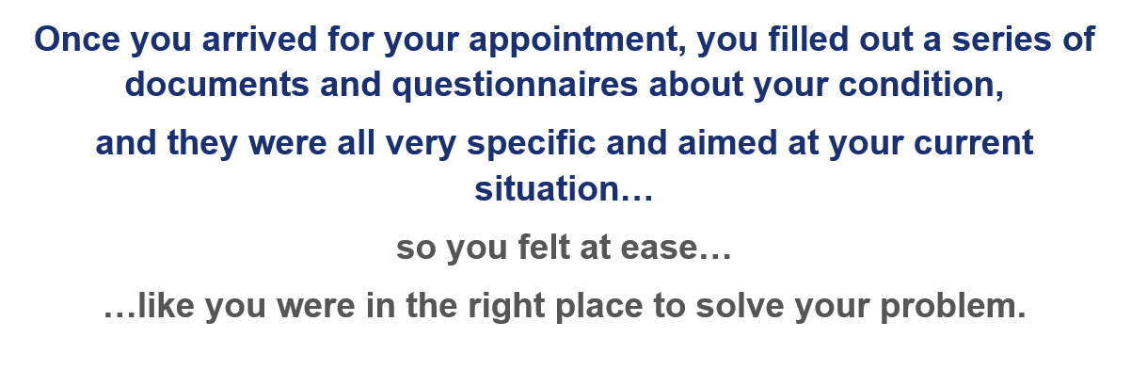
Finally, the consultation started and the doctor came in. This was the first time you’d ever met him or talked with him in person, but you noticed that he seemed friendly, concerned, but also very knowledgeable and calm.
When you described your symptoms, he nodded, wrote down some notes, and asked very specific questions.
After you answered, he jotted more notes down, and then immediately told you that you most likely had 1 of 3 things, and they all weren’t serious if treated right away…but he wanted to do some tests to be sure.
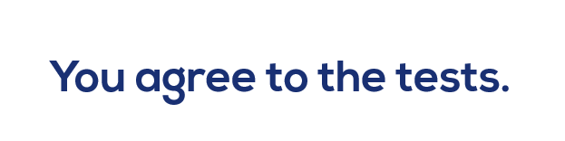
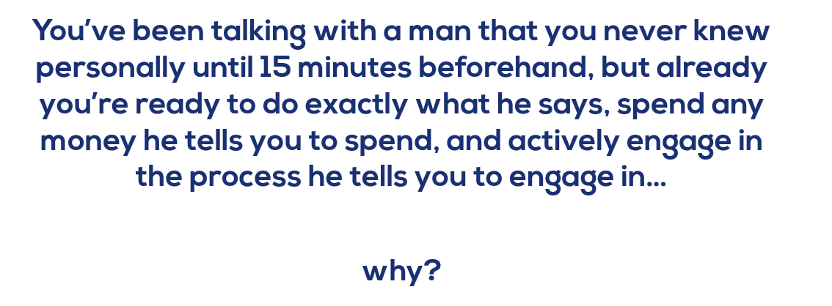


He doesn’t need to “sell” you on anything.
You came to him for a specific reason, and it was a reason that was solvable from his personal expertise.
You arranged never stopped to think,
“Wait…this guy is probably just going to try to sell me something expensive.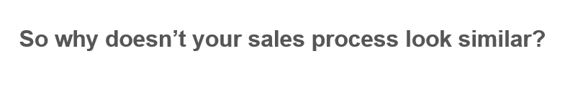
There’s no reason it can’t.
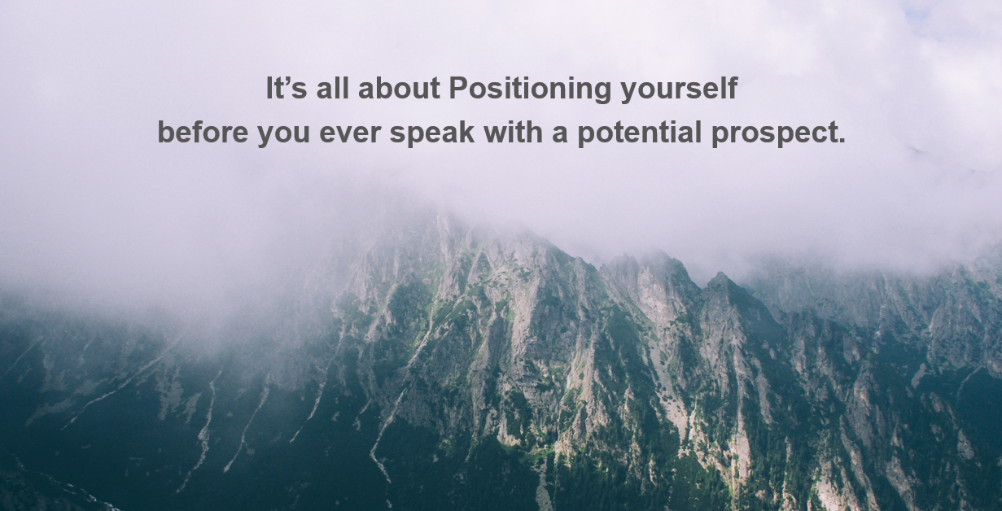
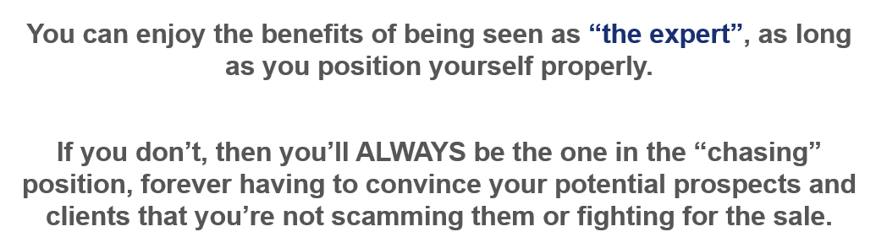

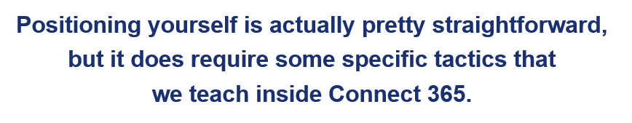
First, you’ll want to spend some time on your headline on LinkedIn. That’s the area right next to your profile picture.
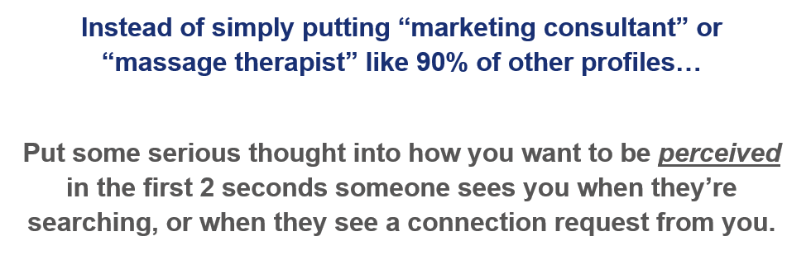
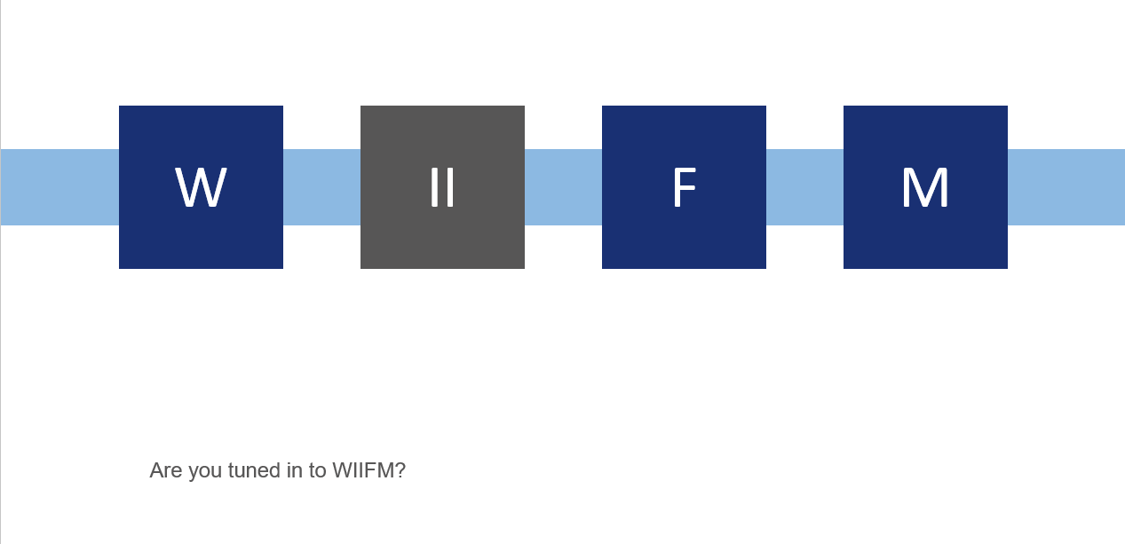
The key is to make sure you are tuned in to WIIFM.


Here’s one example of a great client of ours, Troy Owens…
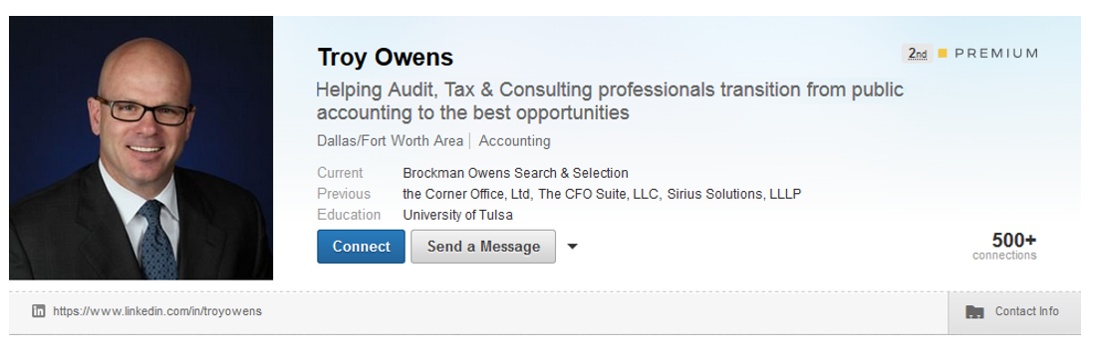
He clearly states who he works with, and the OUTCOME or benefit you get when you work with him.
If you were in the market for Troy’s services…would you feel more compelled to work with Troy…or somebody like most of his competitors who just have the word “Recruiter” in their headline?
TROY, of course!
Most people want to work with an expert and a specialist whenever they have an issue…not a generalist who caters to everyone.
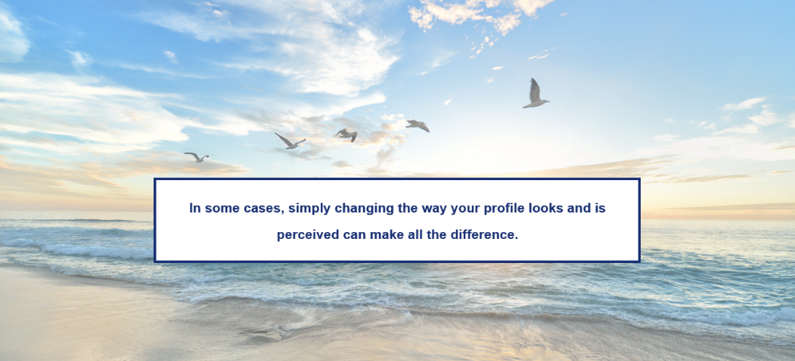
People just want to know what you can help them with…they aren’t lazy or inconsiderate… they’re just focused on their own problems and issues, like everyone else.
Take Ben Cohen, for example.
When Ben first started working with us, he was falling into the “help everyone with everything” trap, and his profile was getting views…but no clients or leads.
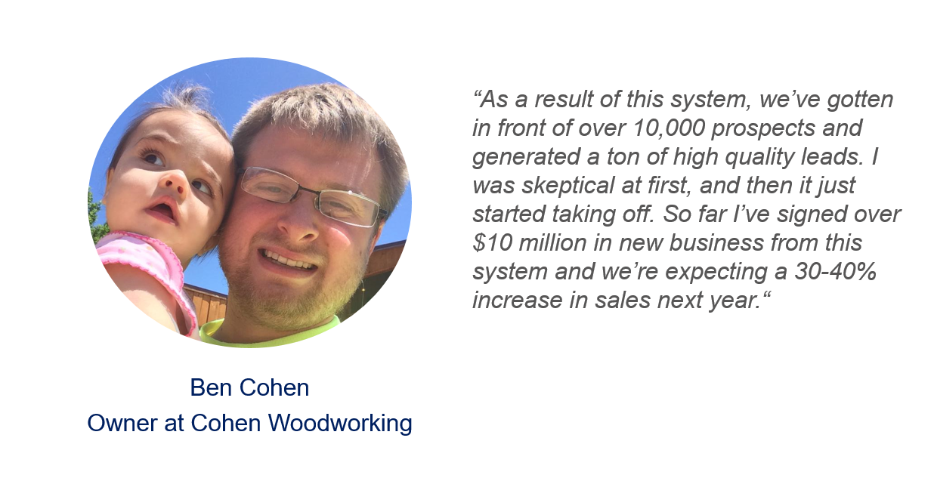
.
He’s POSITIONED in a way now that they are actually turning away business and is only working with clients that they really want to work with.
Or Tom Swip, another client of ours who has completely changed his business with this system.
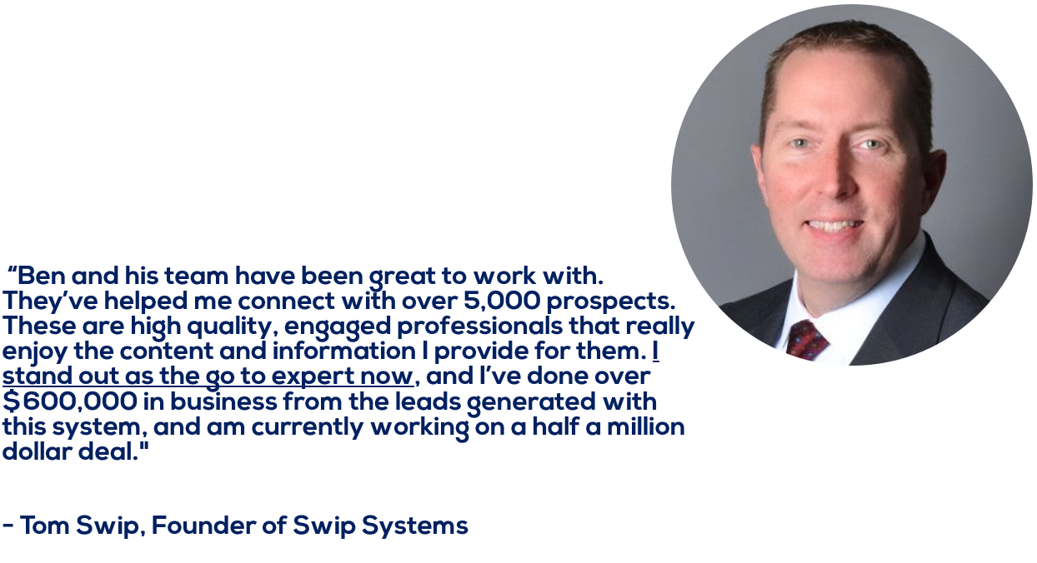
As he said, now he STANDS OUT as the GO TO EXPERT.
In Connect 365, we go into detail on how to set up your entire profile for maximum results, tying it in with your Profiling work and Buyer Personas:
- Step 1:
  - Focus on creating a Value-Based Headline to describe your service or product in the context of WIIFM…what’s in it for your clients.
- Step 2:
  - Focus on your summary and tailor it to sound like a conversation between friends about their specific issue.
Let’s move on now to…
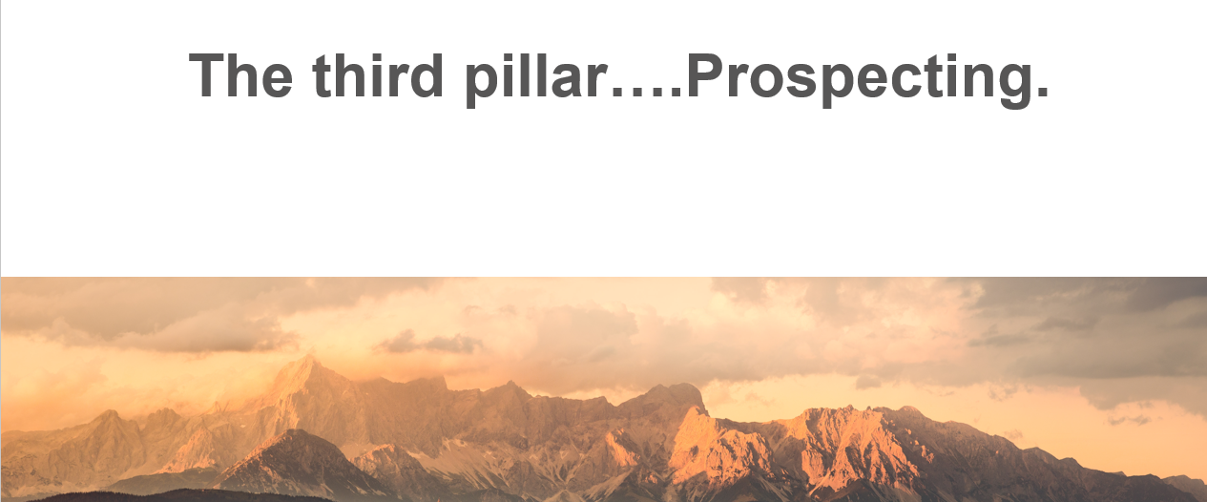
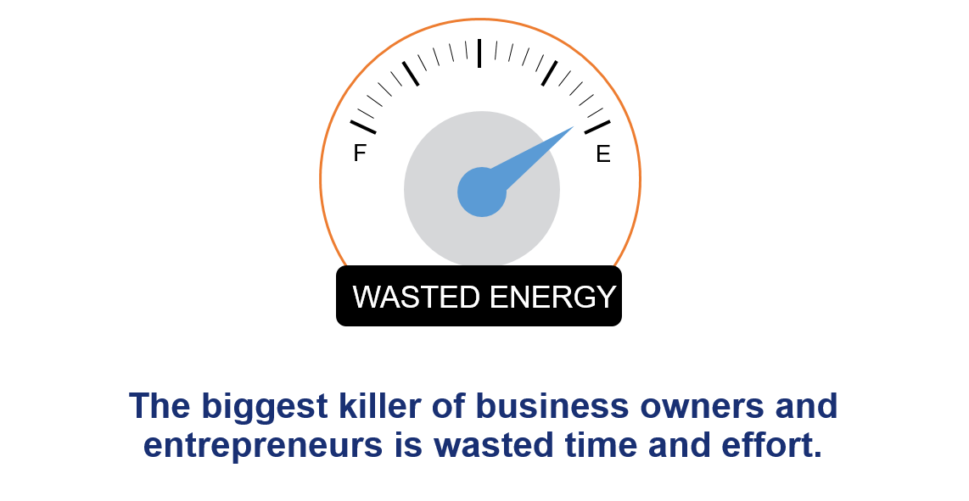
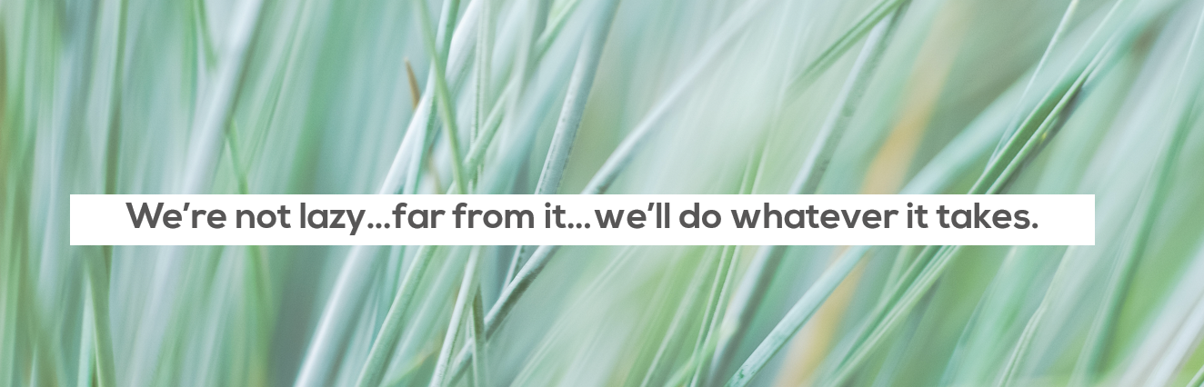
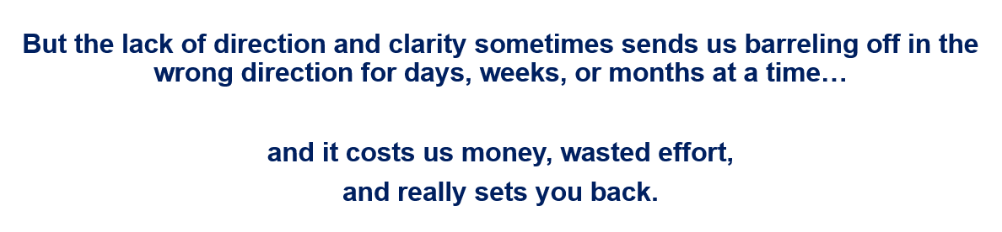
When we conducted the interviews and surveys of nearly 2,000 business owners, the #1 complaint with implementing an effective lead generation system was the TIME it took to implement and sustain it.
We heard things from people like:
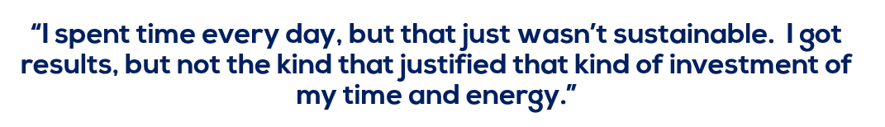
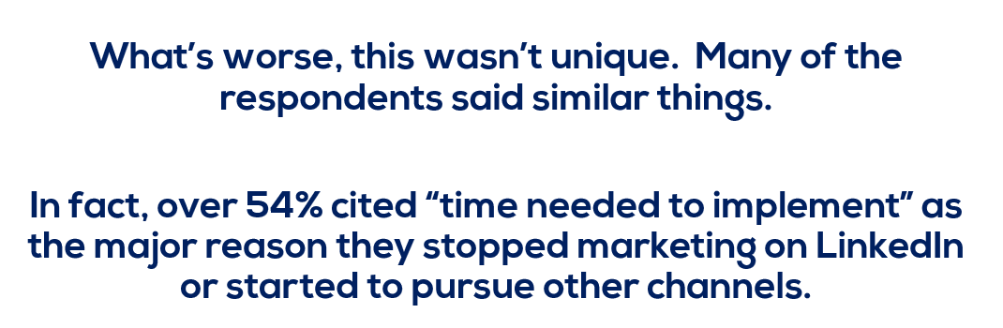
But here’s the reality:
Just over 80% of all B2B leads that converted into sales from social media were on LinkedIn.
KissMetrics did a massive study, and found this data…
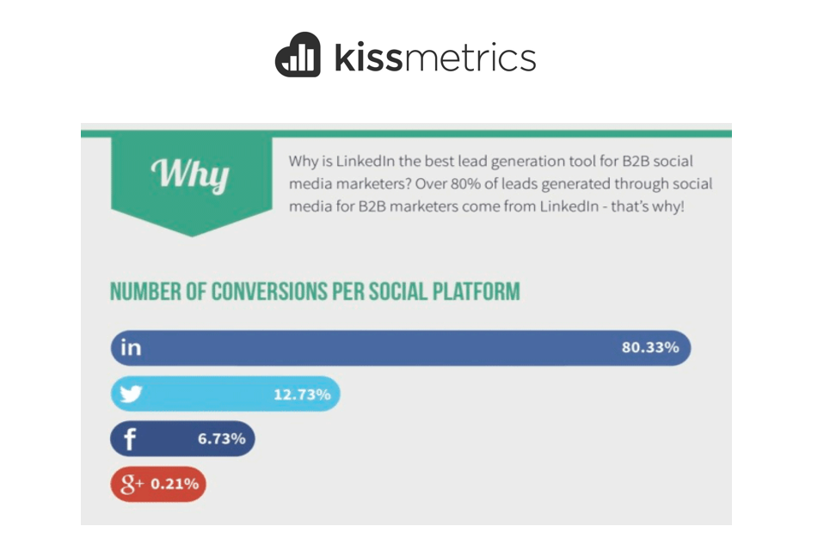


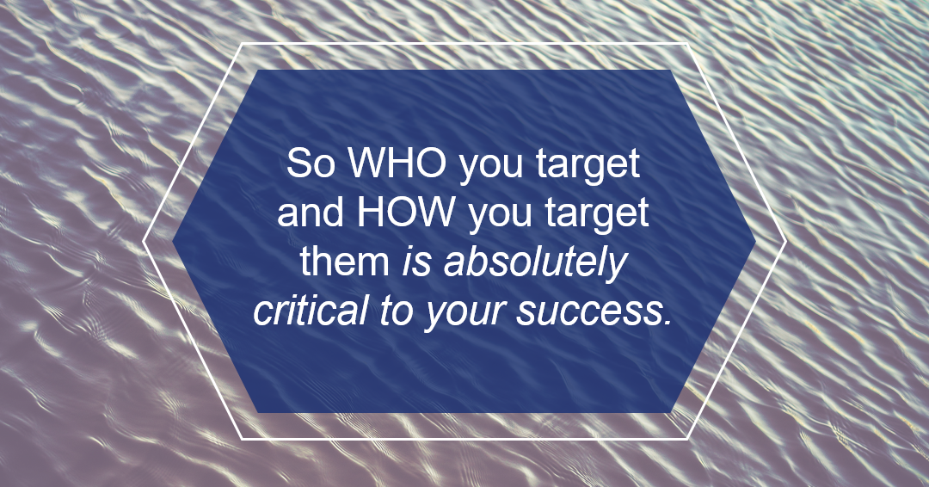
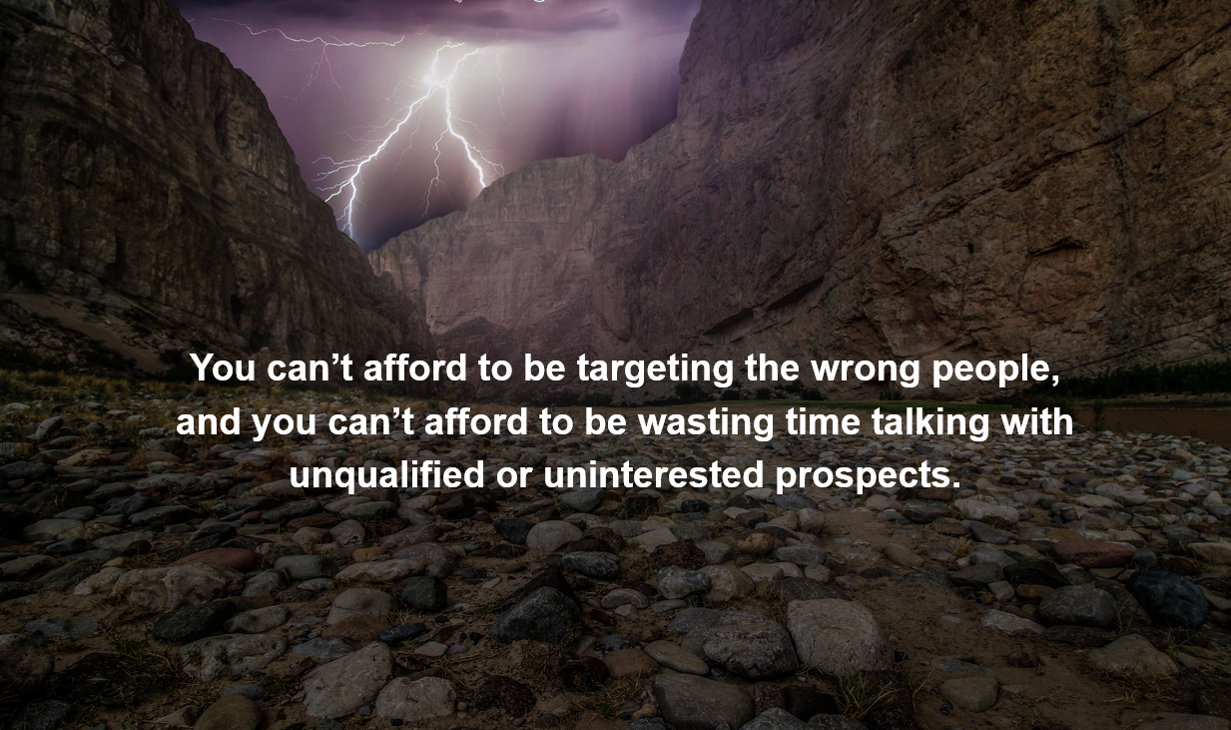
Prospecting on LinkedIn starts with the Advanced People Search page.
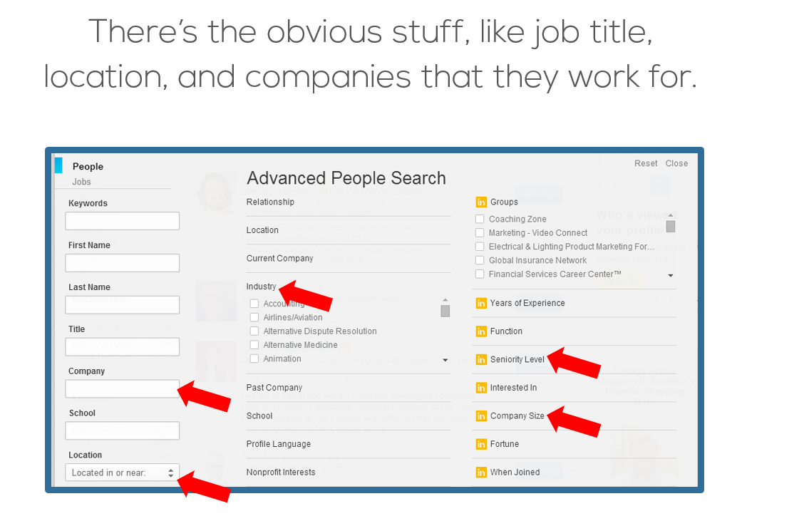
You can also use the Premium features to get even more granular, but you don’t have to.
The trick with Prospecting on LinkedIn is being SUPER clear on which Buyer Persona you are currently trying to target, and why.
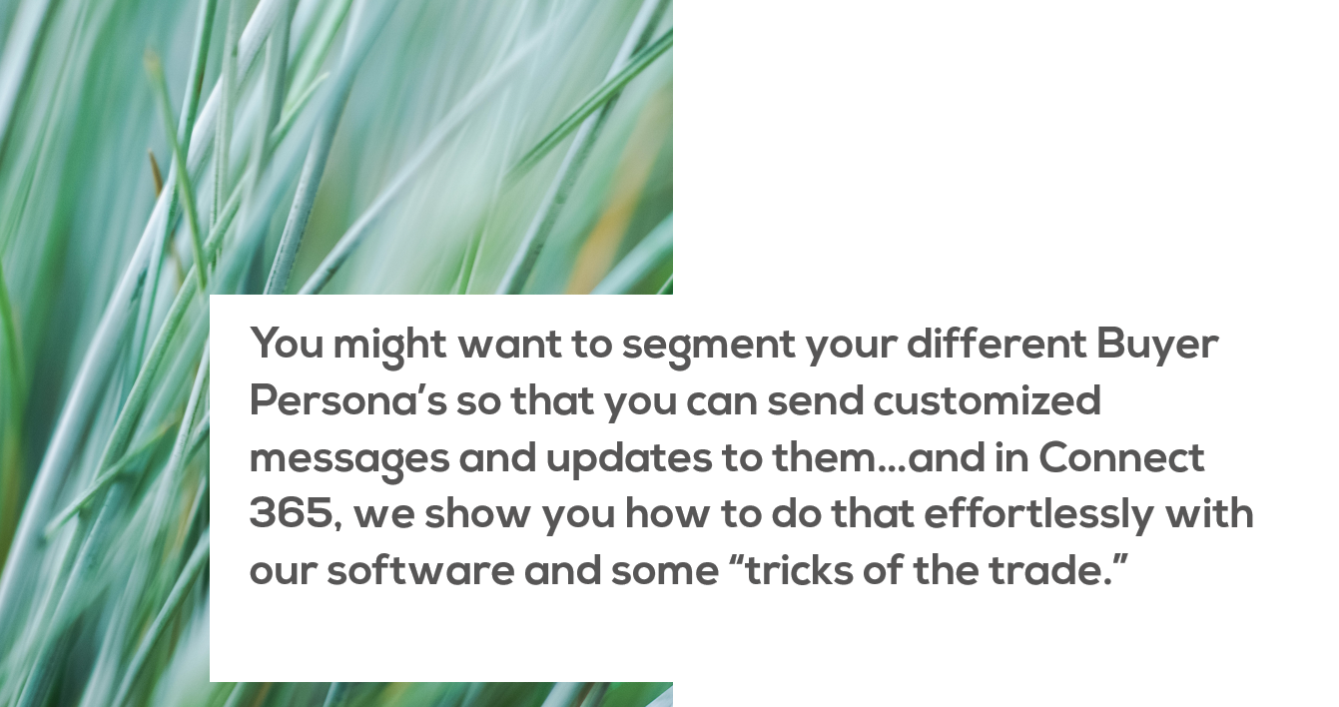

The first trick I want to show you, is called, “negative keywords” to narrow your search and bring up your perfect prospects.
Let’s look at an example.
If you’re selling a service that helps small businesses automate their HR paperwork and taxes, then you’re probably not going to want to connect with HR managers.
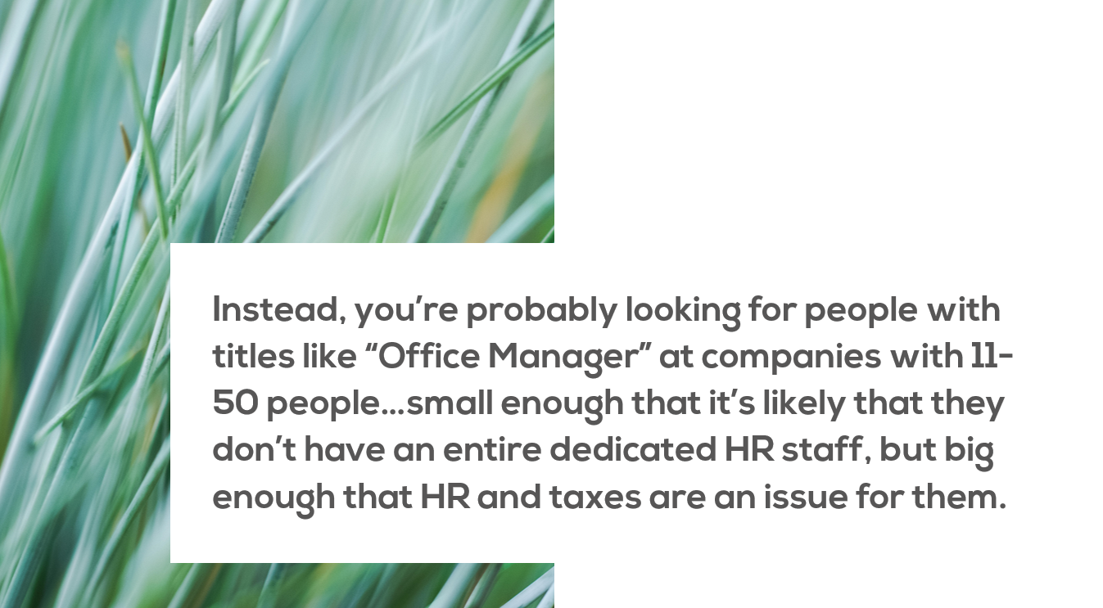
You can’t just type in “Office manager” and leave it because that title often comes with HR Director, Accounting, or other titles that would mean that she isn’t a perfect prospect.
This is where the “negative keywords” comes in.
First, you enter a “minus” sign use the word NOT next to the word that you don’t want to target in the search bar here:
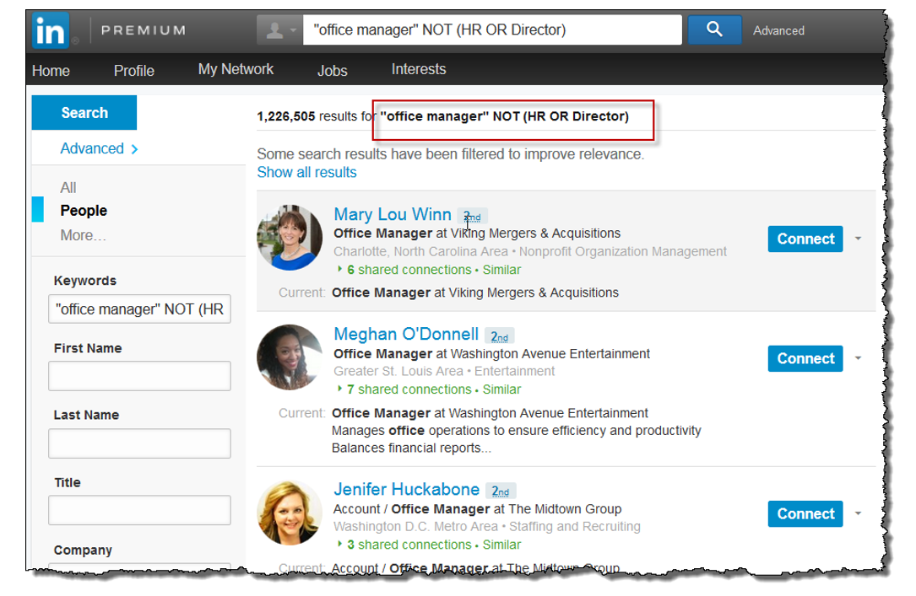
This will filter out anyone with that word in their title.
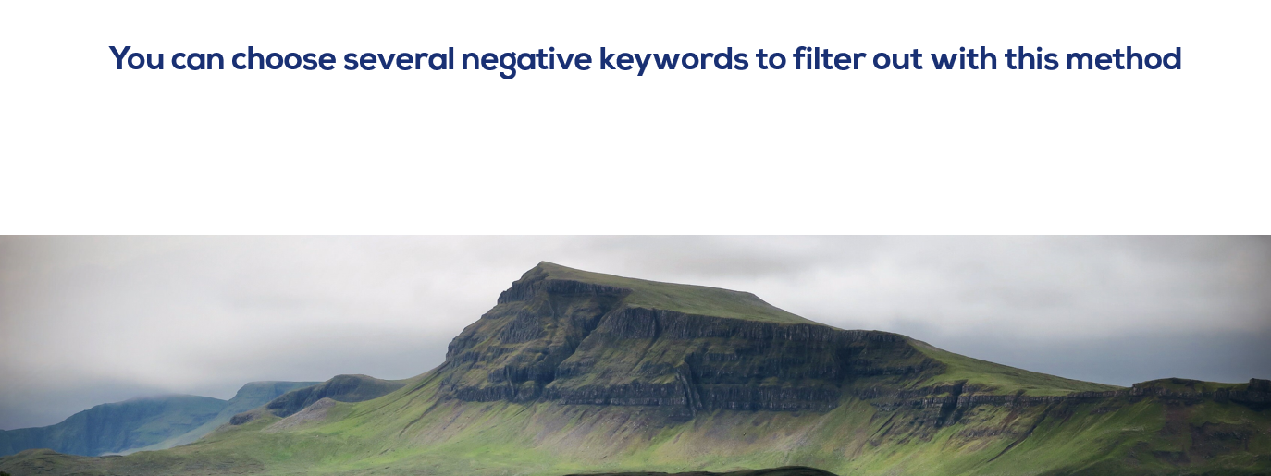
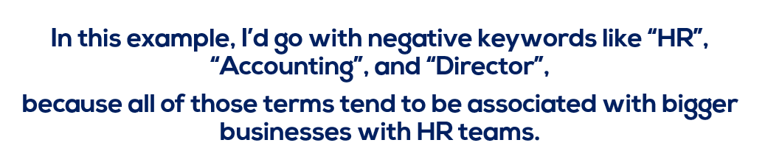
Prospecting for the RIGHT type of people is key.
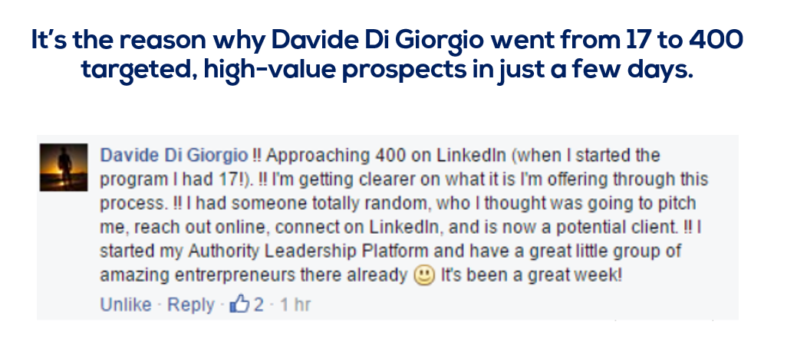
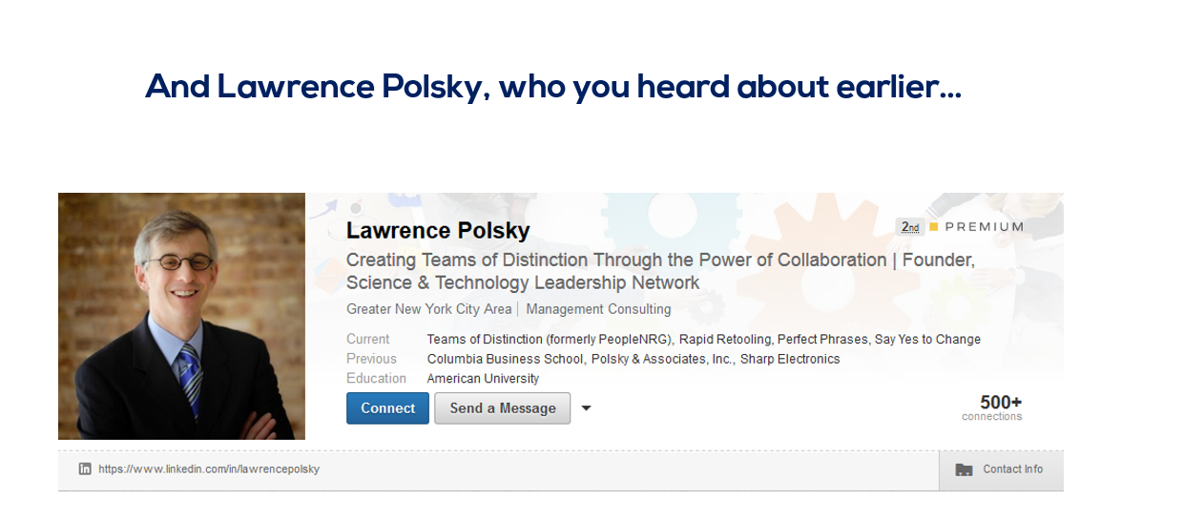
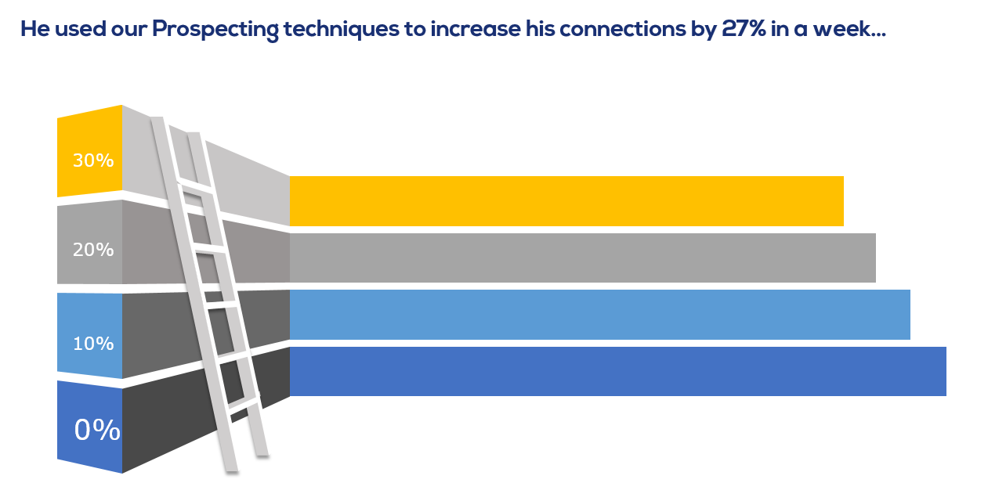
Or there is Aaron Agius, who runs a marketing agency.
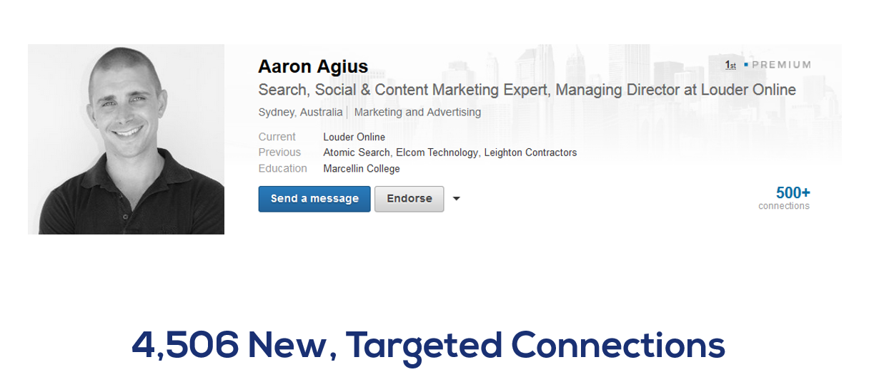
He went from almost nothing to 4,506 new connections, and has done multiple six figures in new business directly as a result of this system.
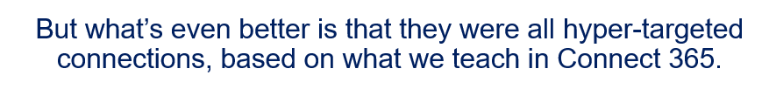
So all of those new connections ended up converting into real business at a much higher rate than his old connections…which tells you how powerful this method is.
ESPECIALLY when combined with the automated messaging software.
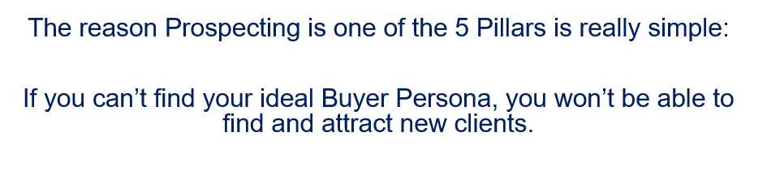
The Prospecting phase is where you make that happen.
So those are the first 3 P’s of the 3PCM pillars. Profiling, Positioning, and Prospecting.
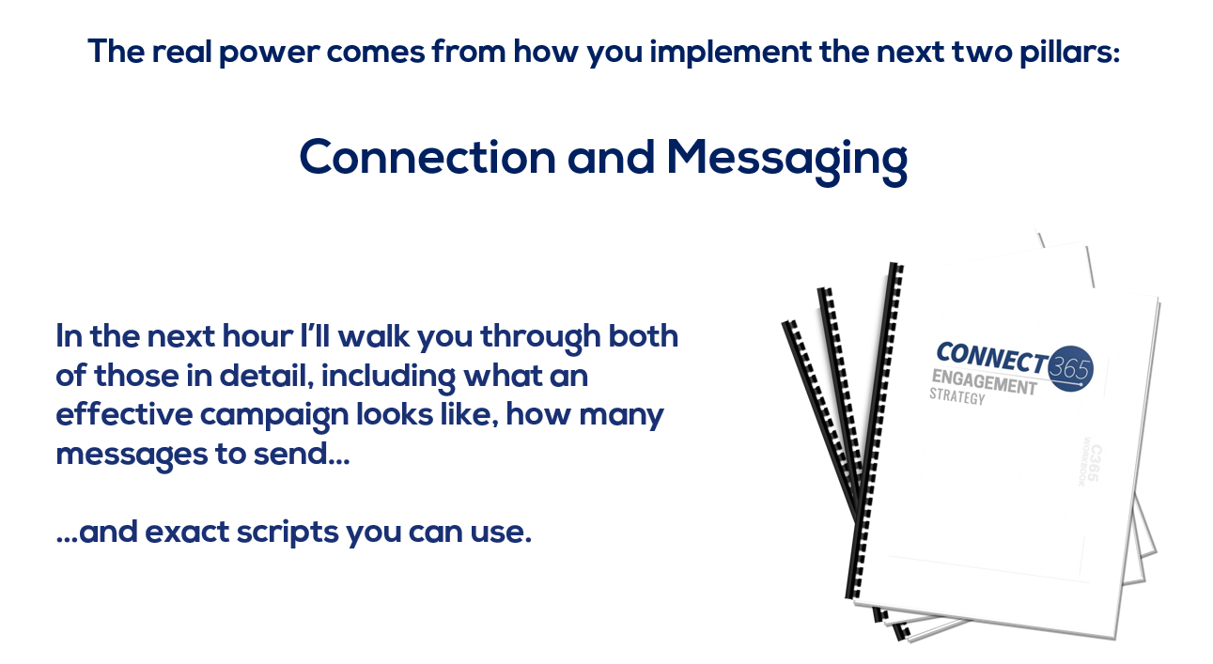
But first, I want to tell you how you can get the Connect 365 system and automated software platform.

Connect 365 is a…
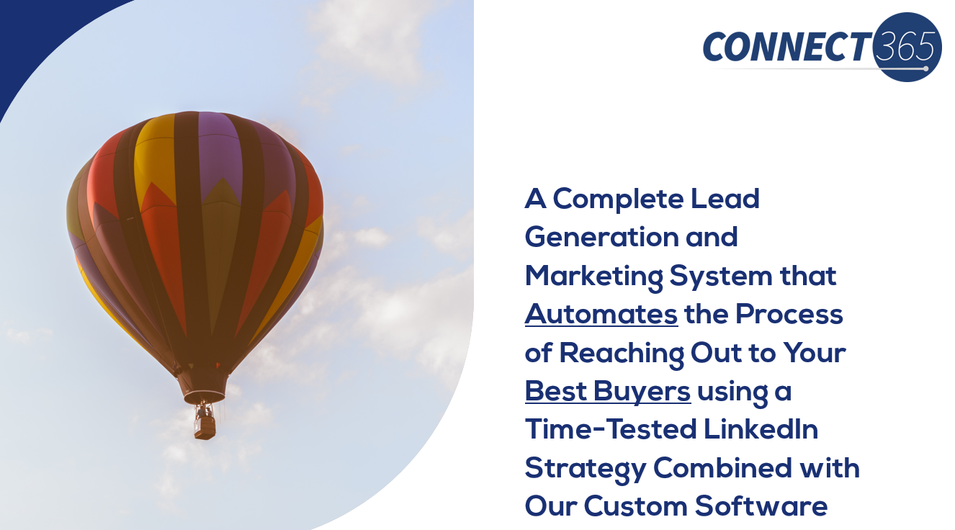
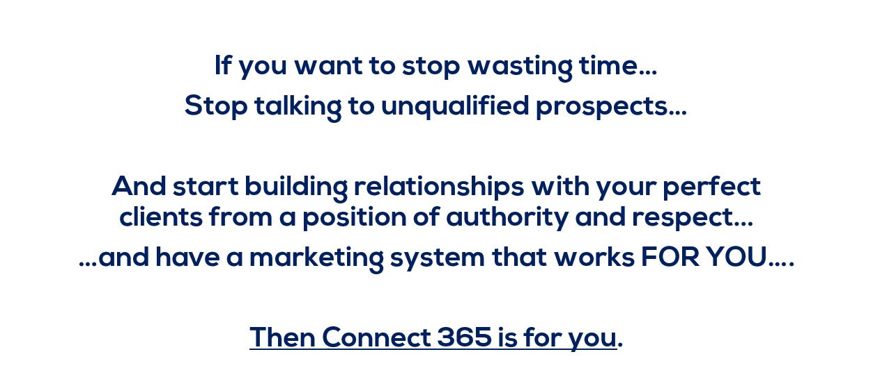
You’ve probably tried other programs in the past, but didn’t see the results you wanted OR couldn’t find the time to work it.
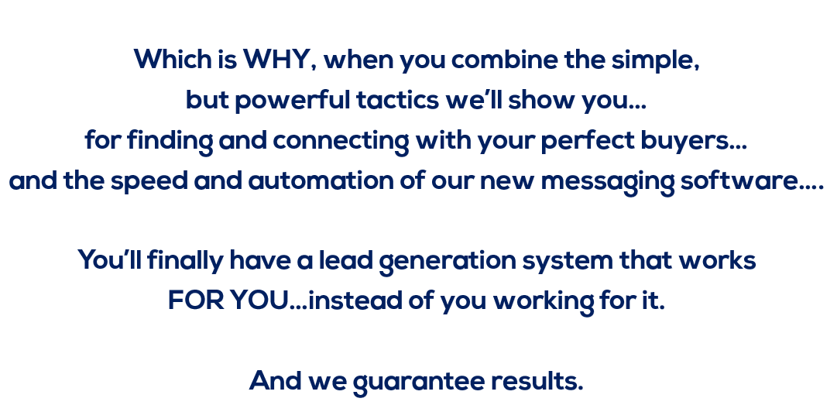
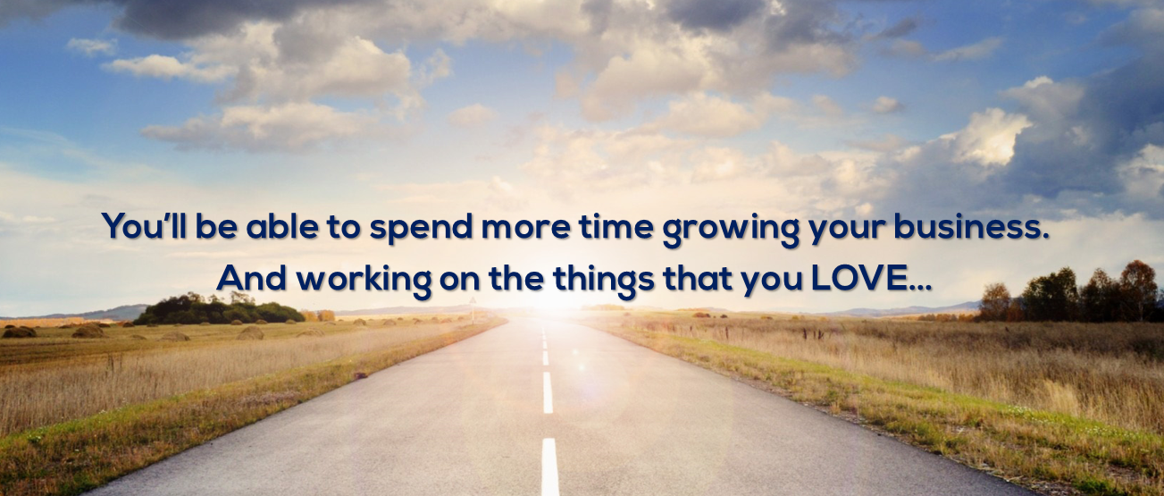

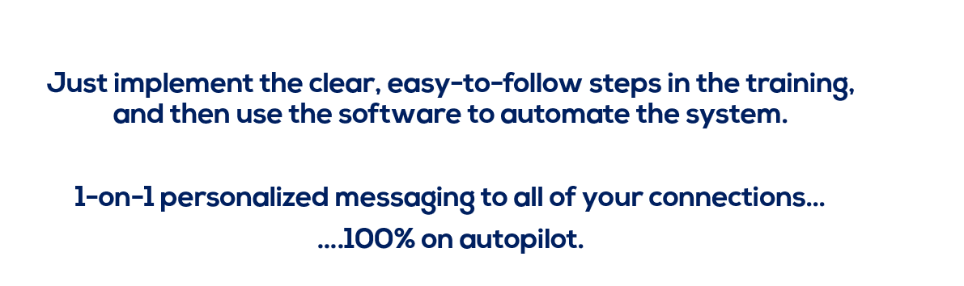
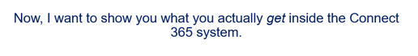
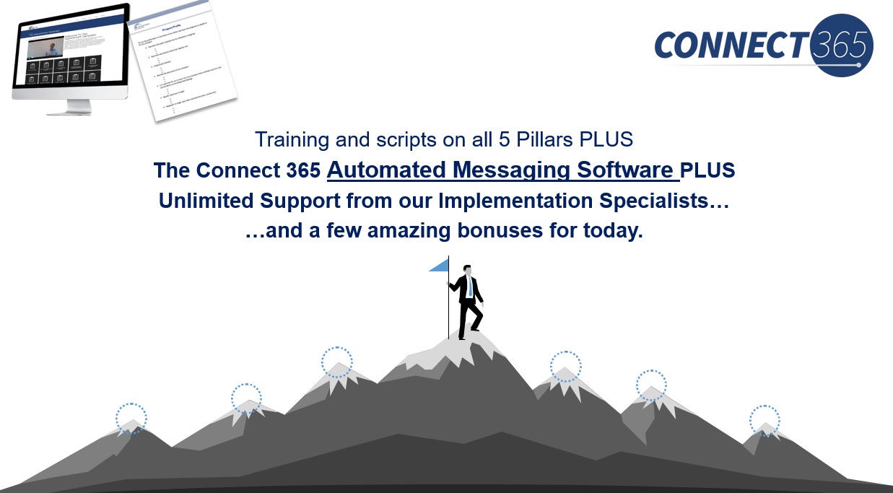
So let me unpack each of these real quick so you know EXACTLY what you’re getting.

The first is our Brand Identity training…

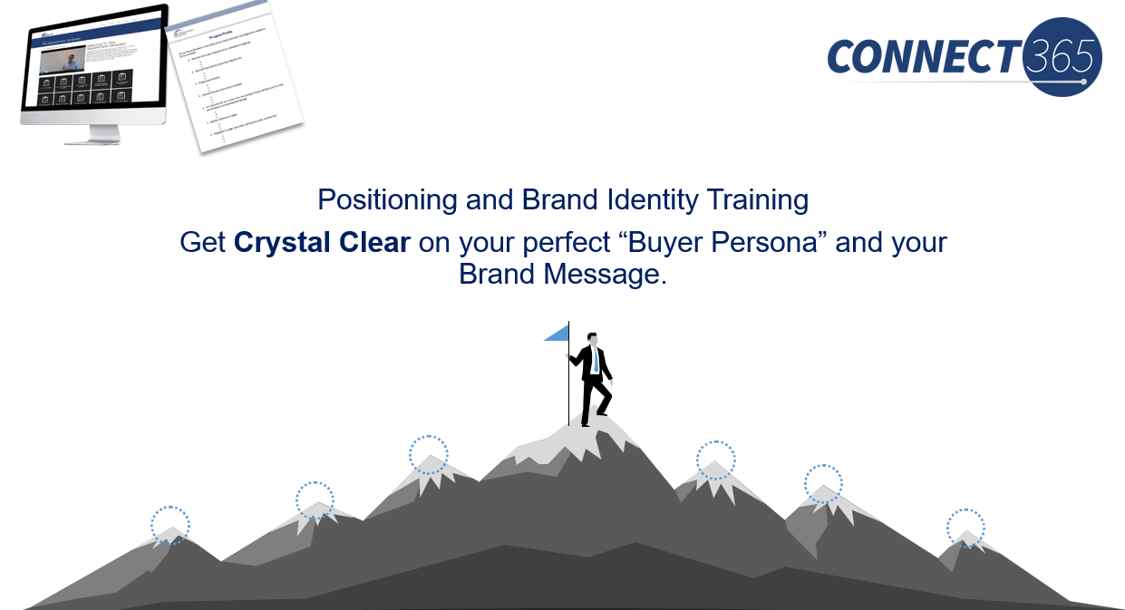
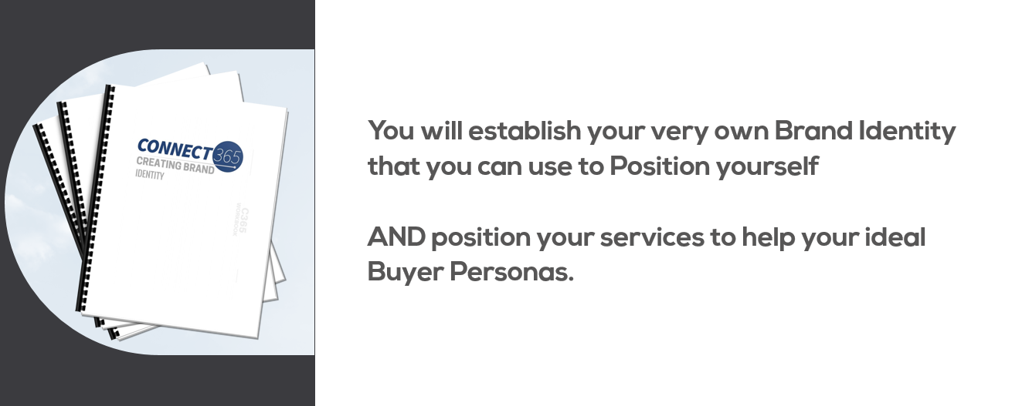
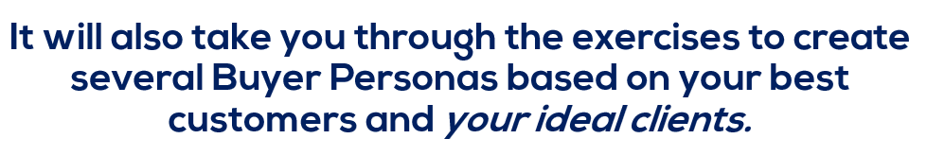
Once you’ve gotten that done, or if you already are clear on that, you’ll move on to the next step…
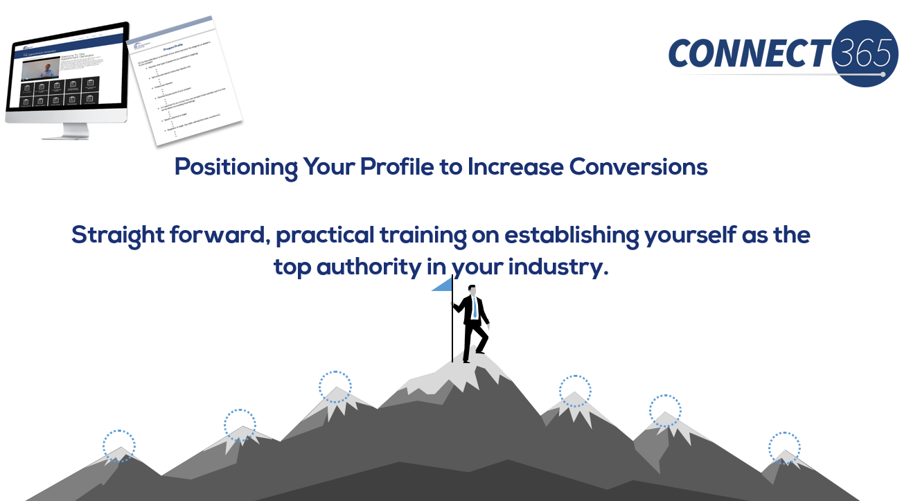
There are very specific tactics you can use that attract your best buyers.
Once you have that in place, you’ll be ready for…
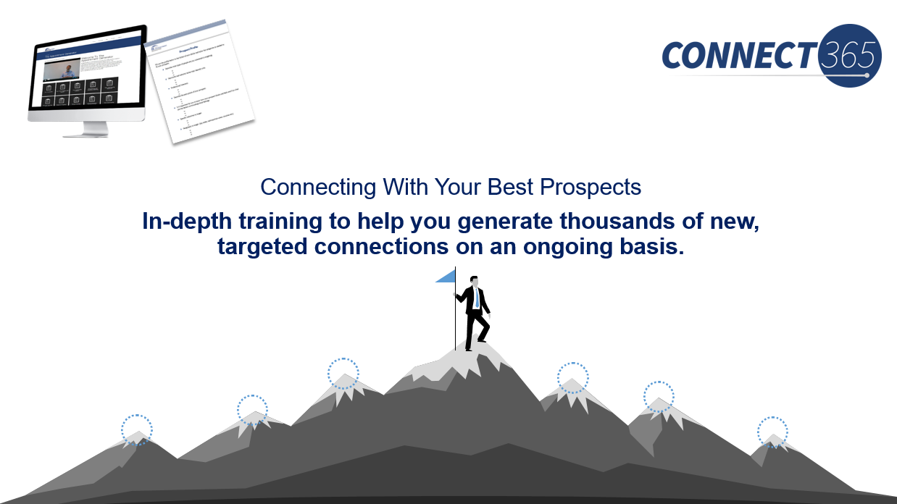
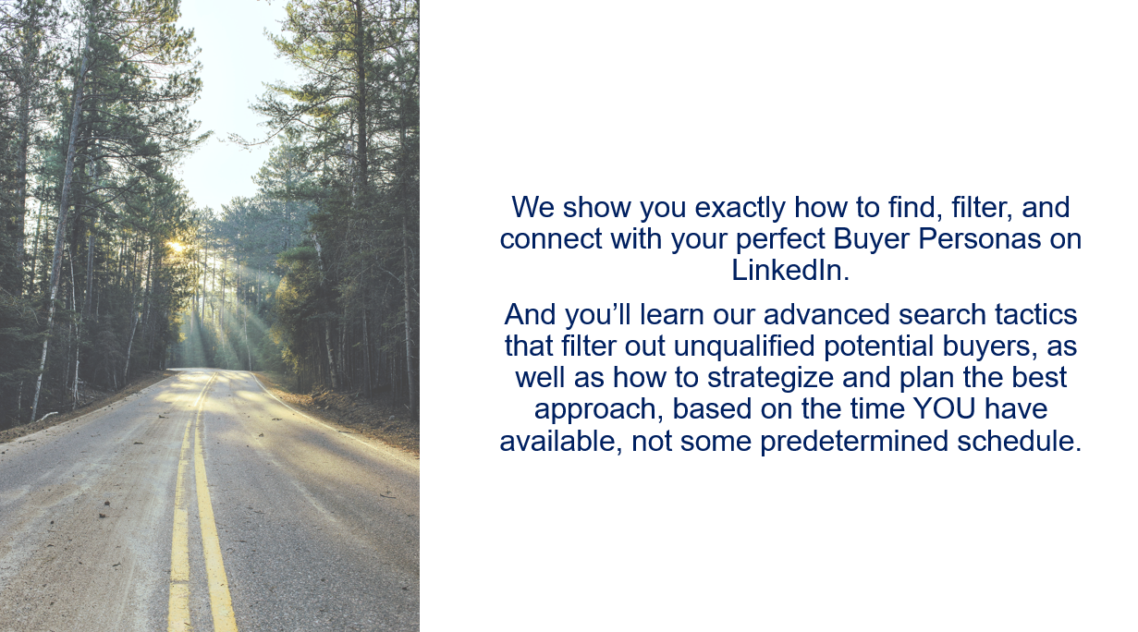
Most marketing systems require your specific input and attention for long periods of time.
But because this system is so hands off, once you get things set up…it’s just a few pushes of a button, to do what used to take HOURS.
You’ll also get …
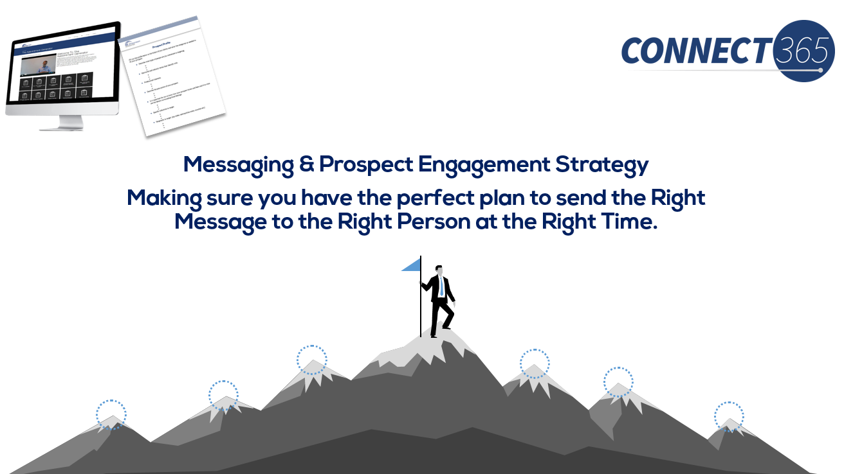
Studies show that only 7% of your target audience is ready to buy right now…

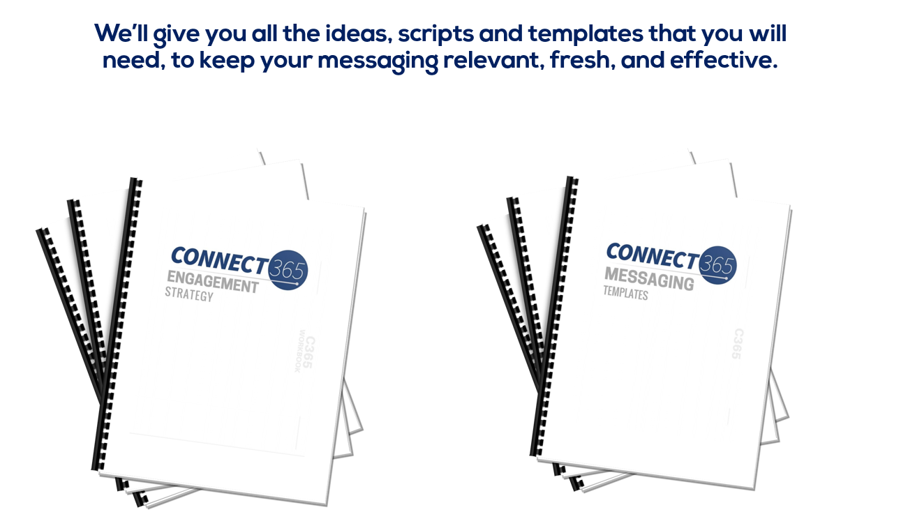
When you do that…that’s how you build a great brand and get great clients. And we’ll show you how to do it at scale.

You’ll also get…
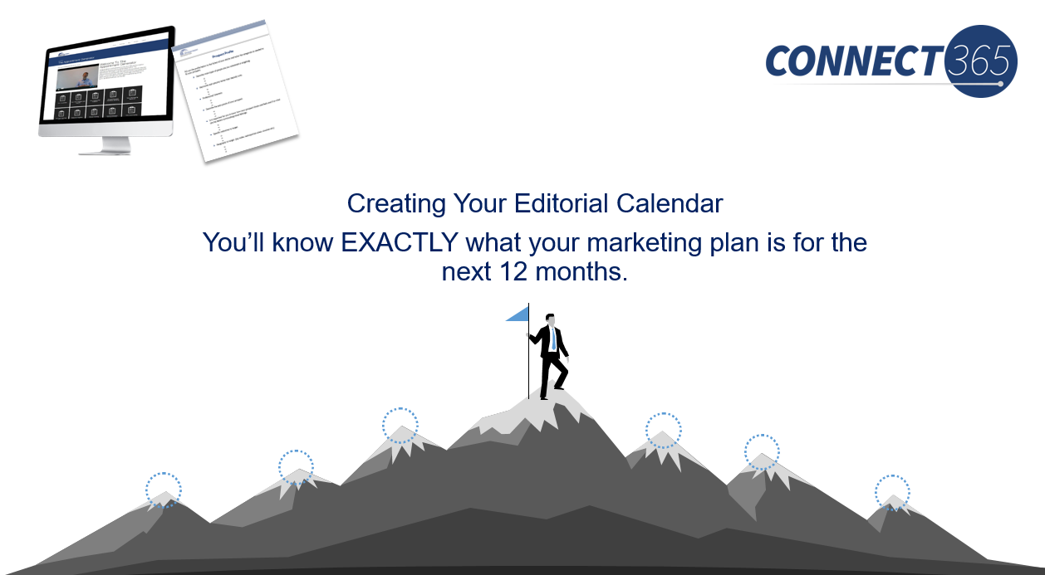



And one way you do that is through…
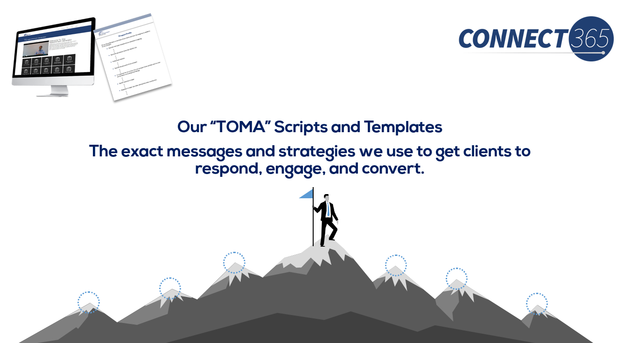

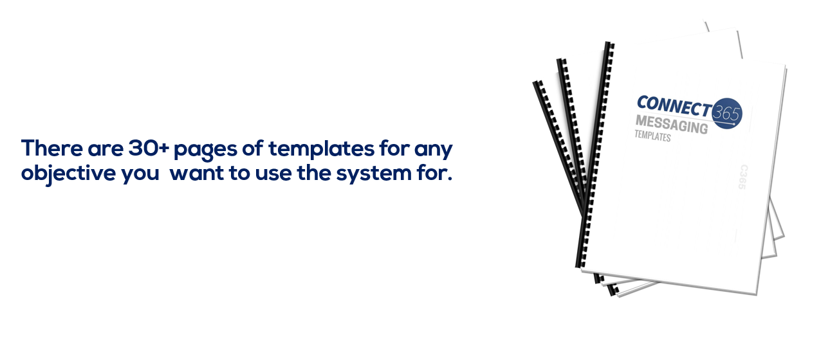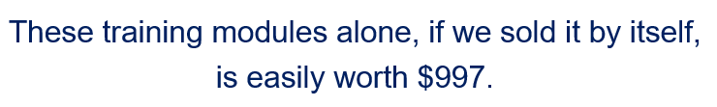
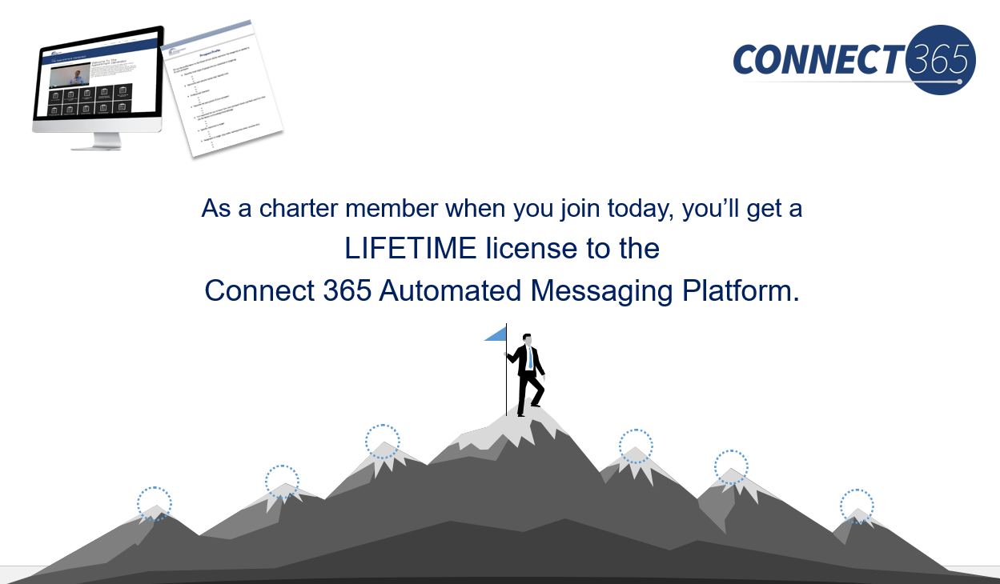
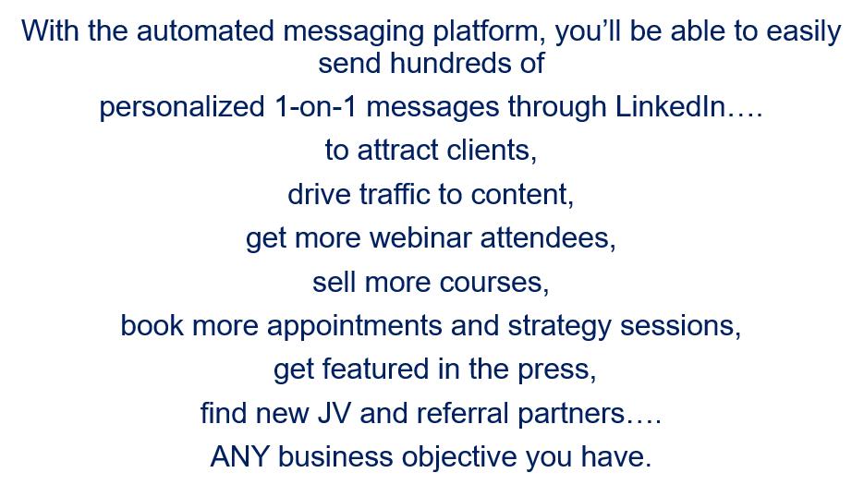
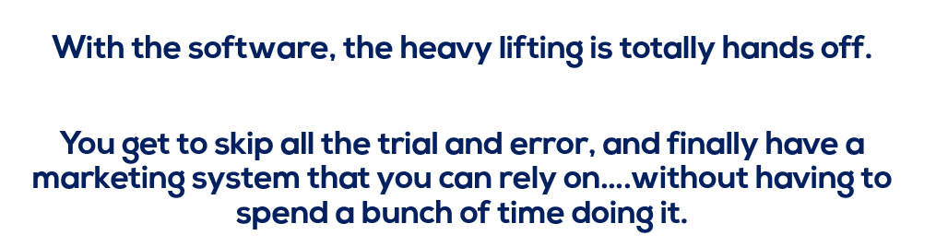
So, let me show you what it looks like…
…it’s a 4 step process…
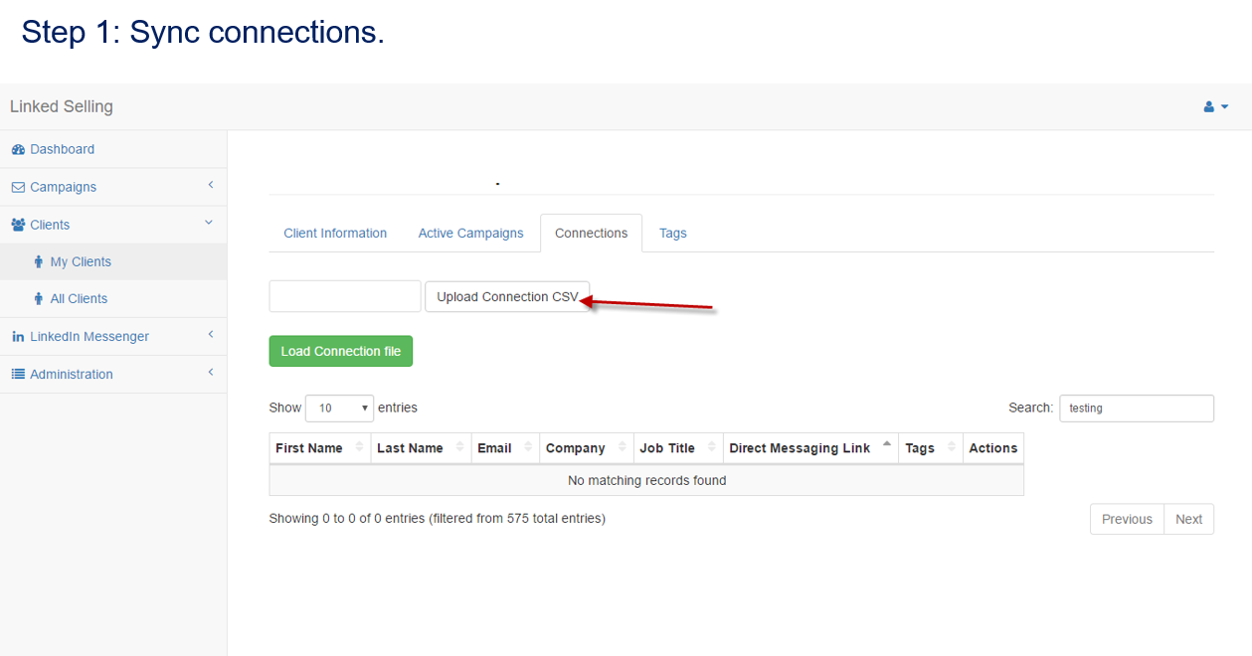

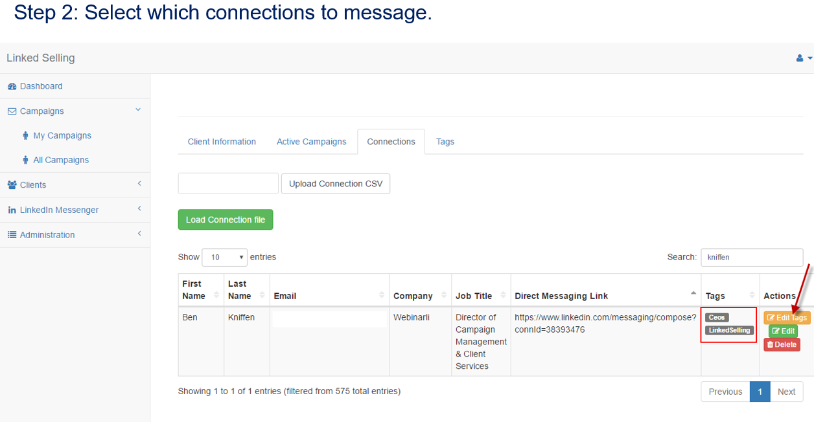
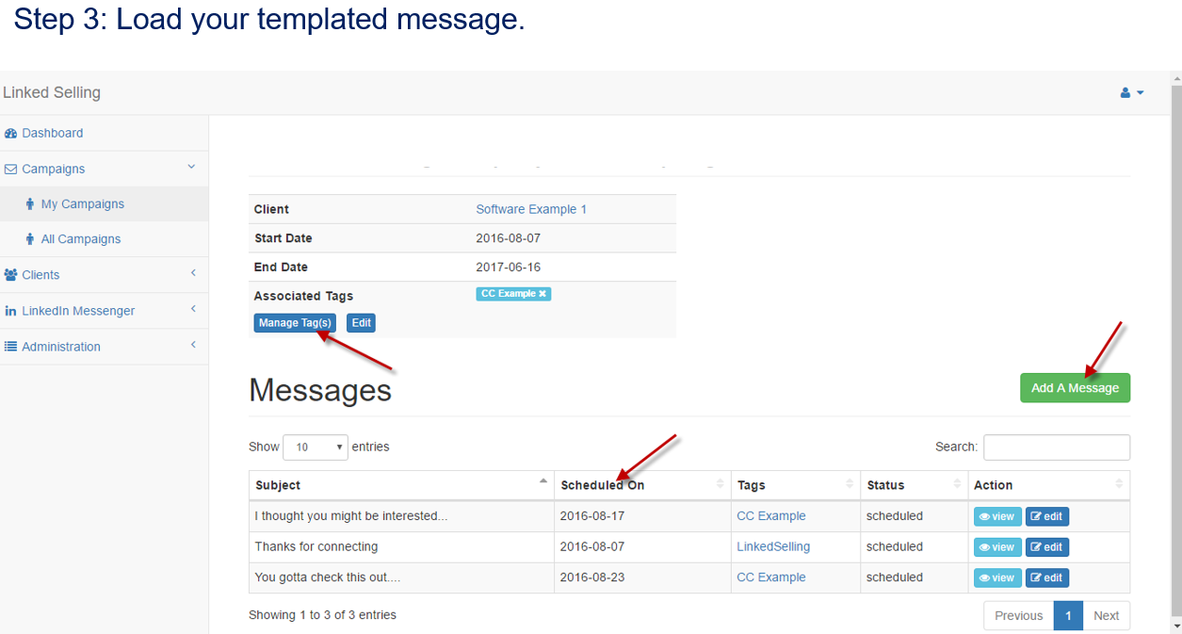

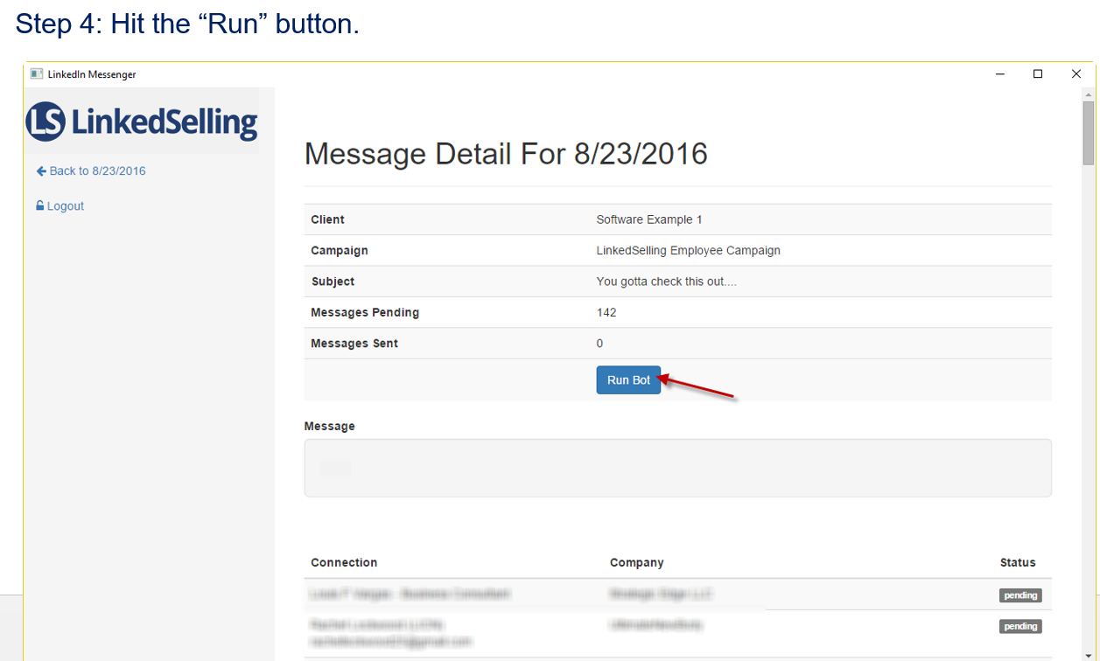
When we release this to the public, it will likely be at least $100/month on subscription. So if you think about the lifetime value or your LIFETIME license, we think it's worth every bit of $4,995.
And I know that you might have questions along the way, so we’re also including…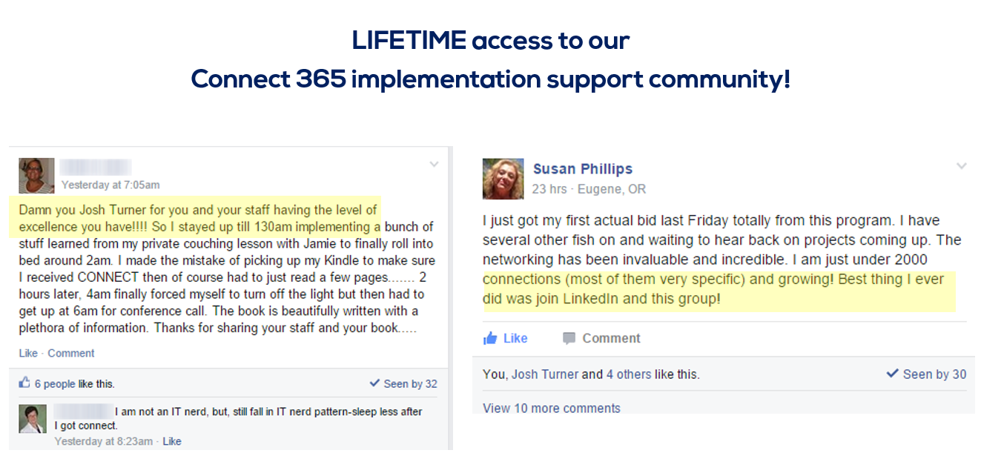
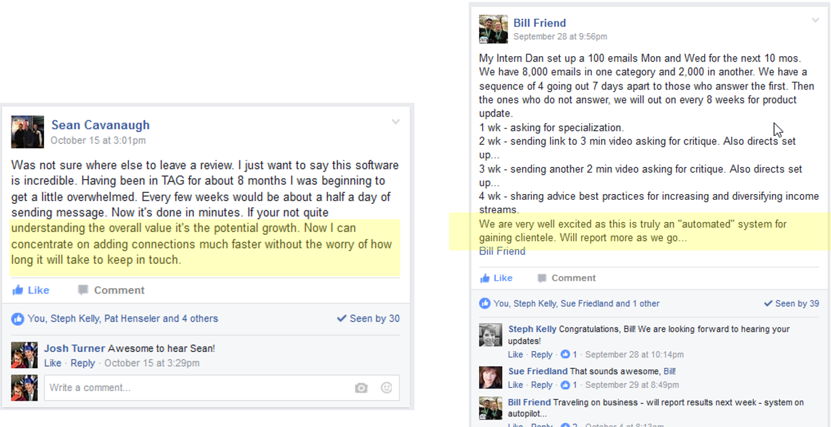
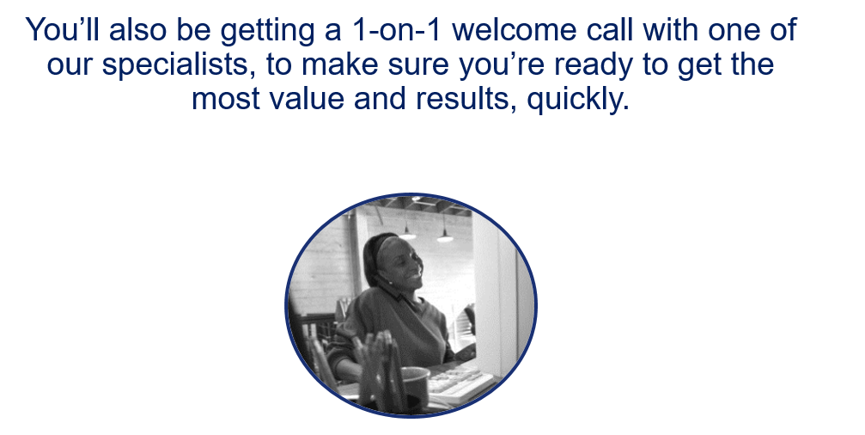
Plus we’re also going to reserve a…

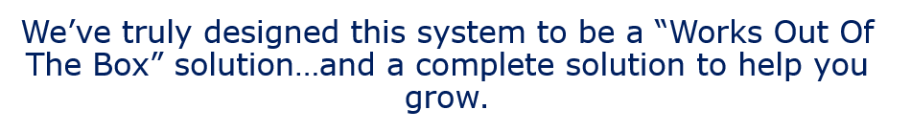
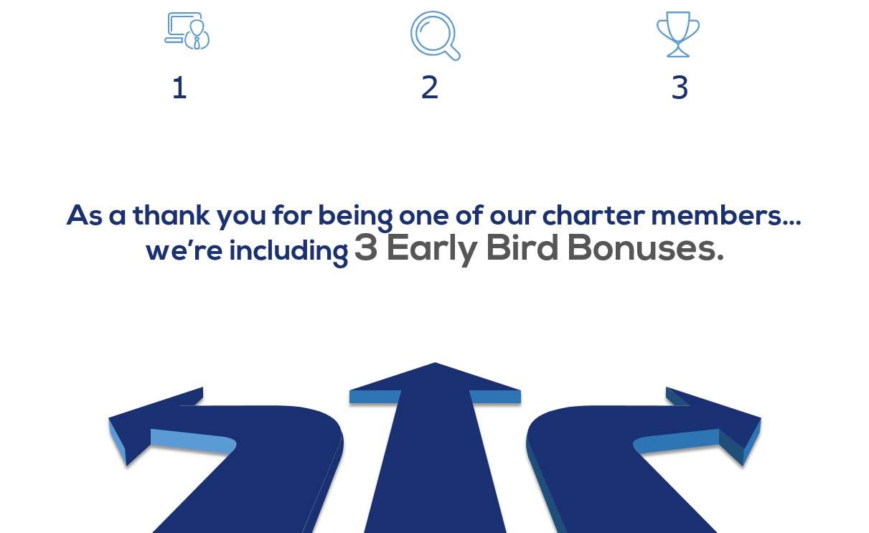

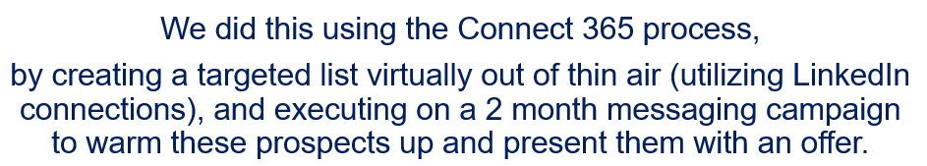
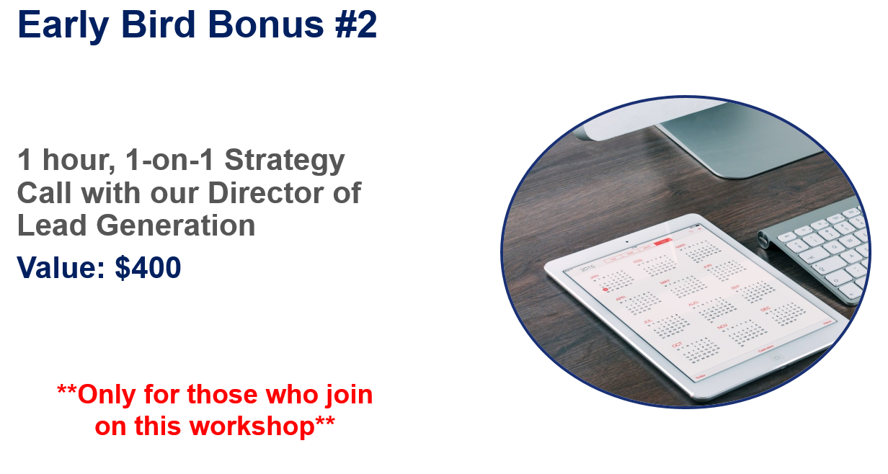
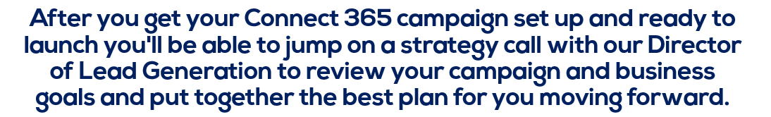
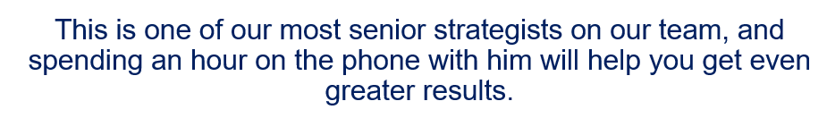
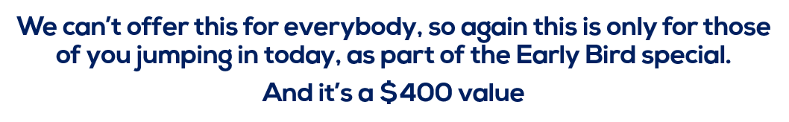
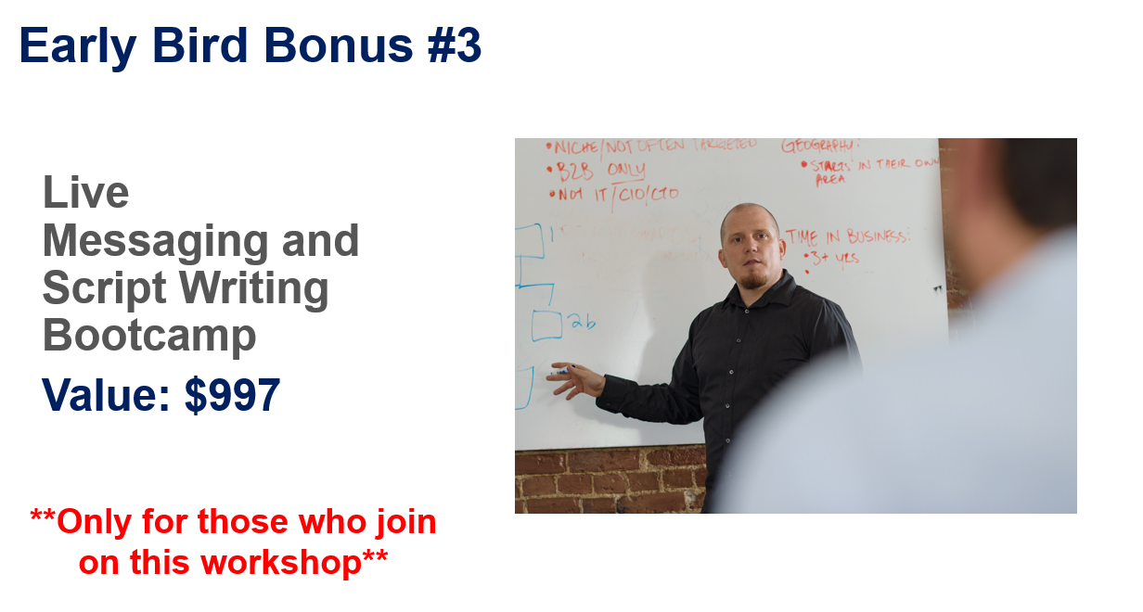
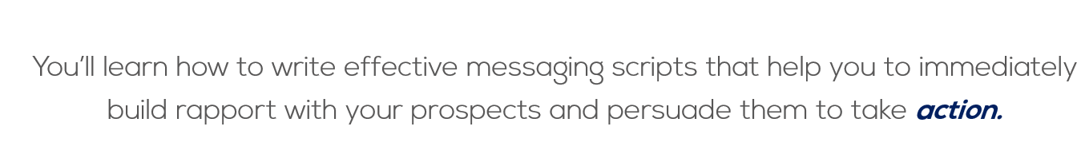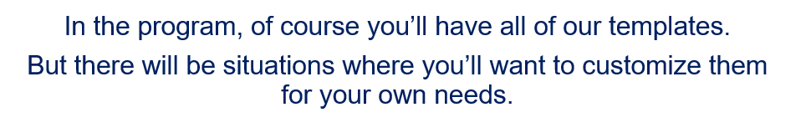
...and if you could see that as a possibility, then this script writing bootcamp will be HUGE for you.

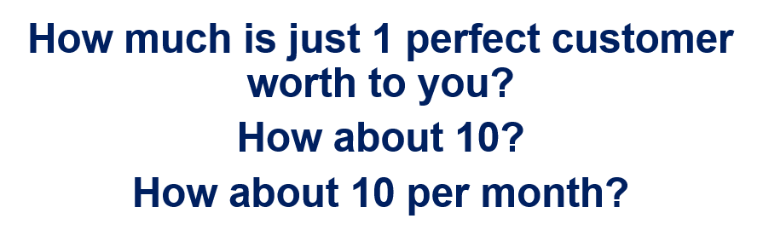
If you had an automated system for growing your business…what would that do you for you?
I’ve seen businesses pulled back from the absolute brink of disaster because they implemented our systems and started to see cash flow come back in.
And with the bonuses and the software to help you automate and scale your outreach, it’s a no brainer.
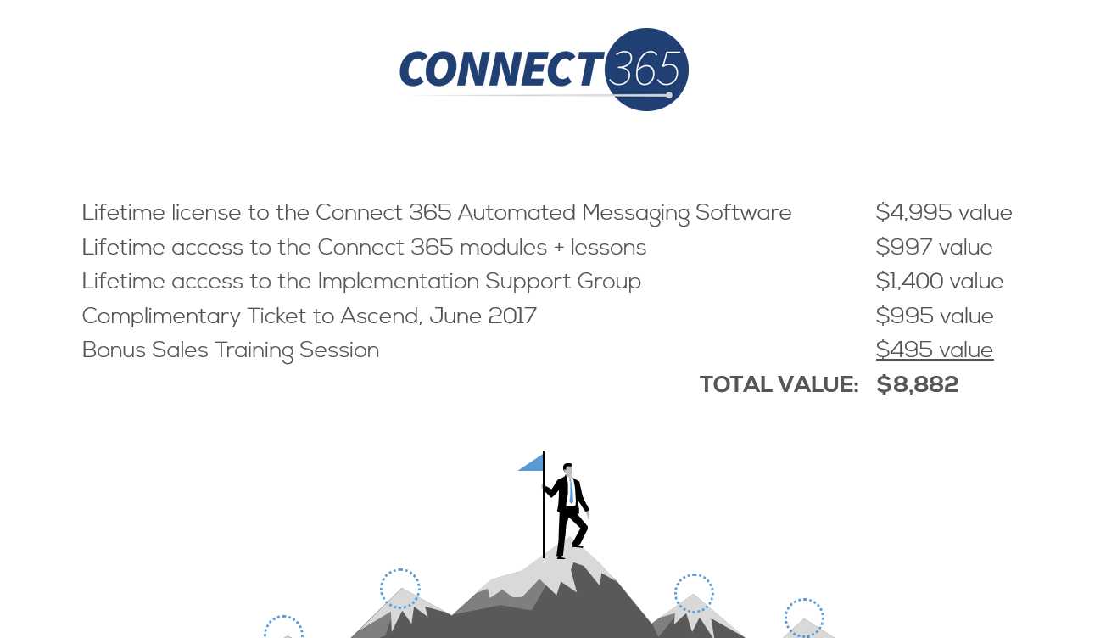
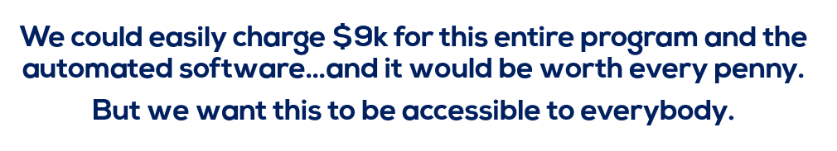


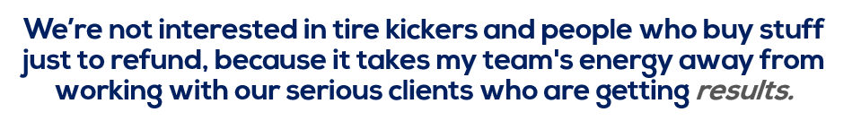
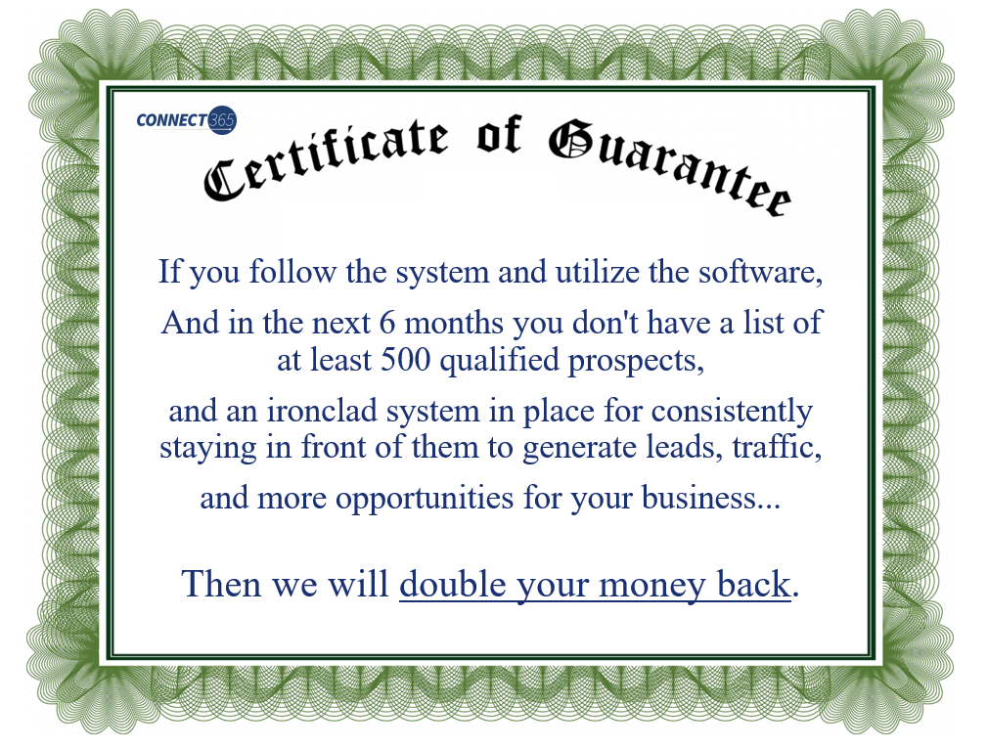
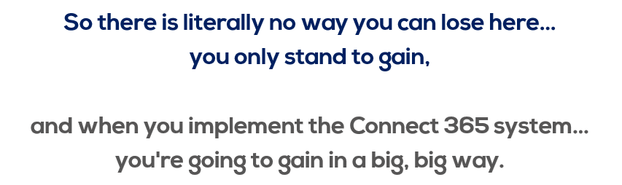
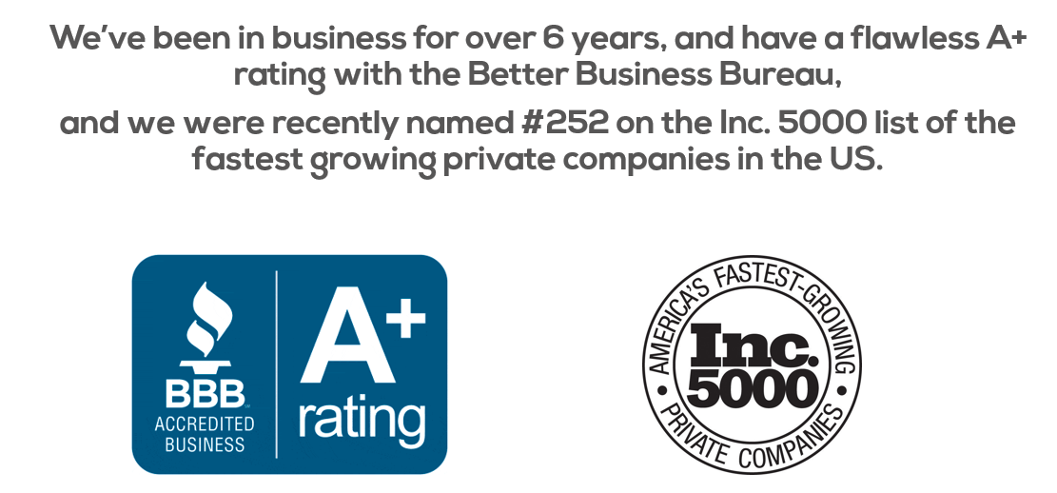
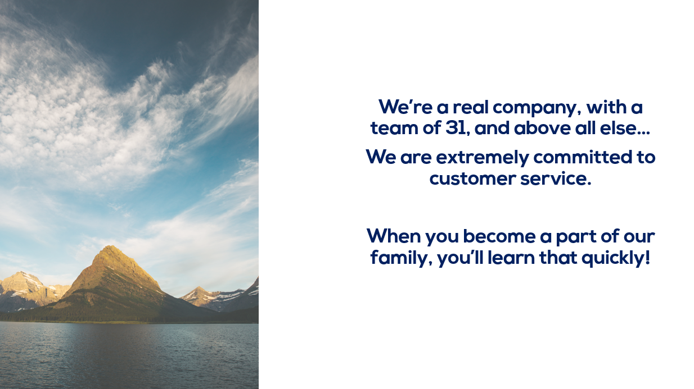
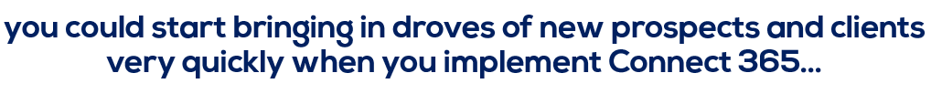
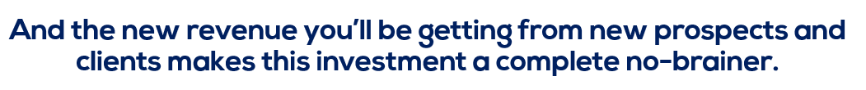You’ll be getting the entire Connect 365 training program…
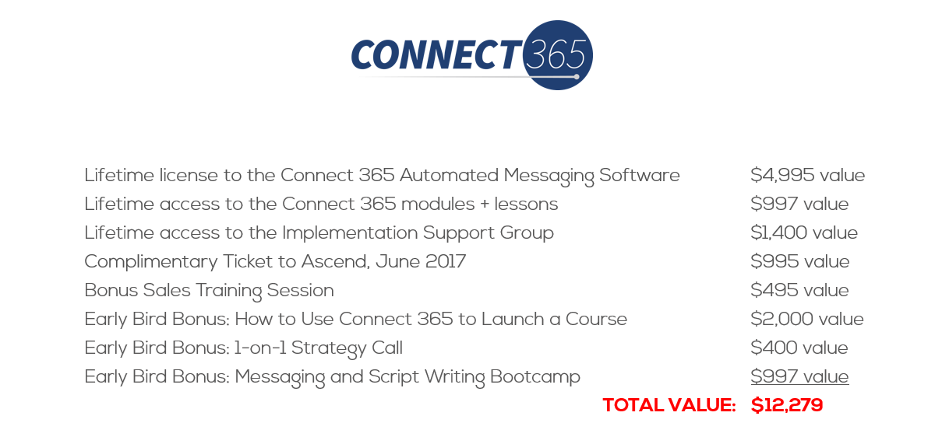

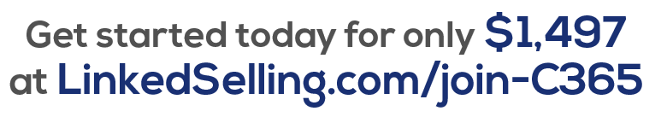

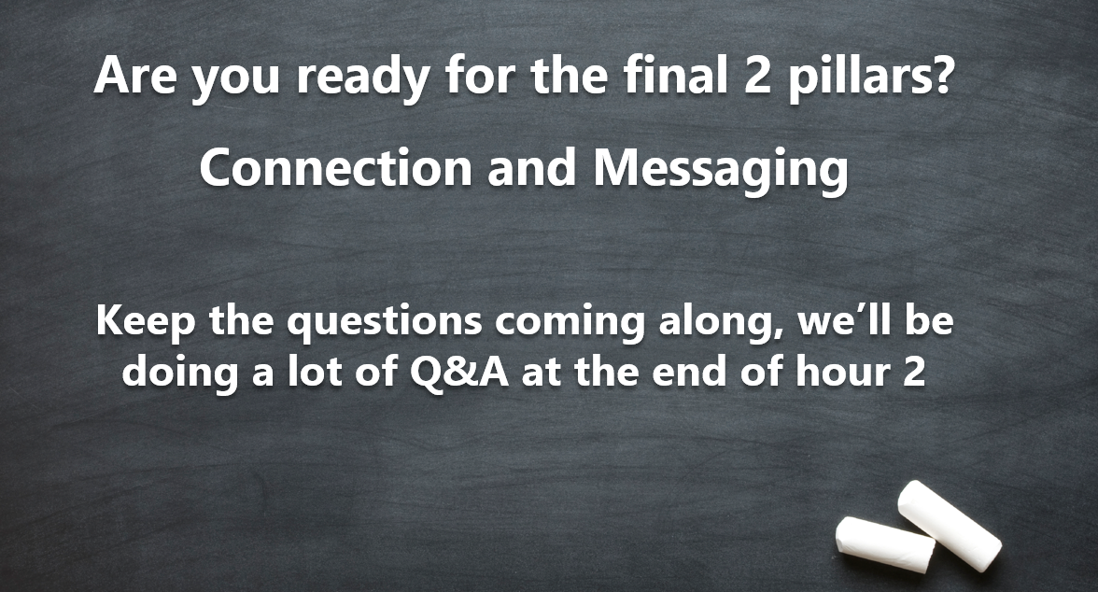
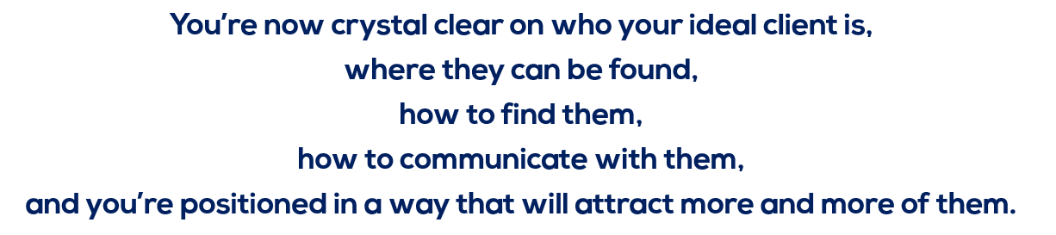
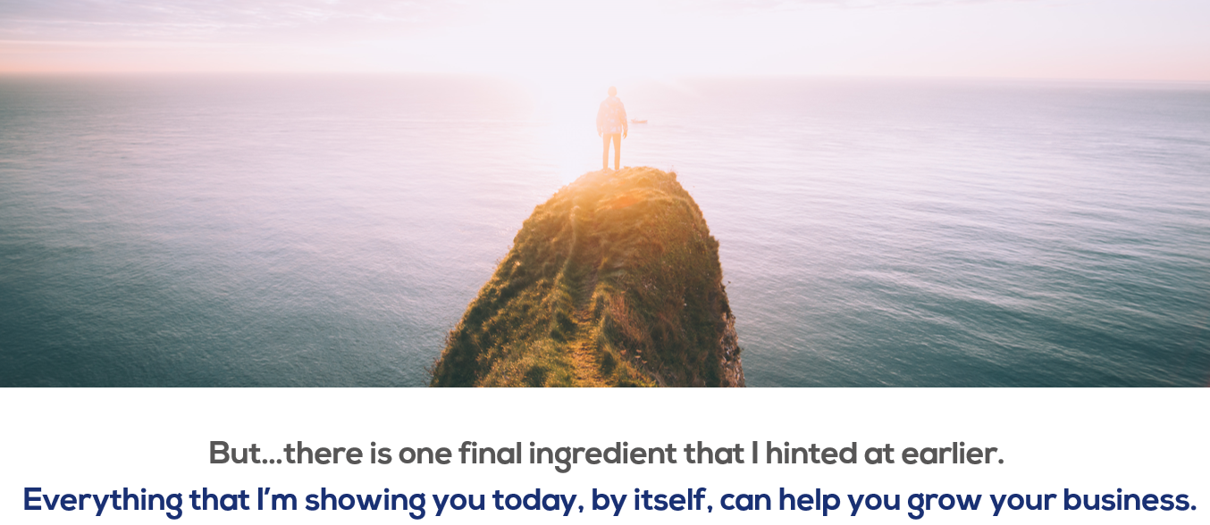
The missing ingredient that I’ve mentioned is TIME.
It takes TIME to do this work if you do it the old fashioned manual way, especially when you’re doing it on your own, without guidance or expertise.
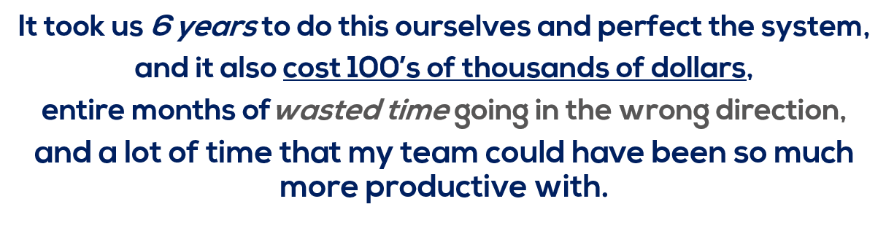
But it was all worth it, because we’ve solved the TIME problem.
Now I’m gonna show you how it works with the Connection and Messaging phases of the system, and the software that comes with Connect 365.
Step 1:
Create your individual Buyer Personas and your company’s Brand Identity.
Step 2:
Position yourself for success by tightening up your profile, focusing on what the buyer wants and needs, and proving your authority (without coming off weird or salesy).
Step 3:
Target your Buyer Personas on LinkedIn with accuracy and weed out prospects that don’t fit.

So these first 3 phases, they go SUPER quick.

And then once you’ve found them, you’re ready to start:

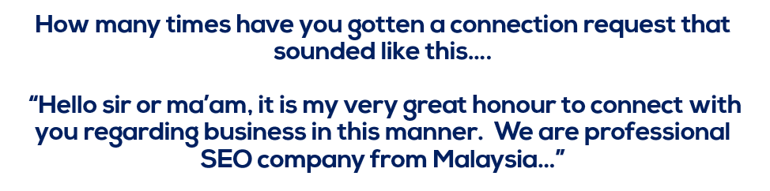
It’s no great secret that unsolicited invitations are viewed with some level of suspicion…
“What’s this person’s angle?”
Just look at your own reaction to unsolicited invites.
ESPECIALLY on LinkedIn, where the environment is more professional and everyone is on there to do business, it’s really important to control how you’re perceived.

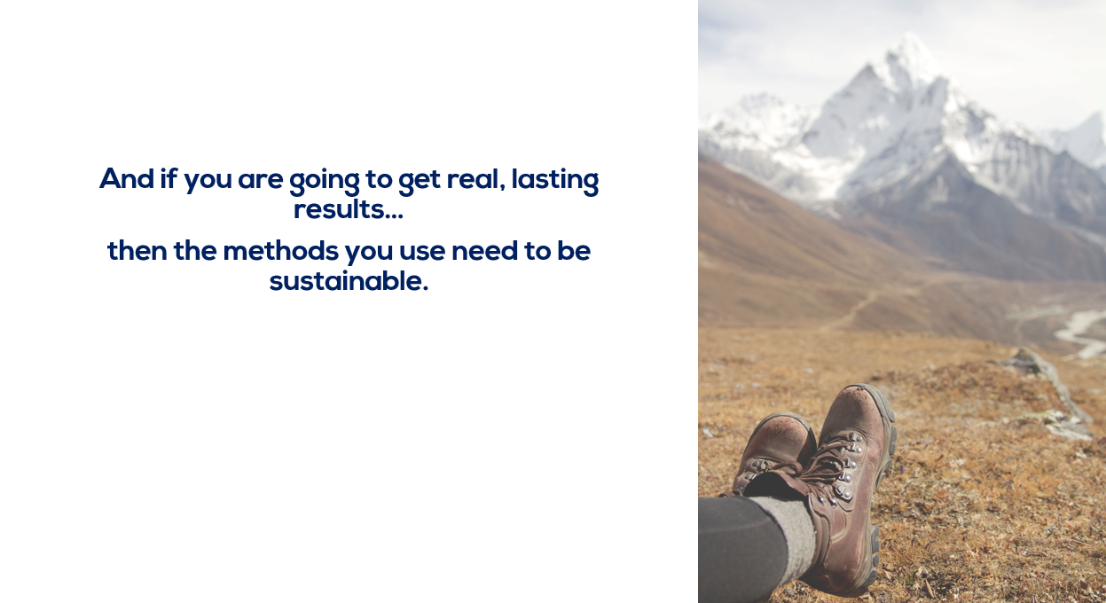

You can’t burn through all of your connections.
ESPECIALLY on a more intimate and relationship focused platform like LinkedIn.
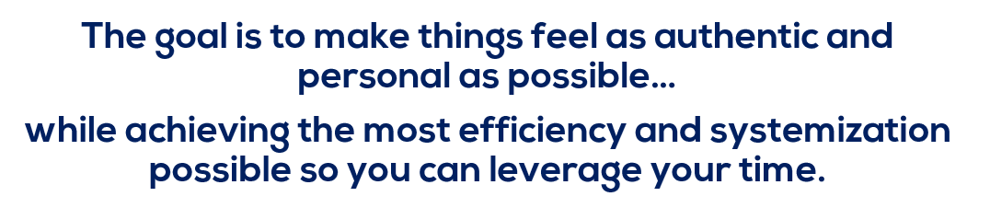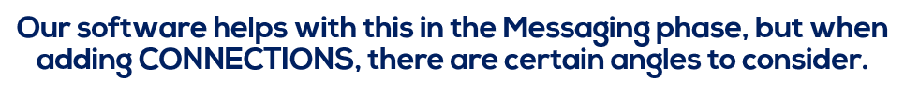
When connecting, it’s often best to be upfront about why you’re reaching out.
It might sound counter-intuitive, but think about it, if you see an invitation from someone you don’t know, you’re immediately thinking…
“Who is this person and what do they want?”
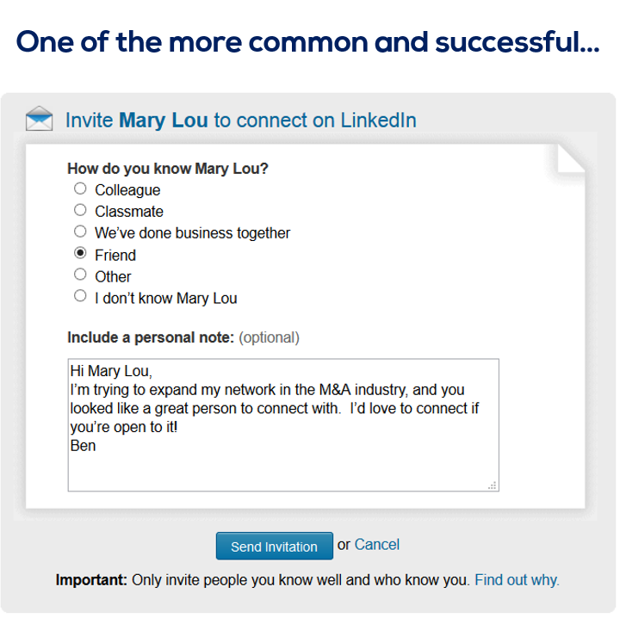
Short, simple, straightforward. You just told them exactly why you were reaching out…no veiled intentions. When you do that, people drop their guard…even if they were suspicious initially.
Here’s another example…
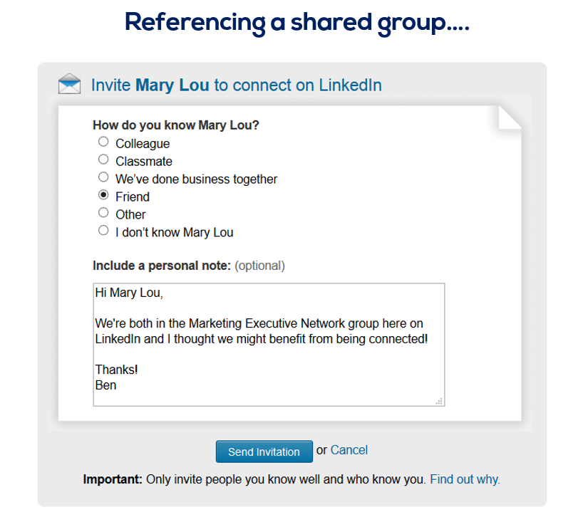
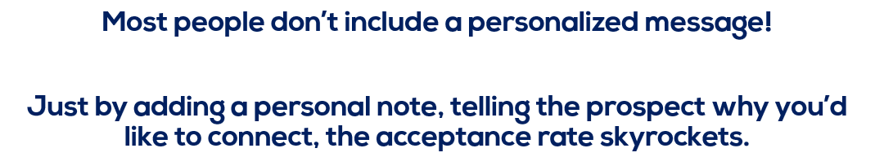
This the same system that all the clients I’ve told you about today have used….but they didn’t have the advantage you will have…because they didn’t have the software.

Like Tom Swip here…
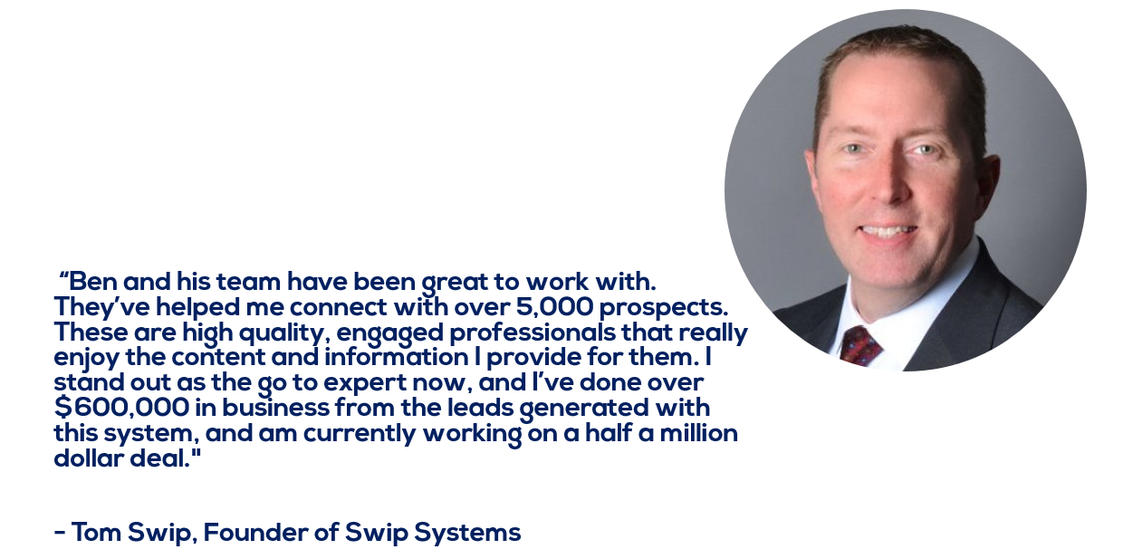
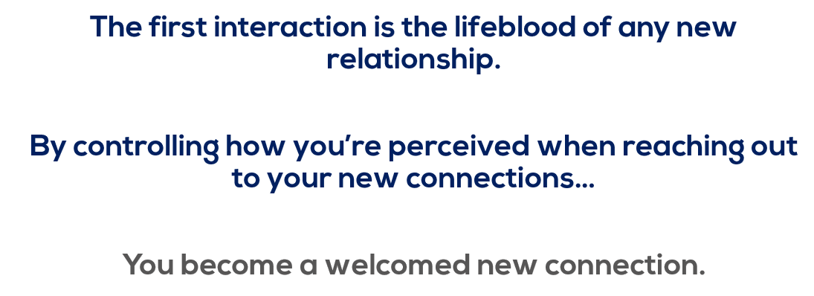
And when you follow the system, in this phase you’ll end up adding hundreds of targeted connections…in a very short amount of time.

Which then gives you an amazing database of potential clients to start working through the …

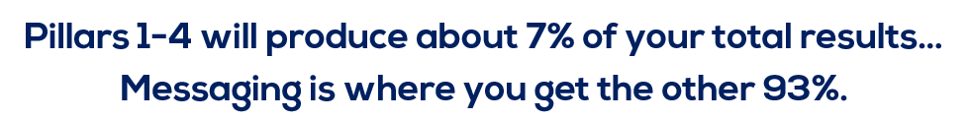
Dozens of studies show that only about 2-3% of all sales are made on the first contact…and nearly 60-70%, depending on the industry, are made after the 5th attempt.
But most people never follow up. If they do, they certainly don’t do it the right way.
By doing the upfront work with the first 4 pillars…
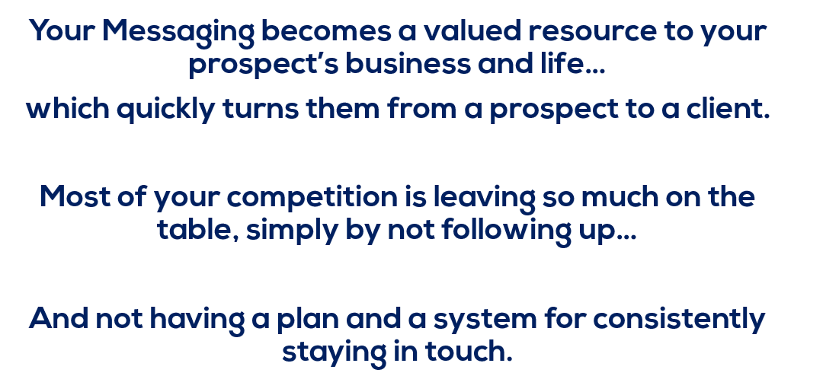

Think about your closest competition…
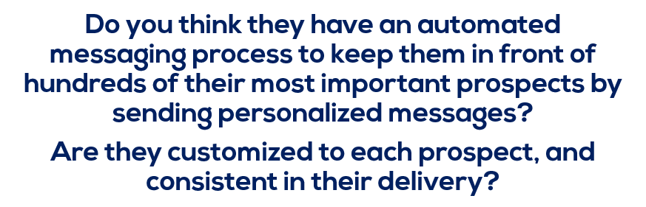
No…of course not, very few do.
So when it comes to the MESSAGING phase, we have a library of…
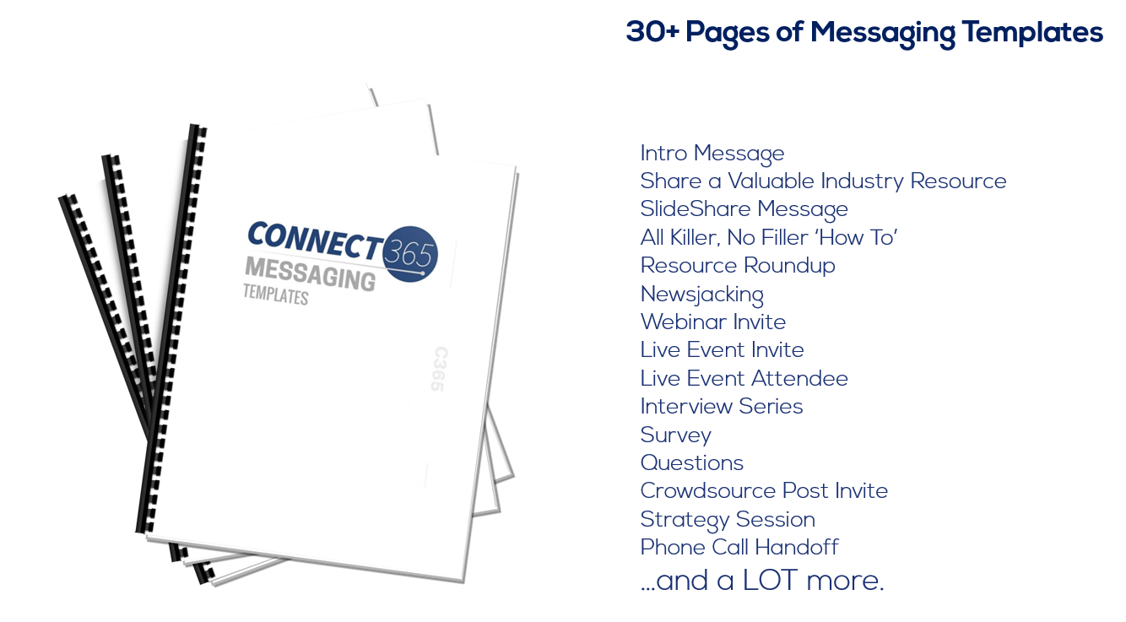
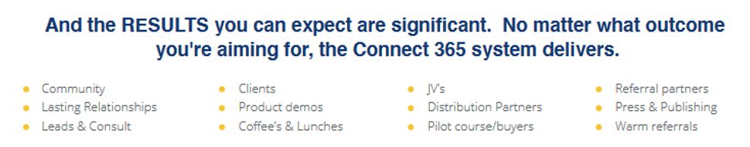
Now, let’s dive into a couple examples of the messaging…
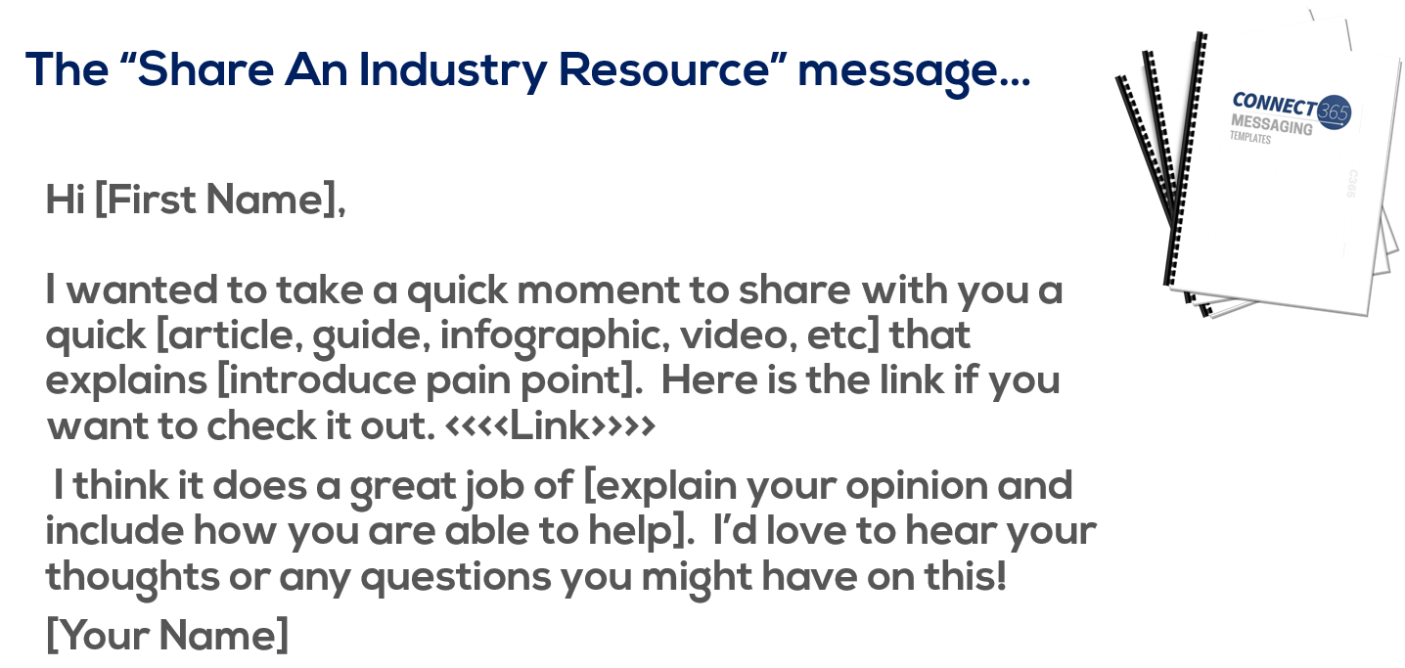

Here’s why it works so well…
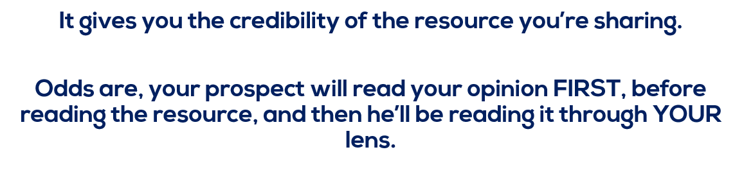
Now, the second message I want to share with you today is…
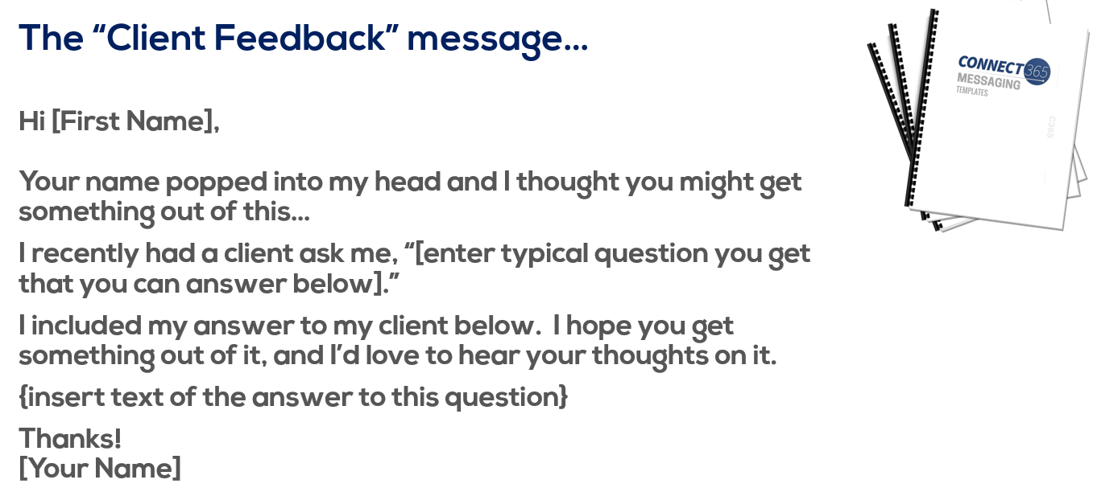
This one works so well because you’re doing three key things:
- You’re providing them with good valuable content.
- You’re doing it in a way that’s informal and conversational.
- You’re demonstrating that you’re working with clients just like them and helping them solve problems!!

Here’s one more for today, and we call this the…
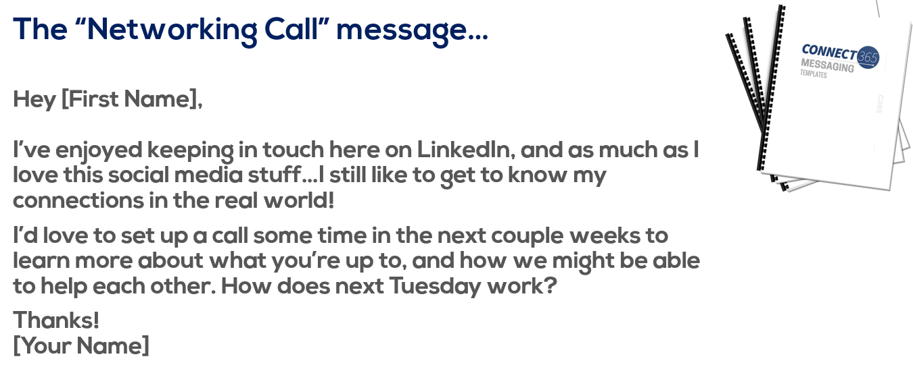
When you have conversational, relevant messaging that adds value to your prospects…and you’re staying in front of them regularly, so that they start to really know, like and trust you.
THEN, when every once in a while you slip in something a bit more promotional, or maybe you offer to schedule a strategy session, or meet up for coffee….they are EXTREMELY open to it.
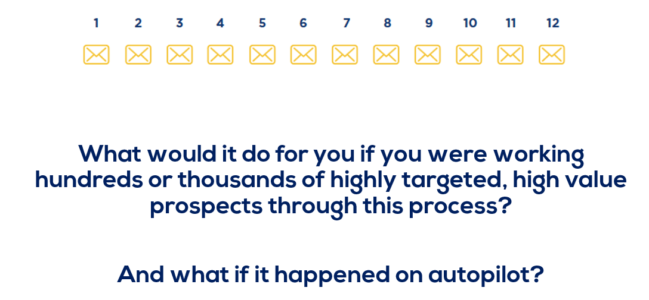
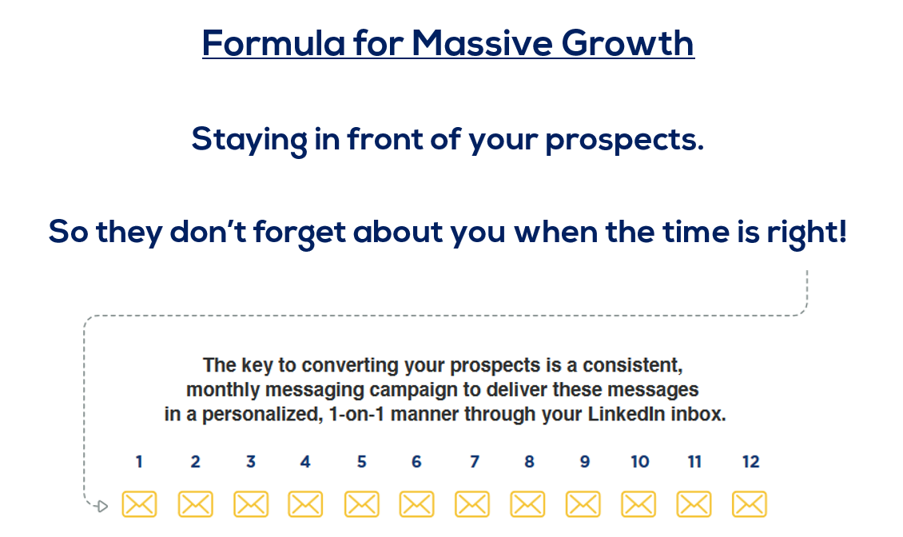
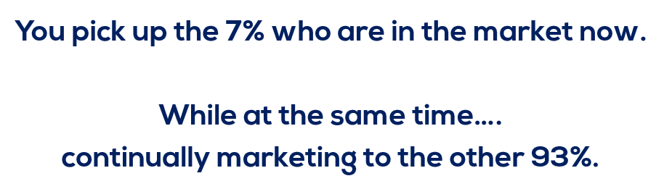
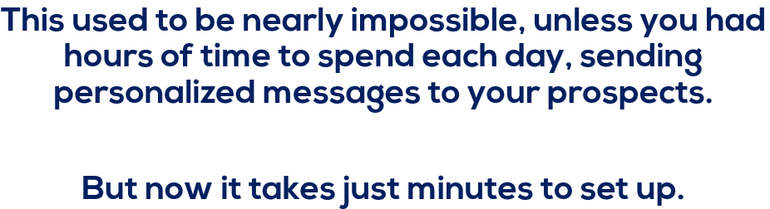

It’s worked for so many of our clients, people like Dan Demers….who has completely changed his business with this system.
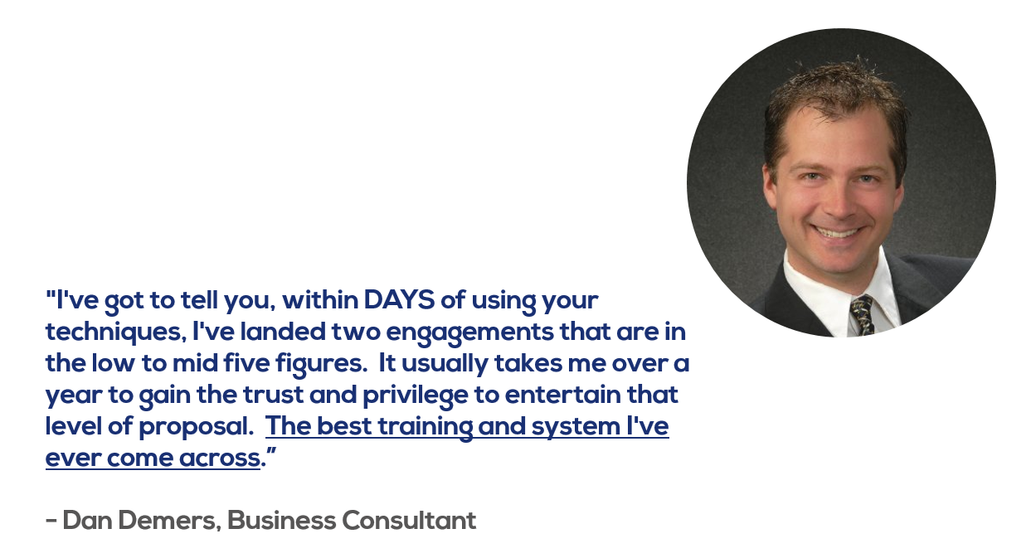
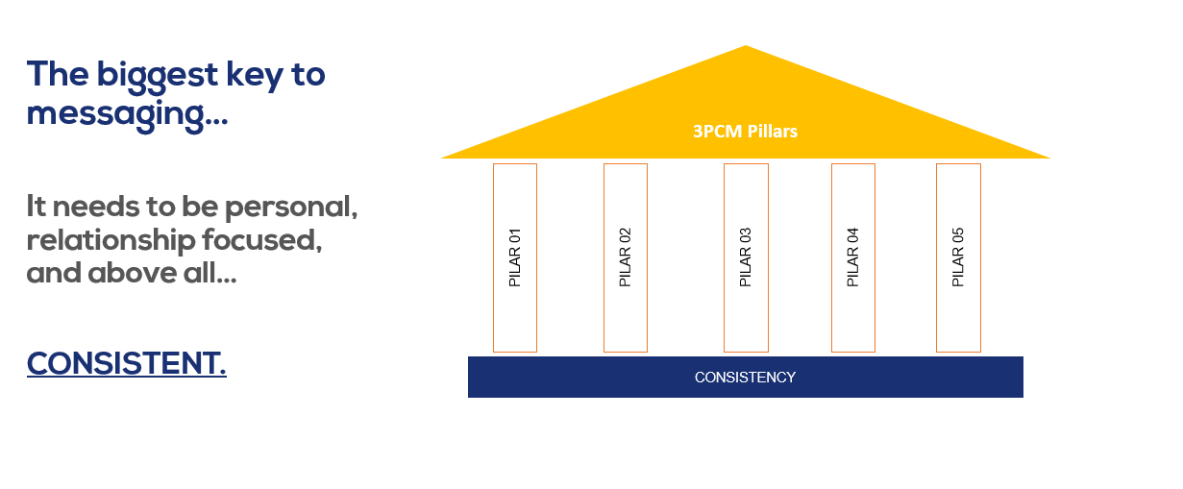
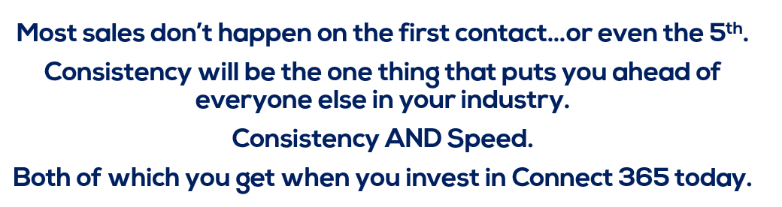
So let me show you exactly what the messaging software looks like, and it’s really pretty straightforward…it’s really just a 4 step process.
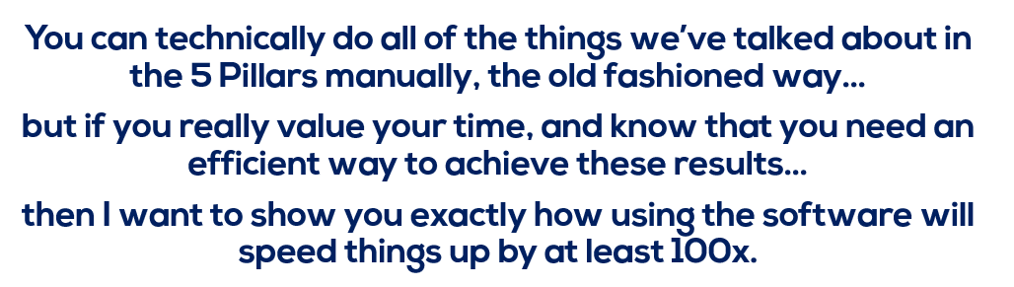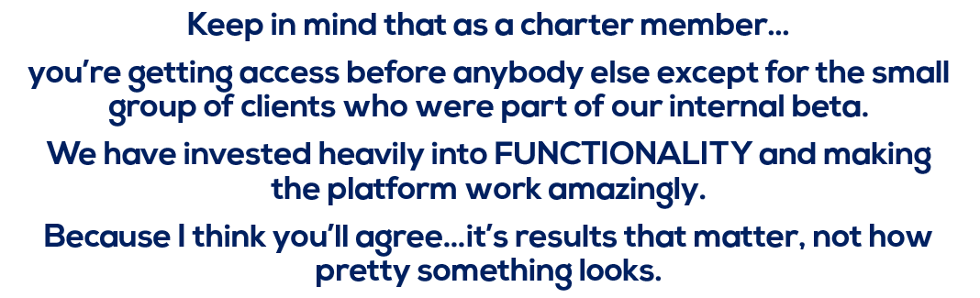
So here’s how it works:

The only question is HOW you’re going to use it. Because you can’t NOT use this information.




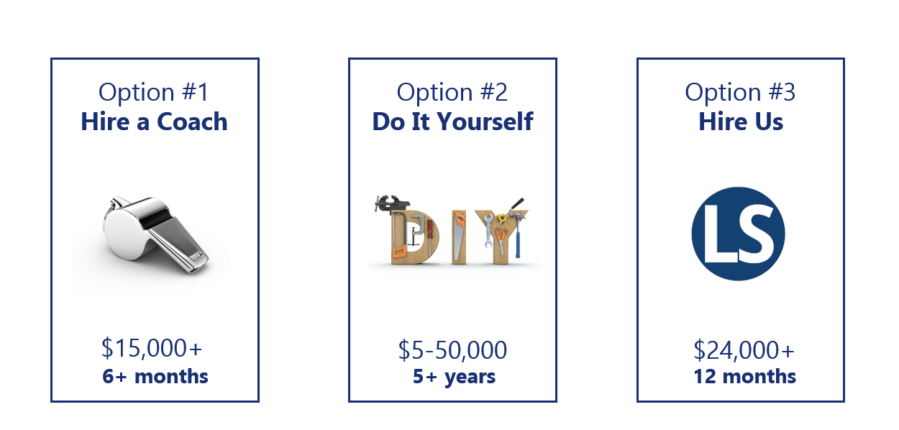

The fourth option is to join us today in Connect 365.
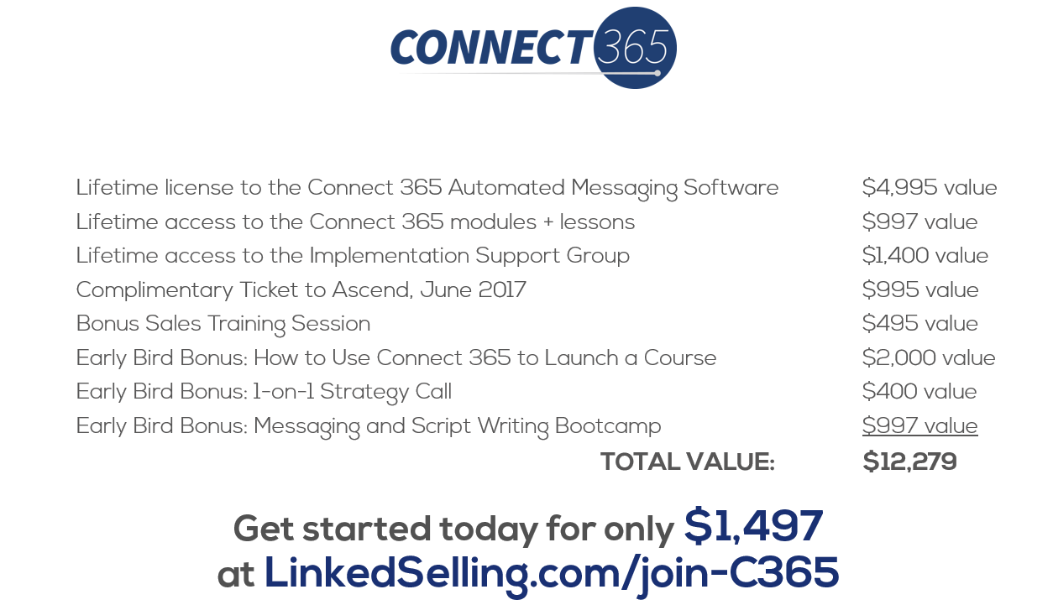
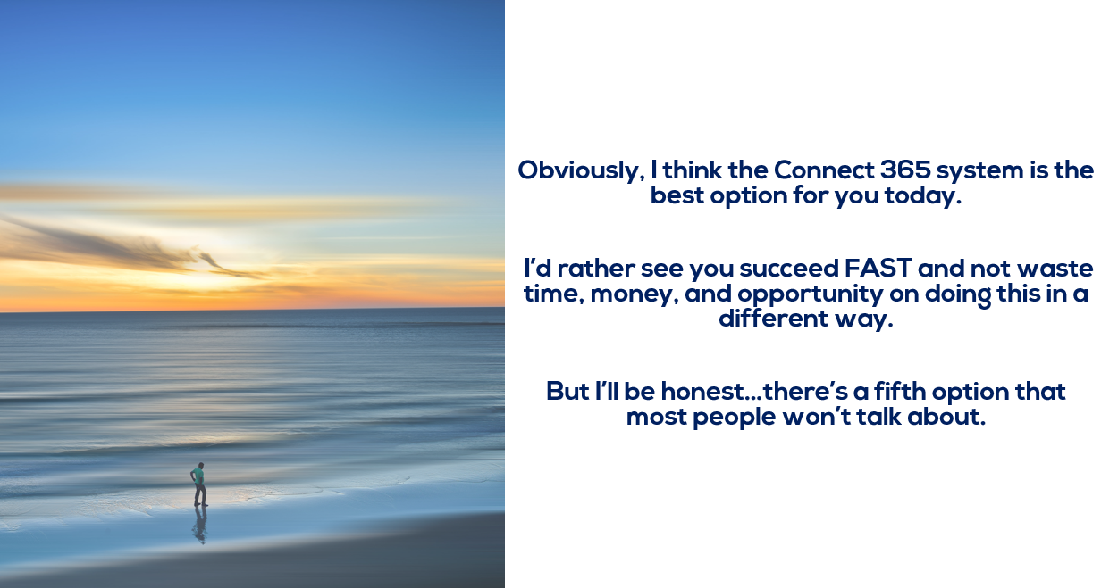
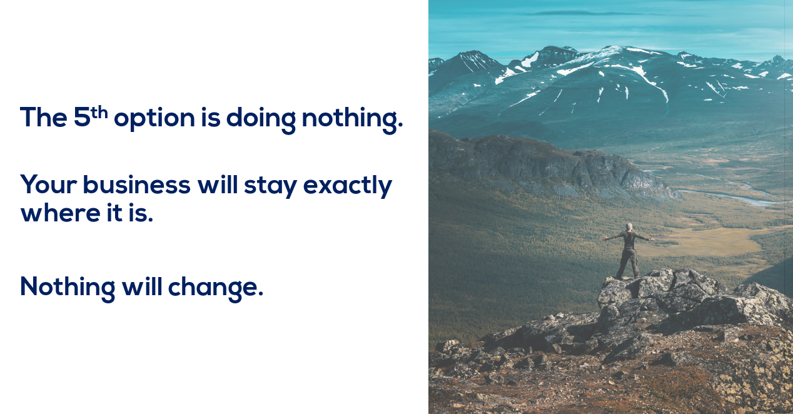
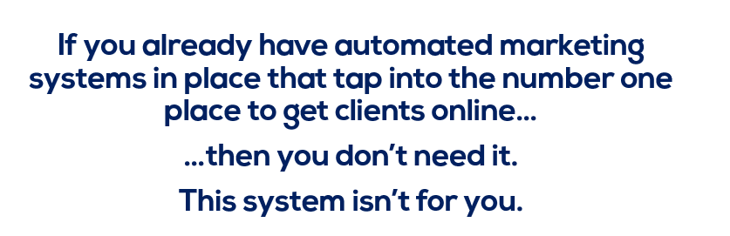.
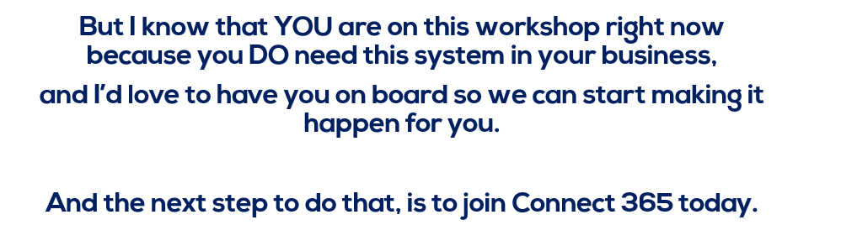
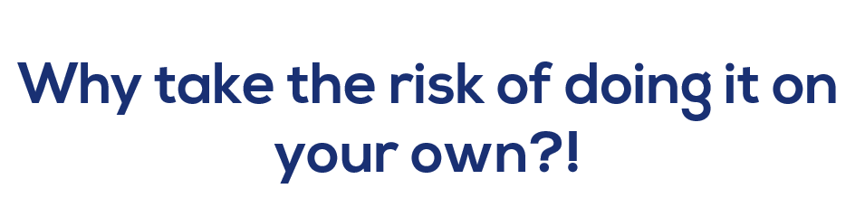

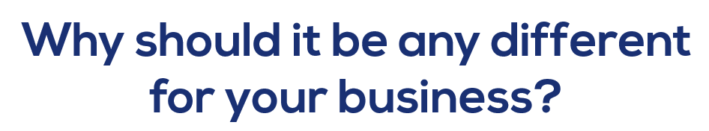

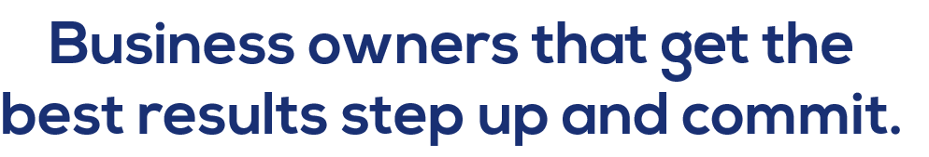
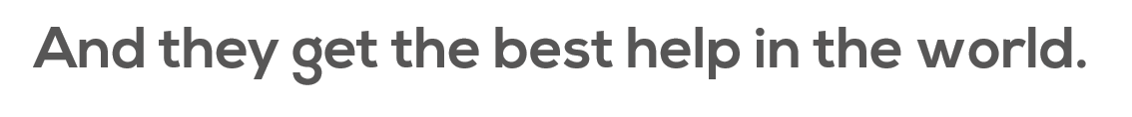
And you can start seeing results like all these other clients of ours have gotten…

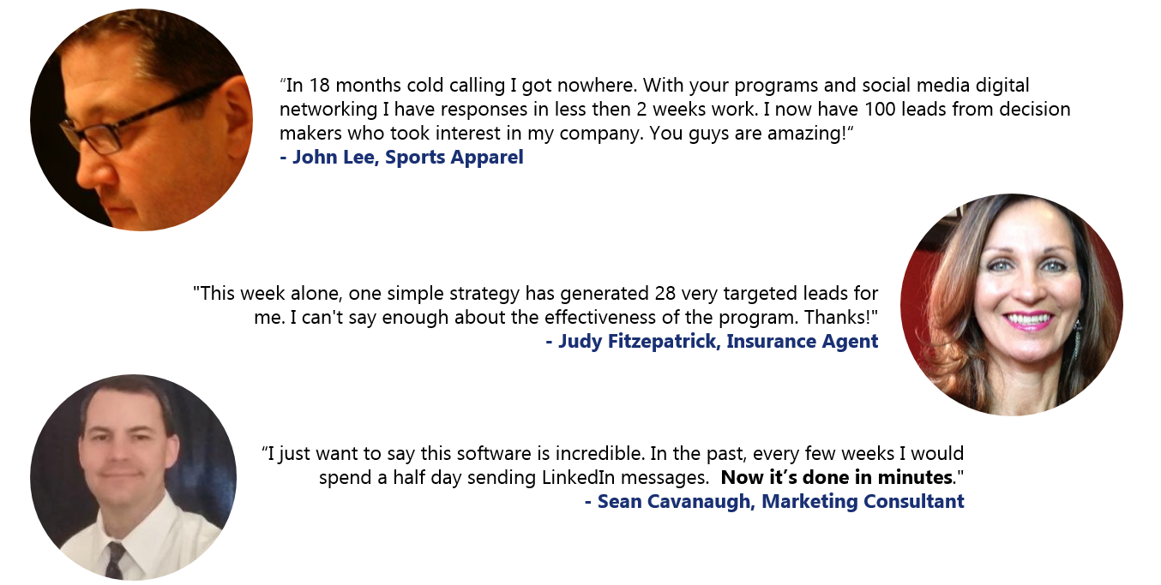
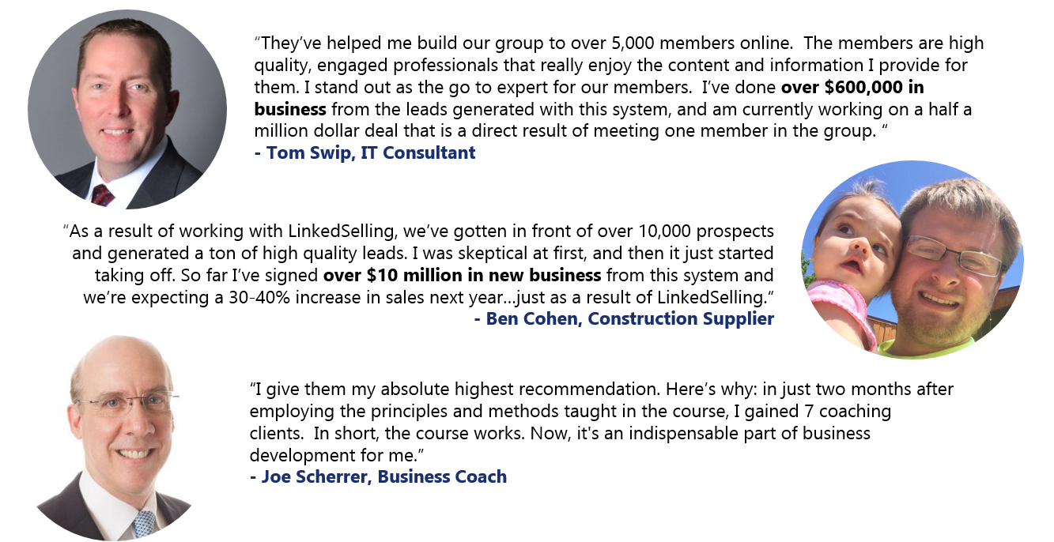
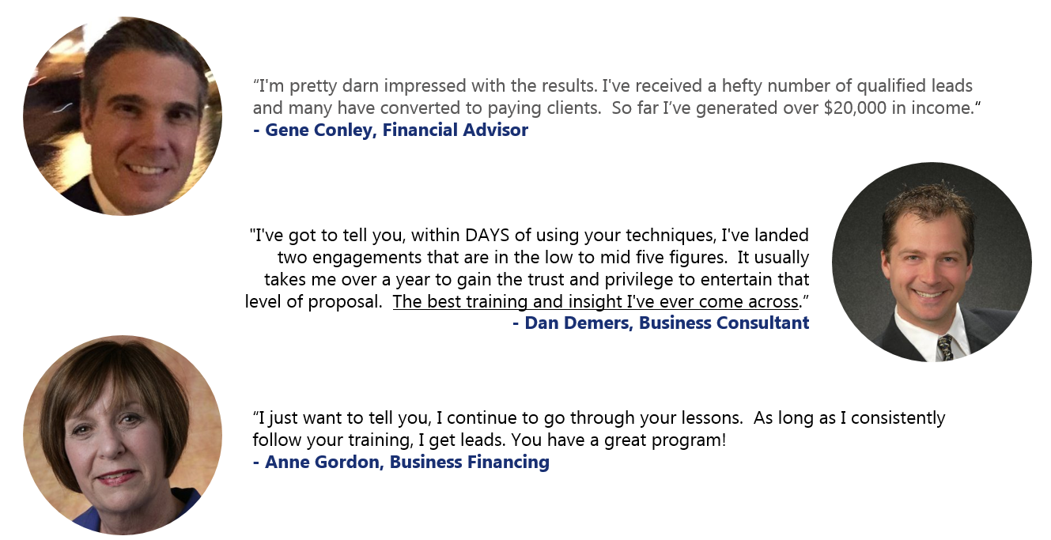
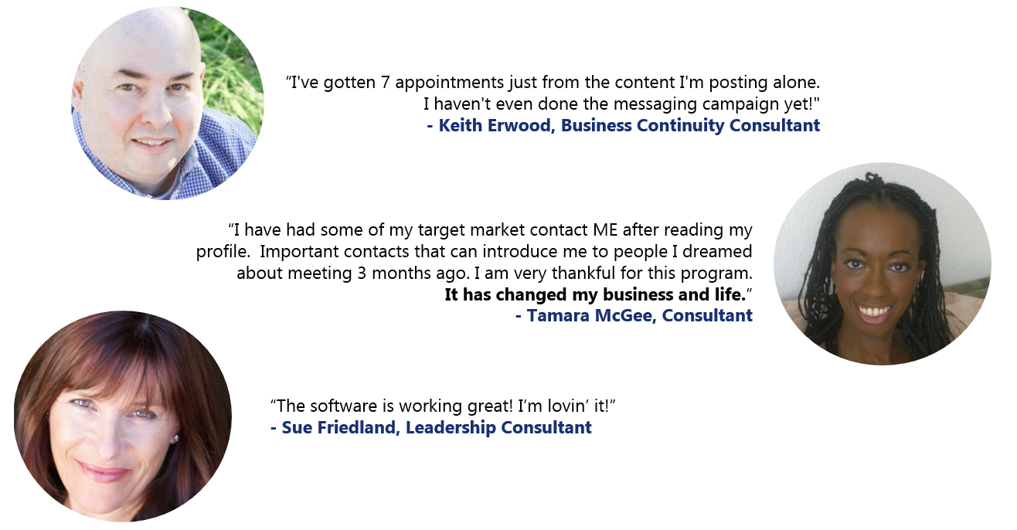
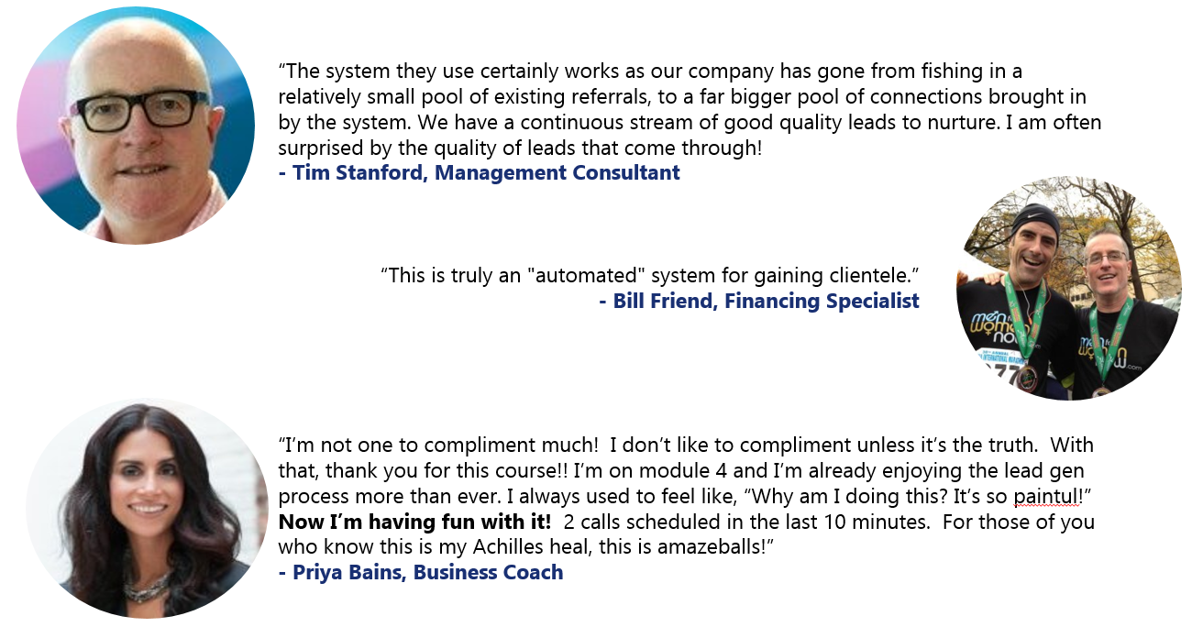
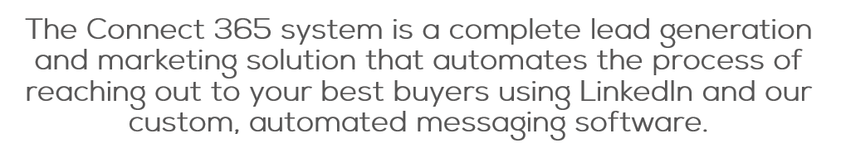
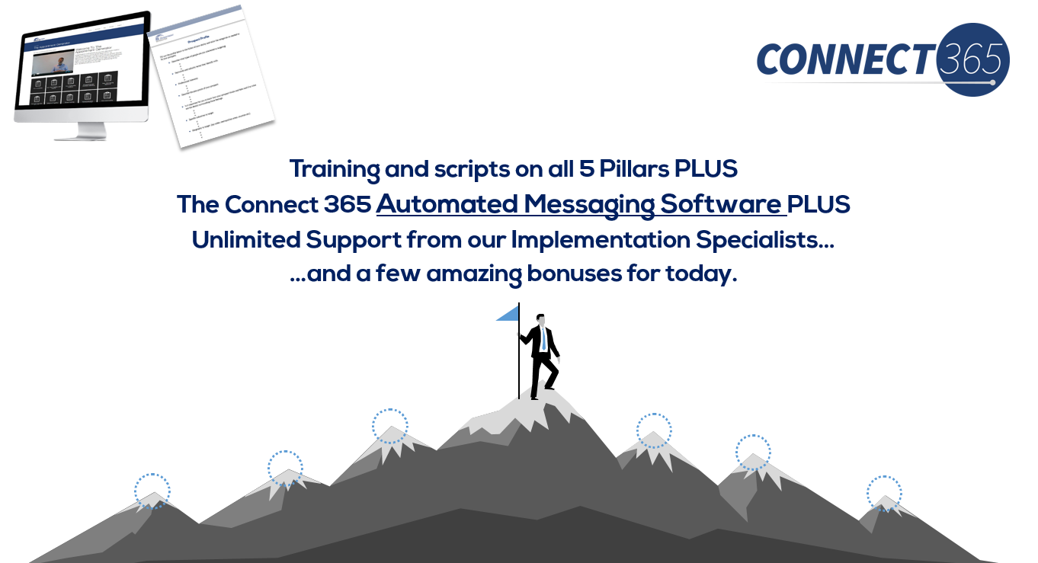
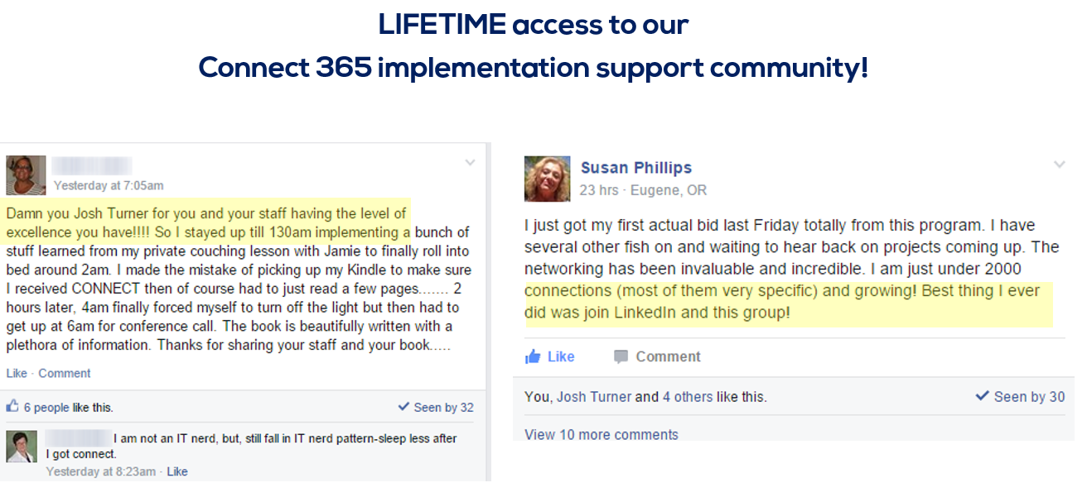
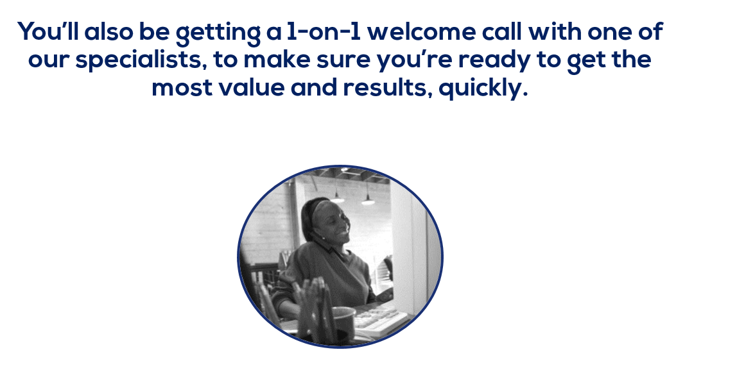

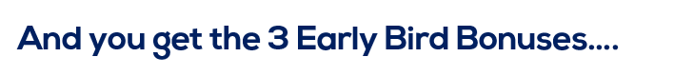
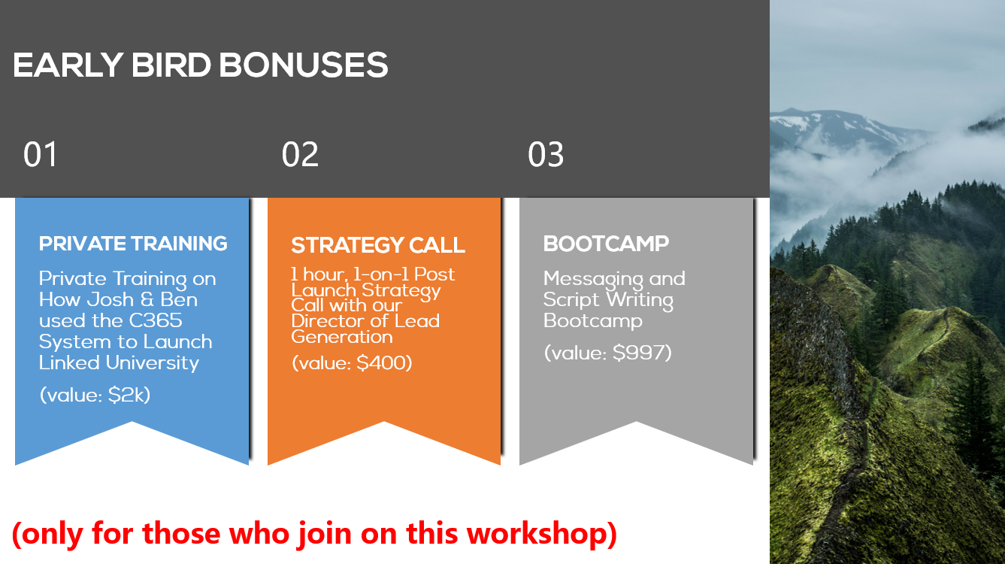
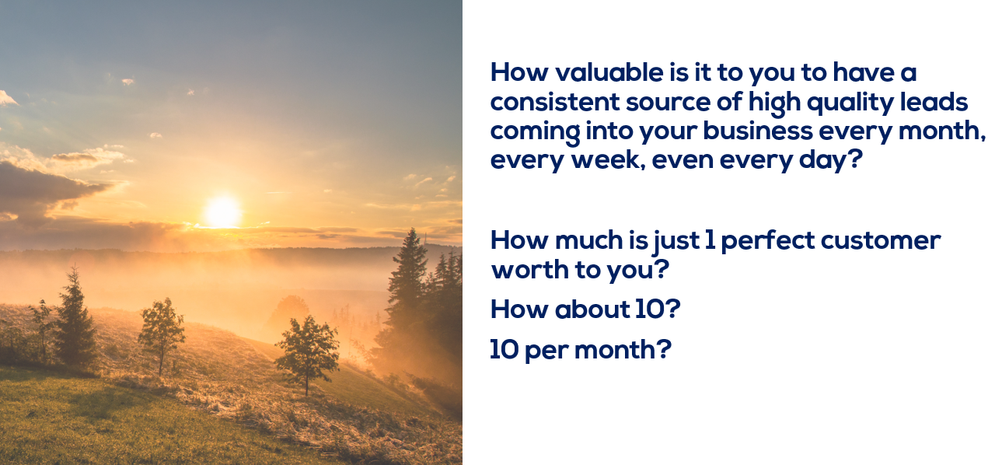

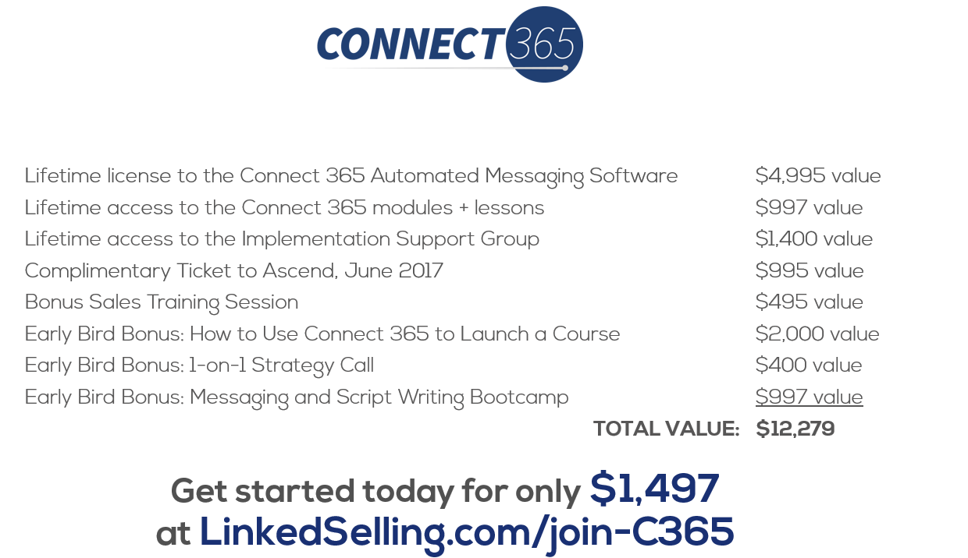
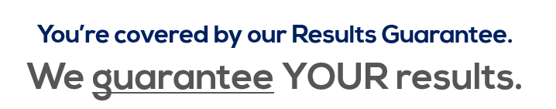
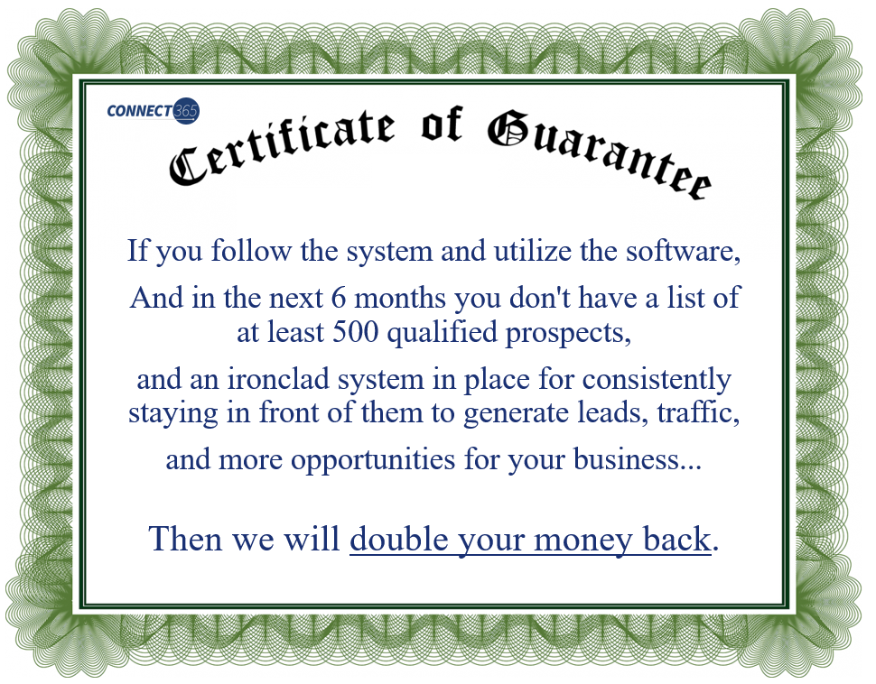
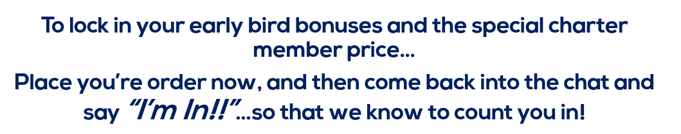
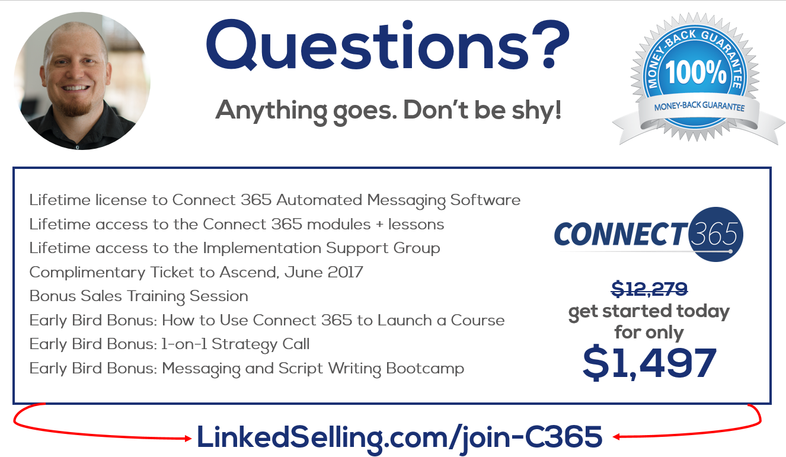
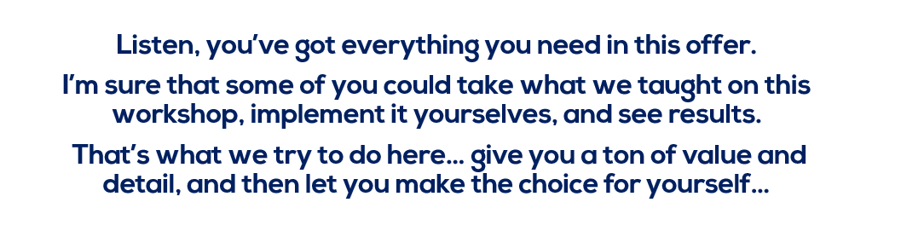
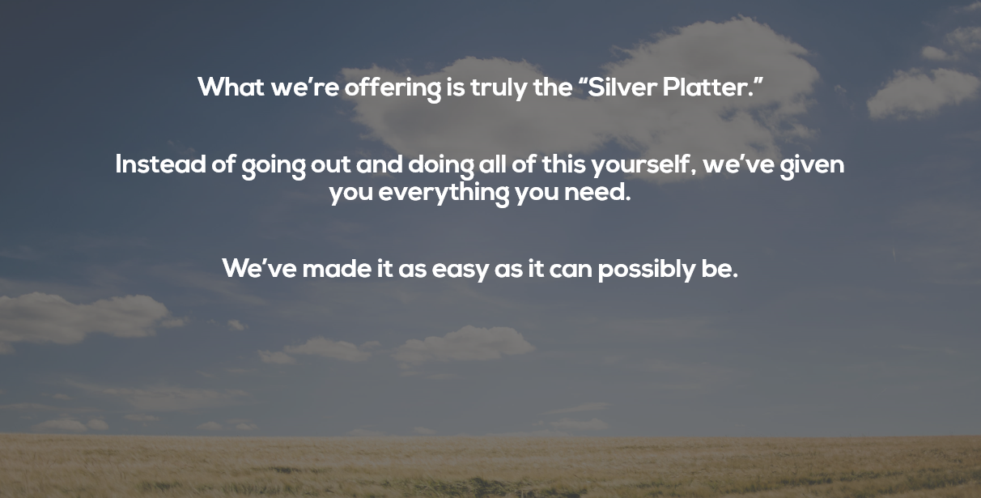
The only real question is: 