All About Groups FAQ Workbook

Do I need to join 100 groups? Why or why not?

You certainly do not have to join 100 groups. The important thing is to join groups that your client’s prospects are in. Joining a client into groups where their prospects are, opens up various avenues to network and connect with those prospects. Again, the number of groups we can get our client in is not the important thing here, but the type of groups we want our client to join.

What should I do if I have 10 pending group membership requests and haven’t been accepted into any?
- If you have 10 pending requests out and you’ve not been accepted to any yet, there are a few things you can do.
  - You can message the group owner or manager and ask them to accept your request.
  - You can see if you have a 1st degree connection that is a member of the group and ask them to invite you to the group. NOTE – when invited to a group, you DO NOT need to be approved by the group owner or manager.
  - You can withdraw your request, and try joining the group at a later date OR finding another – there are lots of fish in the sea.

What is the “discovery” section on the group timeline page?
- The discovery section on the group timeline page is simply a section where LI will recommend groups that you would be interested in based on the type of groups you are a member of. 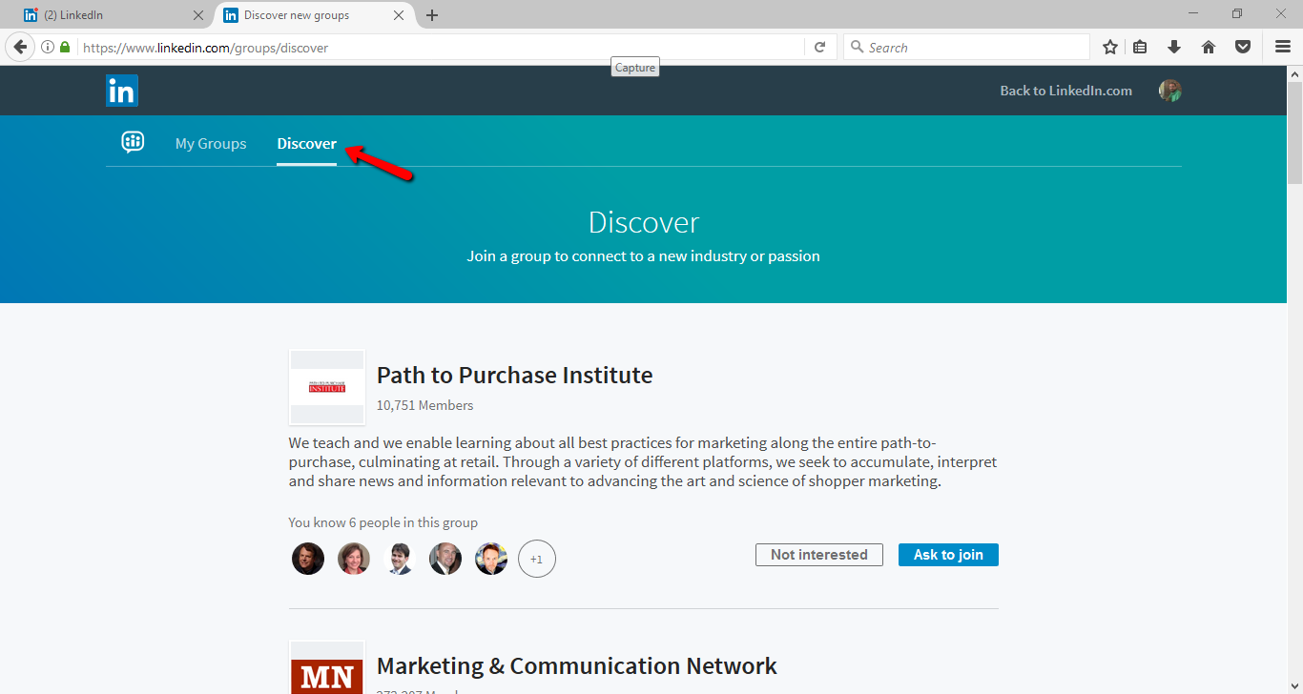

How can I leave a group that I don’t want to be in?
- There are a couple ways you can leave a group.
  - From the “My Groups” page, you can click on the group settings button and in the dropdown box, and “leave group” will be an option you can select.
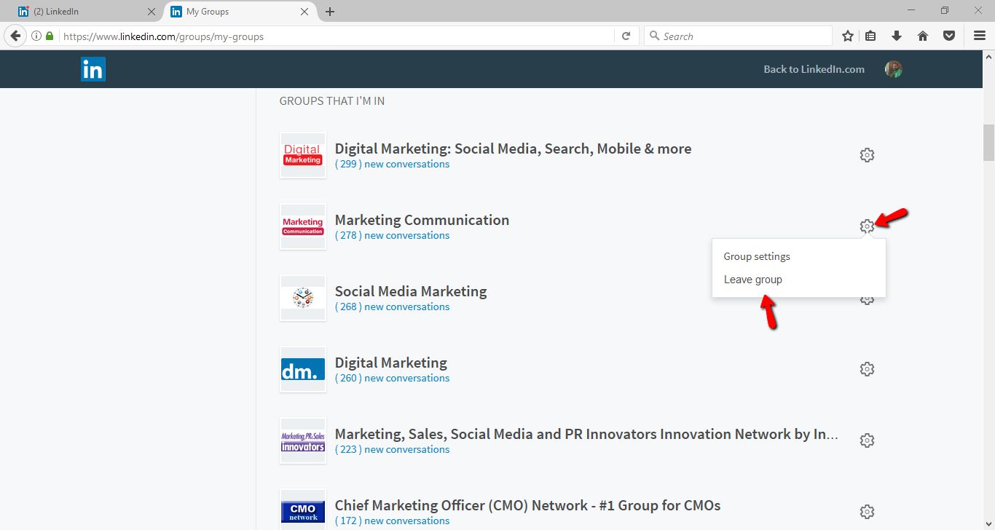

  - On the group’s home page in the top right hand corner there will be a button that says “Member”. If you take your cursor and hover over that button, the button will then say “Leave” and you can simply click that leave button.
