Group Creation Workbook

Authority Leadership Platform

au·thor·i·ty (/əˈTHôrədē/) n. - a person or organization having power or control in a particular, typically political or administrative, sphere.
lead·er /ˈlēdər/ n. - the person who leads or commands a group, organization, or country.
Sharing content and resources or Founding/Managing a group that caters to the interests of your clients prospects builds their positioning as an Authority Leader in the eyes of those prospects.
- Those prospects begin to associate your client with this group and the resources you are sharing for the client in that group. Thereby, positioning your client as the person they think of to call and learn more about.

What makes a good group name?
- Speaks to the interests, geography, job title, industry of the prospect.
- It should not be an explanation of the exact thing the client does – i.e. if you were the owner of a Manufacturing Plant that I (as a Lead Gen/Marketing Consultant) am targeting. Are you more likely to join a group called the “Plant Operations and Management Forum” or “Marketing Tactics for Manufacturers.” While marketing is on a Plant Owners radar, they likely self-identify far more as a plant owner or manufacturer.
- Examples:
  - Small Biz Forum | The Group for Small Business Owners & Professionals
    - This is one of our internal groups. Our target clients are small business owners. We position ourselves as small business experts and share resources that will help that prospect based on their interests. If the group were only title “LinkedIn Lead Gen Tactics for Small Businesses” it comes across as more promotional, salesy, and will likely attract more of our competitors than our ideal prospects.
  - Midwest Manufacturing Leaders - The Community for Midwest Manufacturing Industry Executives
    - This group is run for a client. Our client is the CEO of an IT Consultant/Software Development company. His target for the campaign are Manufacturing ceos, owners, c-level tech execs. We know those people will identify in this industry and position our client as the go-to thought leader within the group he owns. People find themselves turning to our client to find out more about what he does, or get introduced to others in the manufacturing industry, and feel comfortable working and taking appointments with our client.

What to Aim For
- A community of like-minded people sharing, discussing, commenting on topics that interest them.
- The sole focus should not be on your client’s business, product, services, but sharing content/resources that the prospect will care about.
- Position your client as the founder of this community that is different than all the others out there. Not “me, me, me” focused.
- Position your client as an authority leader on the topic of the greatest important to the prospect.

How to Create a Group

1.) To navigate to create your new group, you’ll first click on the ‘Work’ option at the top right of your screen and choose Groups.

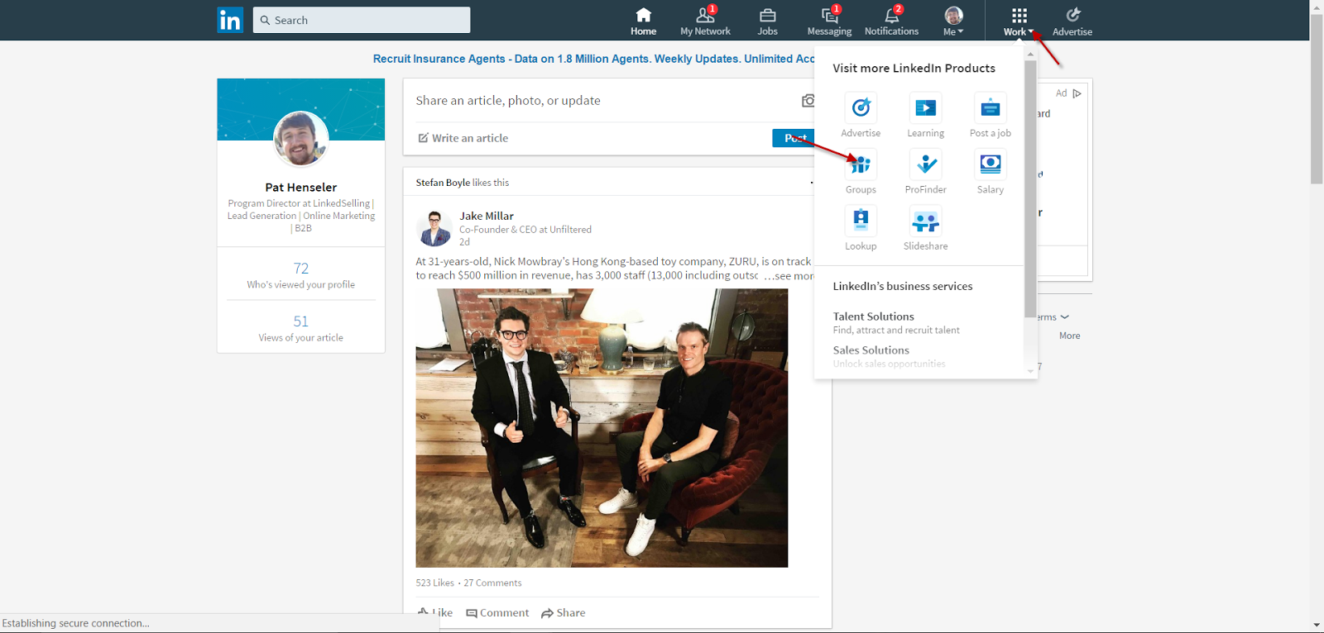

2.) To start your new group, click on My Groups. And then Create Group. From there everything in the training video will still apply.
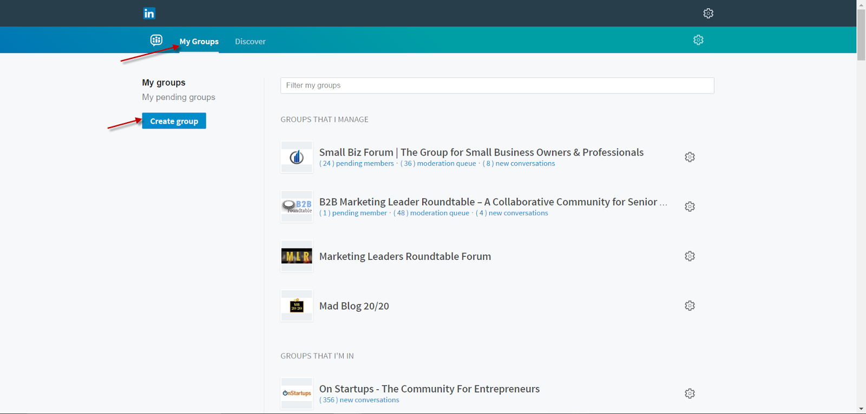

Getting Started
- List 3 characteristics of a good group name.
___________________________________________________________________________________________________________________________________________________________________________________________________________________________
- Write 3 ideas for your group name below. Circle the one that your audience will identify with the most.
____________________________________________________________________________________________________________________________________________________________________________________________________________________________________________________________________________________________________

- Write out your About this Group Section. Feel free to use the B2B Marketing Leader Roundtable (or other groups you are a member of) as a guide.
____________________________________________________________________________________________________________________________________________________________________________________________________________________________________________________________________________________________________

- Write out the names of 10 groups that you will join which should be full of your prospects. BONUS – What makes them good or bad?

____ _ _
____ _ _
____ _ _
____ _ _
____ _ _
____ _ _
____ _ _
____ _ _
____ _ _
____ _ _
____ _ _

