Database Build Theory FAQ Workbook

How many connection request can we send in total?

LinkedIn has changed the number of connection requests you are able to send to 5,000. LinkedIn will warn you when you are getting close to running out of the 5,000 connection requests. If you see that warning that you are running out of connection request, just reach out to LI’s help center and ask for more connection request. It is no guarantee, but I have never been denied a request additional connection request.

Do you still recommend upgrading to the Business Plus Account?
- No, we do not! Sales Navigator is the preferred and recommended profile upgrade. The reason for the switch is that LinkedIn recently altered the Business Plus and Sales Navigator platforms in terms if the number and type of search filters we have access to in order to complete the most effective database build.

Do we still need to export a client’s current connections before starting the database build?
- YES! The results we generate for our clients are phone calls with highly targeted prospects. And a campaign’s results are based on the work, connections and relationships we build for our clients from connection request to the request-for-phone call message. Unless a client specifically tells you that they want to use their current/original connections, all of our results are based on the new connections we get for our client.

Are you still running into captchas when sending connection requests from Sales Navigator?
- Great questions and NO! We have not run into captchas when sending out connection requests from Sales Navigator, which speeds up the process of the database build. Once you get a couple database builds under your belt, I’d be looking to be sending out 100 connection requests per hour.

Is 40% still considered good for an acceptance rate?
- Yes, 35%-40% is still considered a good acceptance rate when doing a database build. It is when I am in the 20’s in terms of percentage when I want to take a look at the client’s headline and profile.

Do you still see the activity or the “I don’t know you” restriction?
- Yes and no. We are not seeing the same activity or “I don’t know you” restriction, but we have seen a restriction that seems to be based on the ratio of connection request sent and accepted vs. connection request pending or denied. If you have a connection request pending, LinkedIn will tell/show you on that prospect's profile that the connection request is pending.
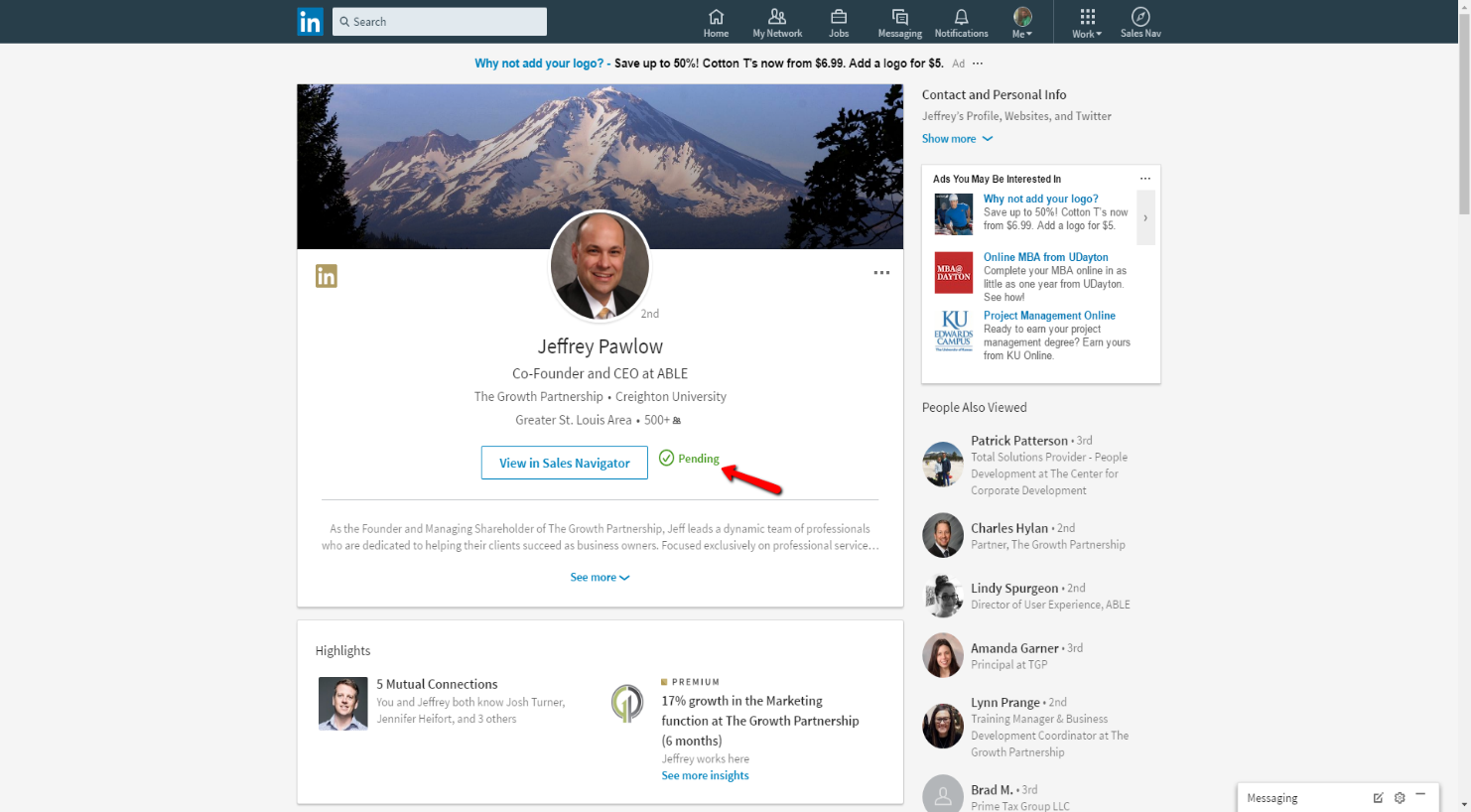
LinkedIn unfortunately does not tell us what the magic number is in this ratio to avoid the restriction. Below is a screenshot of what the message looks like when you see that restriction.
When you see this message when are trying to send connection requests, you can reach out to LI’s help center but they will tell you to withdraw your pending invitations to balance out that ratio, but again, LI does not give us that magic number in the ratio that triggers this restriction.

